12 February 2025
EMPOWERING CSOS AND COMMUNITIES AS LEADING ACTORS AND PARTICIPANTS IN SOCIAL CHANGE AND BUILDING CAPACITIES OF LOCAL AUTHORITIES
Annual Narrative Report

Table of Contents
1. Description 4
2. Assessment of the implementation of the action activities and its results 4
2.1 Executive summary of the action 4
2.2 Results and Activities 5
B. Activities 8
Activity 1 related to Output 1.1 8
A 1.1 Capacity-Building Training of Accountability & Transparency in The Local Government in Borama & Ainabo (YOVENCO) 8
Activity 2 related to Output 1.1 10
A 1.1 Capacity-Building Training for CSOs, CBOs, and Local Development Partners: Policy Discussion on NGO Act Law No. 43/2010 10
Activity 1 related to Output 1.2 13
A 1.2.3 SCAN General Assembly Interactive Meeting (YOVENCO) 13
Activity 2 related to Output 1.2 15
A 1.2.3 Activity Report on Interactive Meeting on CSOs Grassroots Advocacy for Local Impact (YOVENCO) 15
Activity 3 related to Output 1.2 17
A 1.2.2 Consultation Meeting on District Development Forums Formation in Erigavo (YOVENCO) 17
Activity 4 related to Output 1.2 19
A 1.2.1 Townhall Meeting Report: Inclusive Governance: Empowering Women, Youth, and Marginalized Groups (YOVENCO) 19
23
Activity 5 related to Output 1.2 24
A 1.2.2: Activity Report on Community Dialogue: Promoting Peace and Preventing. Conflict During Elections 24
Activity 1 in relation to Output 1.3 27
A 1.3.1 Activity Description: 6 Consultation forums on District Development Forum Establishment Across Major Districts (YOVENCO) 27
Activity 2 in relation to Output 1.3 33
A 1.3.2 Activity Description: Workshop on Local Development Plans & Budgets in Borama & Ainabo (YOVENCO) 33
Activity 3 in relation to Output 1.3 35
A 1.3.2 Activity Description: Two Workshop on Conflict Resolution, Leadership and Strategic Planning for CSOs and Local Authorities in Buro’a & Berbera (YOVENCO) 35
Activity 1 related to output 2.1 38
A 2.1.2 Tailored Capacity-Building Training for Hal-Dhawr, Cafaariigsi, and YODEV Organizations 38
(YOVENCO) 38
Activity 2 related to output 2.1 41
A 2.1.3 Activity Report: Voter Education Public Campaign (2nd - 12th November 2024) (YOVENCO) 41
Activity 1 related to output 2.2 43
A 2.2.1.1 Public Campaign: Toward Disability-Inclusive Public Infrastructure and Services. (YOVENCO) 43
Activity 2 related to output 2.2 45
A 2.2.1 Activity Report on Public Campaigns for Involving Women’s Organizations, Youth Organizations, and Media in the Transformative Process of Engendering Social Change, in particular by challenging stereotypes in Burao and Hargeisa. 45
Activity 1 related to output 3.1 47
A 3.1.1 Activity Report of Training of trainers on Civic education, advocacy and awareness-raising activities at the grassroots level to increase citizen participation in civic activities in Burao. (SOYDAVO) 47
Activity 2 related to output 3.1 49
A 3.1.1 Training of Trainers on Civic Education, Advocacy, and Awareness-Raising Activities in Burao and Erigavo: Report on Achievements and Impact 49
Activity 3 related to output 3.1 50
A 3.1.1.2 Activity Report on Talk Show Sessions: Advancing Somaliland’s Democratization Process 50
Activity 4 related to output 3.1 52
A 3.1.1.3 Activity Report of a community conversation on awareness-raising activities at the grassroots level to increase citizen participation in elections in Burao. 52
Activity 5 related to output 3.1 53
A 3.1.3 Activity Report of Community Conversation on Civic education, advocacy and awareness-raising activities at the grassroots level to increase citizen participation in civic activities in Burao. 53
Activity 1 related to output 3.2 54
A 3.2.1 Community Conversation for Enhancing Peace and Cohesion in the Sanaag Region 54
Activity 2 related to output 3.2 55
A 3.2.2 Community Consultation Workshop on Electoral Challenges for Minorities and Persons with Disabilities in Burao 55
Activity 1 related to output 3.4 56
A 3.4.1 Cultural Events Lobbying, advocacy and awareness campaigns, including the use of media on transparency, accountability, gender equality and environmental stability in Burao. 56
Activity 2 related to output 3.4 58
A 3.4.2 Awareness raising workshop on the importance of media in promoting transparency, accountability and increasing voter participation in elections in Burao (SOYDAVO) 58
Activity 3 related to output 3.4 60
A 3.4.1 Cultural Events on Commemorating Somaliland’s Election and Democracy in Burao (SOYDAVO) 60
2.3 Logframe Matrix Updated 62
2.4 Activity Matrix 67
2.5 Updated Action Plan 0
3. Beneficiaries/affiliated entities, trainees, and other cooperation 0
4. Visibility 0
5. Conclusion 0

- Description

  - Name of coordinator of the grant contract: YOVENCO
  - Name and title of the contact person: Khadar Mariano, Project Manager
  - Name of beneficiary(ies) and affiliated entity(ies) in the action: SOYDAVO
  - Title of the action: Empowering CSOs and communities as leading actors and participants in social and change and building capacities of local authorities to deliver transparent, accountable, people-centered social services
  - Contract number: NDICI CSO/2022/437-611
  - Start date and end date of the reporting period: 1/1/2024- 31/12/2024
  - Target country(ies) or region(s): Somaliland
  - Final beneficiaries &/or target groups (if different) (including numbers of women and men): CSOs, youth, women, PWD, vulnerable/marginalized communities, and local authorities,

Assessment of the implementation of the action activities and its results

2.1 Executive summary of the action

During the reporting period, the project has successfully advanced local governance by strengthening CSO participation in public decision-making and social accountability. Several key activities including capacity-building workshops on advocacy, governance, and service monitoring, alongside multi-stakeholder dialogues, advocacy forums, and town hall meetings that fostered direct engagement between CSOs, government officials, and communities, were implemented. Public campaigns. Which promoted gender equality, disability inclusion, and voter education, ensured marginalized groups played an active role in governance. While youth-led organizations received targeted training to enhance their capacity gaps, identified through the Capacity Assessment Toolkit, for sustained advocacy.
Not only did the project reinforce transparency and accountability through coordination-building efforts, but also structured coordination forums that united development actors labeled as District Development Coordination Forums were established across six key districts. Community engagement was further strengthened through cultural events, televised discussions, and media workshops, for increased awareness of governance issues and fostered civic participation. These interventions collectively contributed to empowering CSOs as key actors in governance and ensured their voices influence policy decisions and service delivery.
However, the project aims to sustain its impact by committing remaining capacity-building activities to strengthen CSO structures, consolidate inter-governance mechanisms, and expand stakeholder engagement. Interactive meetings will be leveraged to attract additional development actors, while institutional frameworks and accountability tools, established through key capacity-building initiatives, will ensure continuity beyond the project’s duration. With these measures in place, the project has laid a strong foundation for transparent, inclusive, and community-driven governance in Somaliland.

2.2 Results and Activities
A. RESULTS (IMPACT, OUTCOMES, OUTPUTS)
Impact – To strengthen Somaliland CSOs to be independent actors in the promotion of transparent, accountable and inclusive local governance in their own right

The project’s initial phase successfully implemented key capacity-building initiatives for CSOs and facilitated the establishment of District Development Coordination Forums (DDCFs) to enhance governance collaboration. Additionally, it developed mechanisms that will be instrumental in supporting CSO-led advocacy efforts aimed at promoting transparency, accountability, and inclusive local governance.
During this reporting period, project activities focused on strengthening CSOs’ capacity to actively participate in governance processes, ensuring their role as key actors in decision-making and policy influence. The creation of an enabling environment for CSOs to thrive has laid a solid foundation for subsequent interventions, where empowered CSOs can effectively monitor government performance, advocate for service improvements, and contribute to broader governance reforms at both district and national levels.
A major milestone of the project in the second year has been the establishment of DDCFs as structured platforms for coordination and accountability. The interconnected activities, such as multi-stakeholder dialogues, advocacy forums, and SCAN-building efforts, have reinforced the ability of DDCFs in unifying governance actors, with reduced fragmentation, and promoted inclusive participation. In the final year, the project intends to use the remaining activities, particularly capacity-building workshops and interactive meetings, to further strengthen the DDCFs. These sessions will capacitate CSO members, assist in preparing working policies and internal bylaws, and ensure that the DDCFs remain well-equipped to sustain their role as mechanisms for transparency and accountability in local governance, sustainably.
Furthermore, interactive meetings will be leveraged to expand the membership base of the DDCFs, attracting potential development actors who have not yet been included, contributing to the inclusivity and effectiveness of the forums. Ultimately, the goal is for the DDCFs, together with SCAN, to continue functioning beyond the project’s timeline, with strengthened capacities, an expanded membership base, and sustainable accountability mechanisms. By embedding these practices within local governance structures, the project aims to ensure long-term impact in promoting transparent, accountable, and community-driven governance.
Outcome 1 – To enhance local governance through the participation of CSOs in public decision-making processes and in social accountability.

The project’s activities directly contributed to achieving Outcome 1: Enhancing local governance through CSO participation in public decision-making and social accountability. Each activity strengthened civil society’s governance role, increased its influence, and fostered accountability by laying effective DDCF mechanisms for responsive, community-driven governance.
Capacity-strengthening workshops equipped CSOs with advocacy skills, conflict-sensitive governance, and service monitoring abilities. These were complemented by tailored capacity-building, ensuring practical application in self-governance. To translate this built capacity into action, multi-stakeholder dialogues and advocacy forums were facilitated in an effort to create direct engagement between CSOs, government officials, and communities. These dialogues, and townhall meetings enabled CSOs to present evidence-based policy recommendations, advocate for community needs, and strengthen their accountability role.
Subsequently, the District Development Forums established, which are designed as social accountability initiatives, will result in empowered CSOs that can monitor government performance, advocate for service improvements, and enhance transparency from within, building trust between communities and public institutions. Challenges such as limited private sector engagement in the DDFs highlighted the iterative nature of governance reforms, emphasizing the need for gradual inclusivity. By integrating these interventions, the project strengthened CSO participation, improved social accountability mechanisms, and contributed to transparent, inclusive, and effective local governance.
Outcome 2 – To increase local CSO capacities to engage in gender equality.
The project made significant progress towards outcome 2 indicators. During the reporting period, the project organized public campaigns on promotion of disability inclusion in public infrastructure and services, and the gender equality. Oftentimes, people with disability struggle to access government buildings, including those newly built due to the absence of proper awareness of such exclusionary practices. Many disabled people opt not to seek government services on their own because those services remain inaccessible, not just physical accessibility but also informational accessibility. The campaigns helped to shed light on the issue of improving disability access to services and governmental building through inclusive construction practices, and accessible information sharing and service delivery systems as well as contributed to the advocacy against long-held gendered stereotypes and to promote the inclusion of women in education, employment and leadership roles as well as their political participation. On the other hand, tailored capacity-building training was provided to three youth-led organizations, Hal-Dhawr, Cafaariigsi, and YODEV, so as to enhance their leadership and governance capacities. The tailored trainings aimed to capacitate emerging youth-focused organizations as part of the project’s goal to enhance the capacities of local CSOs. Those three youth-led organizations are primarily focused on advocacy toward gender equality, promotion of youth and women rights, making them well-positioned to make impact after these interventions. Also, a voter education campaign was conducted from 2nd to 12th November 2024, raising awareness of voting procedures, legal requirements, and electoral fraud prevention mechanisms, with a focus on marginalized groups.

Output 1 Somaliland CSOs Empowered to promote and support transparency, accountability and policy-making in the local government

The project’s activities were strategically interconnected to achieve Outcome 1: Enhancing local governance through CSO participation in public decision-making and social accountability. Each activity reinforced civil society’s governance role, increased its influence, and fostered accountability by laying effective DDCF mechanisms for responsive, community-driven governance.
Capacity-strengthening workshops equipped CSOs with advocacy skills, conflict-sensitive governance, and service monitoring abilities. These were complemented by tailored capacity-building, ensuring practical application in self-governance. To translate this built capacity into action, multi-stakeholder dialogues and advocacy forums were facilitated in an effort to create direct engagement between CSOs, government officials, and communities. These dialogues, and townhall meetings enabled CSOs to present evidence-based policy recommendations, advocate for community needs, and strengthen their accountability role.
The SCAN Network’s coalition-building efforts fostered stronger CSO partnerships, amplifying their collective voice in governance. A major contributing activity of this project was the establishment of District Development Coordination Forums (DDCFs) across six key districts, facilitated by YOVENCO with EU support. These forums united development actors in those respective districts by addressing their otherwise fragmented efforts. The DDCFs brought together local government, CSOs, academia, the private sector, and community members, ensuring coordinated action under a unified governance framework.
Consequently, the forums, which are designed as social accountability initiatives, will result in empowered CSOs that can monitor government performance, advocate for service improvements, and enhance transparency from within, building trust between communities and public institutions. Challenges such as limited private sector engagement in the DDFs highlighted the iterative nature of governance reforms, emphasizing the need for gradual inclusivity. By integrating these interventions, the project strengthened CSO participation and improved social.
The project has successfully conducted all activities associated with Output 1 planned for the reporting period, making the project on track to achieve all output indicators.

Output 2 Women, Youth, Marginalized, and Vulnerable people, PWDs, and minority clans take a leading role in the promotion and support of entrenching the engendering policy and decision-making in local governance and social accountability in Somaliland.
During the reporting period, the project promoted gender and disability inclusion in Somaliland through many initiatives. Tailored capacity-building training was provided to three youth-led organizations, Hal-Dhawr, Cafaariigsi, and YODEV, so as to enhance their leadership and governance capacities. A voter education campaign was conducted from 2nd to 12th November 2024, raising awareness of voting procedures, legal requirements, and electoral fraud prevention mechanisms, with a focus on marginalized groups. Moreover, a public campaign advocating disability-inclusive infrastructure aiming for public buildings engaged disability-focused organizations to address accessibility challenges.
Public campaigns in Burao and Hargeisa both promoted gender equality, challenged stereotypes, and encouraged women's leadership participation. Overall, the project succeeded to strengthen CSOs to advocate for disability inclusion and gender-responsive policies, and ensured marginalized voices play a key role in governance and social accountability, while keeping it on track toward achieving its output indicators.

Output 3 The Somaliland Media and Population take an active role in participation, and decision-making in the governance of local.

During the reporting period, the project successfully improve citizen participation and media engagement in local governance. Several key activities were implemented such as community conversations, advocacy campaigns, cultural events, and televised discussions, to promote transparency, accountability, and electoral participation.
The Cultural Night in Burao, organized by CSI Burao and SOYDAVO celebrated Somali heritage through poetry, traditional dances, and exhibitions, and provided a platform for young poets to address local governance themes. The events also strengthened collaboration between academia and civil society, reinforcing mutual advocacy through culture.
In addition to that, an awareness-raising workshop on the role of media in governance was conducted to emphasize its impact on transparency, accountability, and voter participation. Through interactive sessions coupled with cultural performances, participants explored the connection between democracy and traditional national identity, highlighting the role of culture in strengthening democratic values and fostering social cohesion.
The project made significant progress by directly reaching over 350 citizens through these interventions, training 50 community educators, and engaging key stakeholders, including government officials and CSOs; which led to further advancing accountable governance and democratic participation. These activities ensured that the project remained on track to achieve its objectives.
These activities have improved the role of the community in civic participation and decision-making in the local governance matters, including elections, peacebuilding, and accountability and transparency advocacy.

B. Activities
Output 1: Somaliland CSOs Empowered to promote and support transparency, accountability, and policymaking in the local government.

Activity 1 related to Output 1.1

A 1.1 Capacity-Building Training of Accountability & Transparency in The Local Government in Borama & Ainabo (YOVENCO)

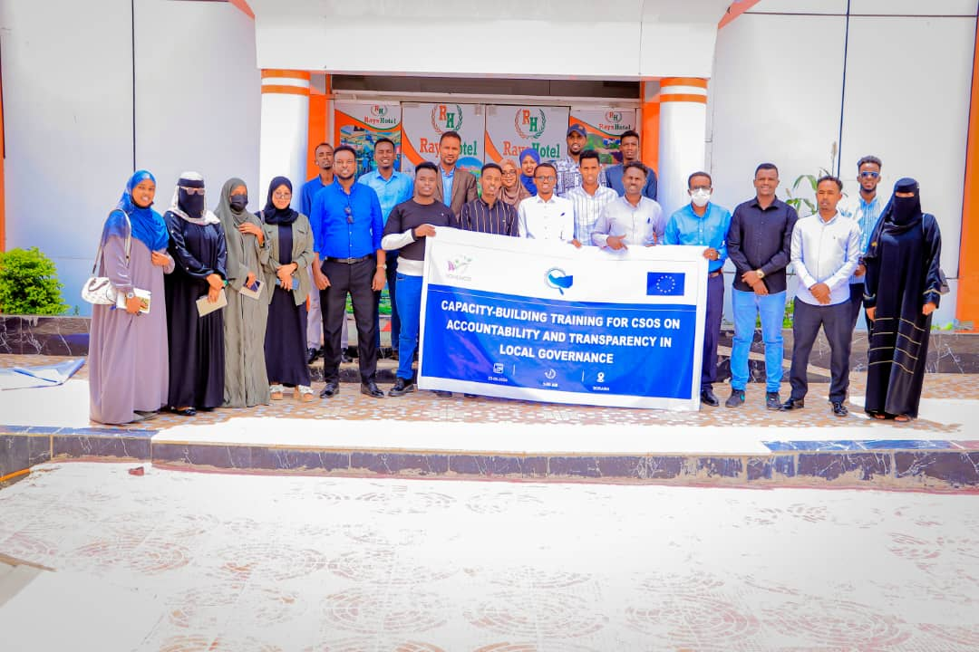
Figure 1 Photo Group of Participants of the Capacity-building training

Introduction
Civil society organizations (CSOs) play a crucial role in promoting good governance and accountability at the local level. In Somaliland, their contributions to development are particularly significant, given the decentralized nature of the government and the importance of community engagement. However, CSOs perceive a lack of access to information of the government about public planning and programming. Civil society development in Somaliland is also hindered by the non-conducive environment and by civil society's low capacity, where CSOs fundamentally lack strategic planning and other capacities. To address the issues outlined above, YOVENCO Organization planned to carry out a series of capacity-building trainings which started last year, targeting the CSOs based in different regions, starting with Hargeisa, Buro’a, and Erigavo. This series of capacity-building trainings were conducted in Hargeisa, Buro'a, and Erigavo on Accountability and transparency in Local Government. To expand its reach, YOVENCO has conducted capacity-building training in Borama, and Ainabo during the reporting period on the same area of accountability and transparency enforcement through the lenses of CSOs.
During the capacity-building training, 60 participants were engaged (35M/25F), in a discussion on concepts of local governance, accountability, and transparency. The goal was to elevate the awareness and understanding of CSOs, ensuring they were well-versed in the principles and practices that underpin effective community development.
A pivotal aspect of the training initiative focused on elevating the skills and competencies of CSOs. The program touched upon various aspects such as advocacy, communication, networking, monitoring, and evaluation, providing participants with a robust toolkit for active participation in local governance and accountability processes.
Recognizing the practical needs of CSOs, the training equipped participants with significant tools and resources. This strategic provision aimed to support their active engagement in local governance and accountability processes, translating theoretical knowledge into actionable strategies.
The capacity-building training and the subsequent workshops were facilitated by an expert consultant of governance who has been involved in the sphere of governance for the past 10 years, with extensive hands-on experience on the topics in discussion.
Implementation Approach & Participation Overview:
The impact of the training was seen through the active participation of representatives from highly engaged organizations in each region. Sixty individuals (45% females, 55% males), representing approximately 14 diverse organizations, have taken part in the trainings. Through the collective capacity enhancement of the CSOs, we have not just taken individual capacities into the next level but also fostered a collaborative network that could catalyze a cooperative culture between the existing CSOs in Awdal & Saraar regions.
Key Training Content:
The training program covered a wide range of topics relevant to effective CSO engagement in local governance. These included:
- Principles of good governance: Transparency, accountability, participation, and rule of law.
- Decentralization and local government structure in Somaliland: Understanding the division of power and responsibilities between different levels of government.
- Laws governing local government: Knowledge of relevant legal frameworks and regulations.
- Relationship between central and local government: Comprehending the role of regional councils in bridging the gap.
- Role of village councils: Recognizing the importance of grassroots engagement in local decision-making.
- Communication flow between local government and citizens: Fostering open and transparent communication channels.
- Financial management functions of district councils: Understanding how local governments manage their budgets.
- Responsibility matrix: Identifying key actors and their roles in holding local governments accountable.
Activity Achievement & Results
Equipping CSOs with the necessary knowledge, skills, and resources, these capacity-building initiatives serve as steppingstones to a more robust and inclusive local governance system in Somaliland. Empowered CSOs can effectively advocate for the needs of their communities, hold local authorities accountable, and contribute to the development and implementation of policies that reflect the aspirations of the people. This ultimately leads to stronger communities, improved service delivery, and a more transparent and accountable local government.
Achievements
Participants demonstrated an improvement in their understanding of local governance concepts, principles, and practices. This was evident in their active participation in discussions and insightful questions.
Participants gained practical skills in advocacy, communication, networking, monitoring, and evaluation through the training, questions raised, and discussion on relevant issues at hand.
These skills were further honed during the subsequent workshops on local development plans and budgets, where participants actively engaged with local authorities and community members.
The provided tools and resources, such as the responsibility matrix and communication flow diagrams, were readily adopted by participants and could be integrated into their work.
These tools distributed have the potential to improve communication and collaboration between CSOs, local government officials, and community members.
Participants reported feeling more confident and equipped to engage with local authorities on a meaningful level and hold them accountable for their actions.

Activity 2 related to Output 1.1

A 1.1 Capacity-Building Training for CSOs, CBOs, and Local Development Partners: Policy Discussion on NGO Act Law No. 43/2010

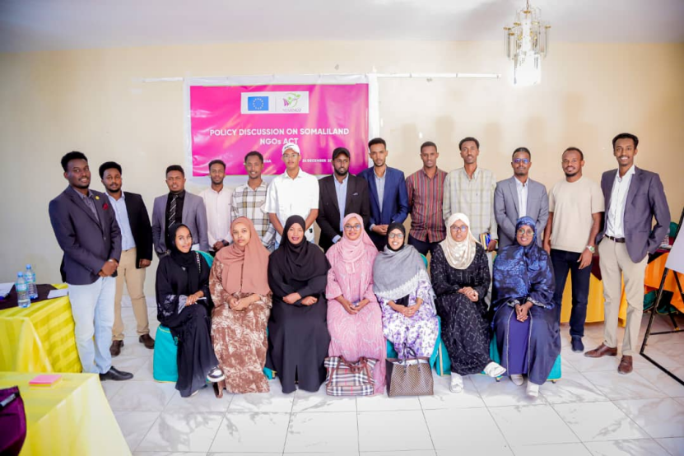
Image: Policy Discussion on NGO's Act in Hargeisa
Introduction
On 24th of December, 2024, YOVENCO Organization, with the funding support of the European Union, has organized Policy Discussion on Somaliland NGO Act, 43/2010. This policy has long been the subject of interest among the leading members of Somaliland Civil Society Organizations.
Aiming to facilitate thorough discussion on the existing NGO Act and bring such discussion closer to the stakeholders of the act, YOVENCO brought together local organizations, particularly those among the leading advocates of the Act amendment, to critically examine its impact on NGO operations. The discussion aimed to identify challenges stemming from the Act, assess its effectiveness, and propose actionable recommendations. Legal professionals and prominent community members of 25 in total, 16M/9F, including representatives from the Somaliland Lawyers Association, participated in the discussion to provide expert insights.
The discussion started with a brief presentation of the Act, its chapters, articles, and the overall content. The session began with a brief presentation outlining the Act’s chapters, articles, and overall content. This introduction was meant to provide participants with foundational knowledge, stimulate critical thinking, and lay the groundwork for a productive discussion.
Following the presentation, participants engaged in focused group discussions, analyzing the Act’s strengths, weaknesses, language, compliance, and regulatory mechanisms. Group discussions were structured to examine specific chapters and corresponding articles, allowing for in-depth engagement with the Act’s content. This approach enabled participants to have ample time to identify shortcomings, provide constructive critiques, and propose concrete solutions with the parts of the act in hand.

Key Findings and Recommendations

Group 1 (Articles 1-17):
- The Act's title should be revised to reflect a broader scope beyond charity efforts to include a diverse range of NGO functions.
- The group expressed concern over the lack of a regulatory mechanism defining the extent to which international organizations are permitted to directly engage in implementing activities. They argued that local chapters of international organizations, operating with a local implementation mindset, contributed to the shrinking space for CSOs and hindered the capacity growth of local organizations.
Group 2 (Articles 18-28):
- The Act should mandate that merging organizations share thematic focus areas to ensure alignment in mission and objectives.
- Article 19 should provide clearer distinctions of roles and responsibilities to prevent ambiguity.
- Article 20 should enhance the appeal process by incorporating additional review levels to ensure fairness.
- Article 21 should clarify whether district and regional registrars possess the same authority as the General Registrar or if registration processes occur solely at the national level.
- Articles 20-21 lack clear criteria for determining when an organization is no longer active.
- The Act should reinforce two-way accountability, obligating the government to facilitate CSOs' ability to hold it accountable.
- The appointment process for the General Registrar and the National Consultative Committee should be made impartial and transparent to avoid ministerial influence.
Group 3 (Articles 29-40):
- The overall framework of the Act is sound; however, several amendments are needed including to limit excessive ministerial discretion in Article 31 (sub-articles 3 and 4) regarding disciplinary actions for NGOs failing to submit reports.
- Article 39 (3) should be revised to reassess the obligation of host organizations to cover all expenses incurred by expatriates in the event of expatriates are not found, as this creates unjust financial burden. A certain protocols of expatriate engagement and employer-employee obligations in the case of hiring expatriates should be introduced to prevent such situation beforehand, where failure to comply such protocols and obligations may lead to the proposed penalty.
- Article 38 (1) should define a transparent and structured process for issuing warnings and disciplinary actions against international NGOs to ensure due process.
Group 4 (Articles 42-48):
- Employment guidelines should be clearly defined to provide legal certainty for NGO staff.
- The Act should include a structured ranking system for NGOs based on capacity, operational scope, and thematic focus areas, strictly stipulated in the law.
- Capacity-building initiatives should be institutionalized with clear mandates, coming with national competence certification and informing CSO ranking system, to ensure its effectiveness.
- The Act lacks comprehensive dissolution guidelines, which should be elaborated upon the provision of strict dissolution criteria.
- Language and technical ambiguities in several articles should be revised to improve clarity.

Overall Recommendations
- Develop clear employment and ranking guidelines to ensure structured NGO operations.
- Clarify the authority of registrars at different levels to prevent administrative confusion.
- Establish a neutral and transparent mechanism for appointing key officials to prevent political interference.
- Strengthen accountability provisions to ensure that government obligations to NGOs are explicitly outlined.
- Revise articles that grant excessive discretionary powers to the Minister of Planning & Development to ensure fairness and regulatory balance.
- Improve dissolution procedures and introduce clear criteria for determining organizational inactivity.
- Recognition of Monitoring & Evaluation (M&E) practices and the establishment of principles protecting employee rights should be coupled with the alignment of solid implementation and compliance mechanisms.

Key Achievement

YOVENCO conducted this policy discussion to revitalize ongoing CSO efforts to advocate for amendments to the NGO Act, aiming to meet the following objectives; to equip participants with a clear understanding of the NGO Act Law No. 43/2010, including its key provisions, implementation mechanisms, and areas requiring review; foster meaningful dialogue on the challenges and gaps identified within the law while exploring actionable recommendations for improvement; and building the capacity of CSOs, CBOs, and development partners to engage in policy advocacy and legislative reform actively.
The session built a strong consensus on the need for sustained engagement, including follow-up discussions and structured efforts to push for meaningful amendments to the Act.
In conclusion, YOVENCO committed to compiling the key recommendations from the discussion into a formal document of policy brief for submission to relevant authorities and stakeholders. This marks a significant step toward strengthening the regulatory framework governing Somaliland’s NGOs, ensuring it remains responsive to evolving needs and challenges.

Activity 1 related to Output 1.2

A 1.2.3 SCAN General Assembly Interactive Meeting (YOVENCO)
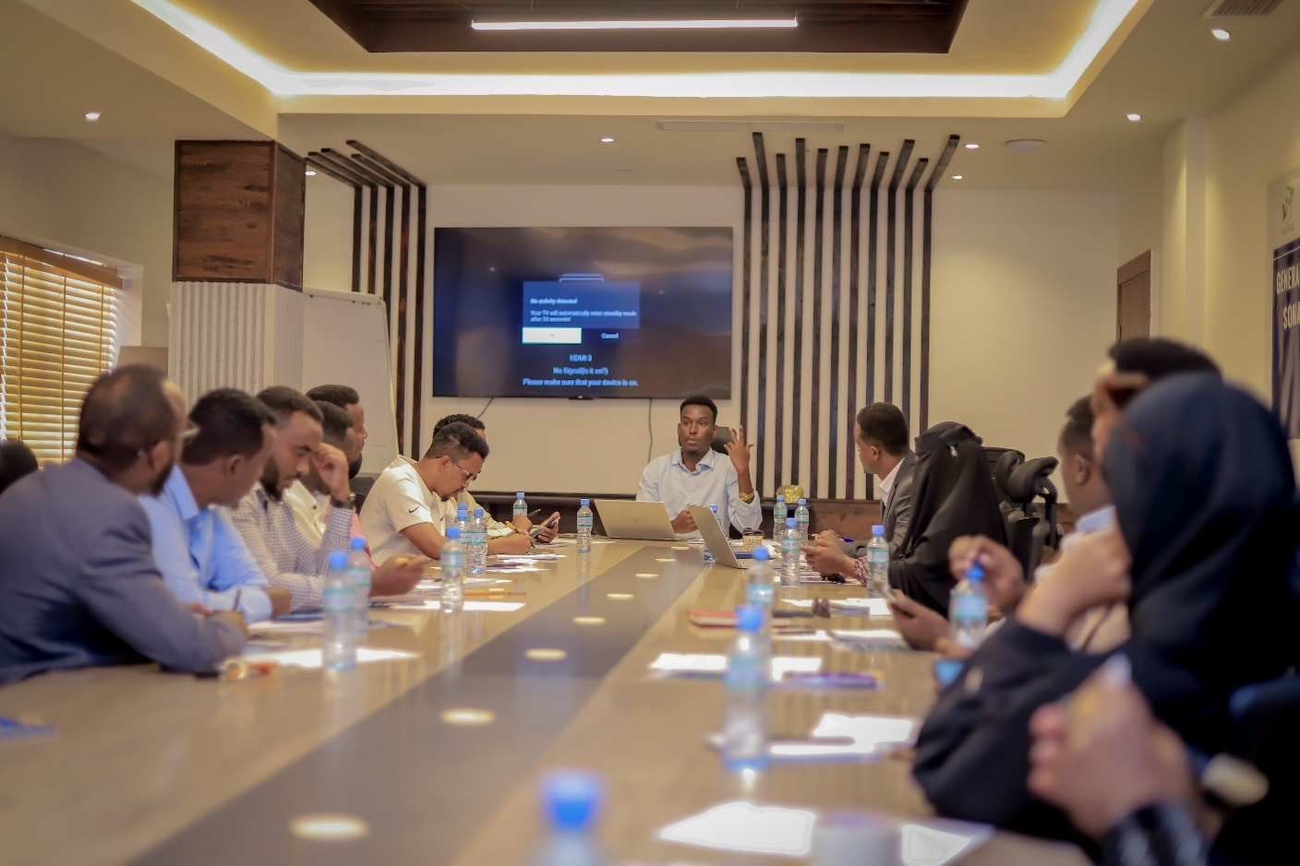
Figure 2 Photo Group of the General Assembly Meeting
Introduction
In an effort to revitalize the CSOs’ crucial role in fostering accountability and transparency across local development spheres, particularly that of the local governments, YOVENCO Organization, in close cooperation with the European Union, has organized an interactive meeting that brought together standing members of the Somaliland CSOs Accountability Network (SCAN) for a second general assembly meeting after the first founding meeting earlier. The objectives of the interactive general assembly meeting were to replace the interim steering committee by establishing and electing a new steering committee, discuss the review and updates on policies of SCAN and make final inputs where needed, and explore opportunities and strategies for working together between the members to help support accountability and transparency efforts, particularly during this time of elections. The meeting participants were 19 representatives, 15M/4F.
Achievement & Results
Seven organizations have been selected in a democratic, open, and transparent manner with particular regard to their thematic areas, regional representation, and strong portfolios. The selected organizations include HRDO representing Sanaag region, YOVENCO representing Sahil region, SOYDAVO representing the implementing consortium, SCA representing Sool region, SNDF representing Disability Organization nationwide, SWRC representing Marodijeh region, TAAKULO representing Togdheer region, Adam Academy representing minority groups, and SAYS representing Awdal region.
Additionally, the general assembly has approved the drafts of the key regulations and policies in which the SCAN Network will have in order to spearhead its programs. The policies were subject to all members of the Network’s scrutiny, review, and input. Among the approved policies are the Constitution of the Network, Conflict of Interest Policy, Membership Policy, and Code of Conduct.
In addition, the Assembly approved the formation of three key working groups that will work under the secretariat, to decentralize the Network’s approach of action through its highly experienced member organizations. The formation criteria were based on the merits of the relevant member organizations, with each organization focusing on the area it has the greatest impact and experience. Among the formed working groups include; Good Governance, Community Empowerment, and Water, Health & Safety Nexus.
The expected outcomes of the General Assembly meeting have been achieved. A new steering committee comprising competent and committed members was elected. A consensus was reached on the approval of the key policies by addressing the existing inconsistencies and gaps through collective analysis and review.
More importantly, the members discussed the rationale and approach toward fostering action to propel the change that the Network envisions to bring, the concept of implementation through member organization rather than SCAN acting as Parent Organization, means and ways toward harmonizing the otherwise scattered efforts of the CSOs during this time of election. The members agreed on the significance of uniting their efforts through SCAN to actively gauge for increased calls on accountability of community development and transparency, to influence the national debate on accountability-making, and toward an electoral process that is accountable, transparent, and reminiscent of community needs. An in-depth understanding of the necessity of pushing local governance issues into the national election debate was also highlighted and underscored.
Conclusion
The General Assembly meeting succeeded to elect standing steering committee, formed working groups that will be essential for facilitating smooth implementation, and finalized the key policies that will govern the operations of SCAN. All of these results were reached in a consensus-based manner, with all members bolstering their commitment to making tangible work ahead.

Activity 2 related to Output 1.2

A 1.2.3 Activity Report on Interactive Meeting on CSOs Grassroots Advocacy for Local Impact (YOVENCO)

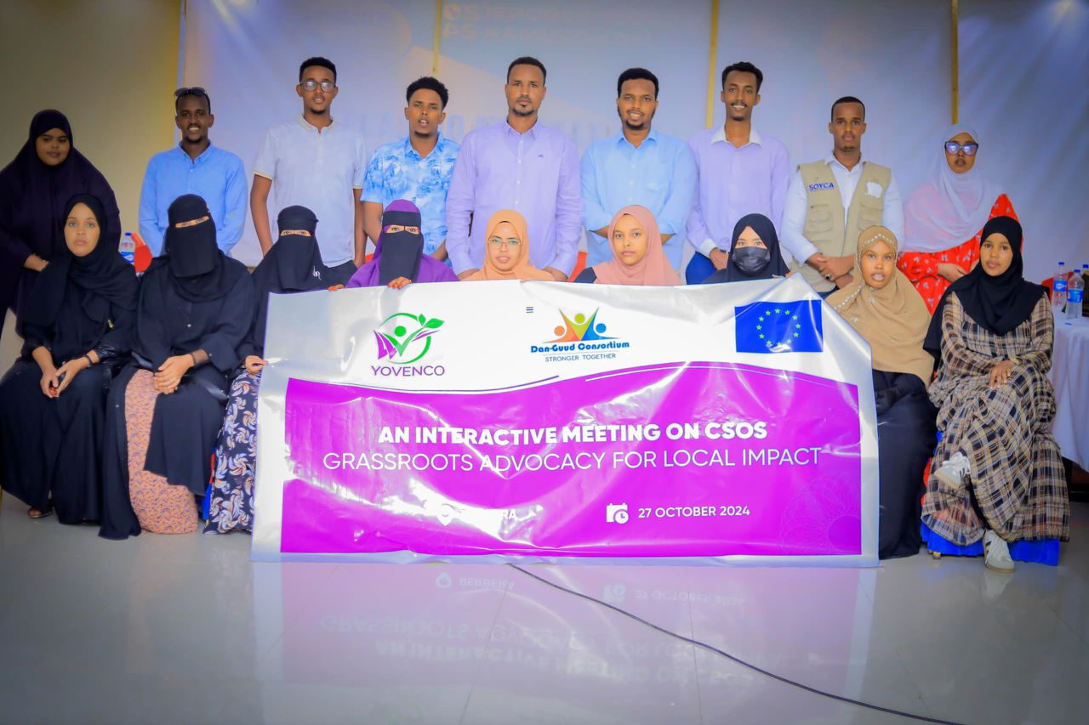
Introduction
Civil Society Organizations (CSOs) in Somaliland face structural and operational challenges, including institutional weaknesses, resource dependency, and limited influence in policy advocacy, particularly outside of the capital Hargeisa where resources and government bureaucracy are prevalent. These significant issues have hindered their ability to effectively mobilize communities, engage with government and other crucial stakeholders, and implement effective and sustainable grassroots advocacy initiatives. In order to address these gaps, YOVENCO Organization, with funding support from the European Union, organized an interactive meeting in Berbera under the title "CSOs Grassroots Advocacy for Local Impact." The event aimed to enhance CSO capacity in advocacy, further strengthen communication skills among local CSOs, and actively facilitate the development of targeted advocacy campaigns.
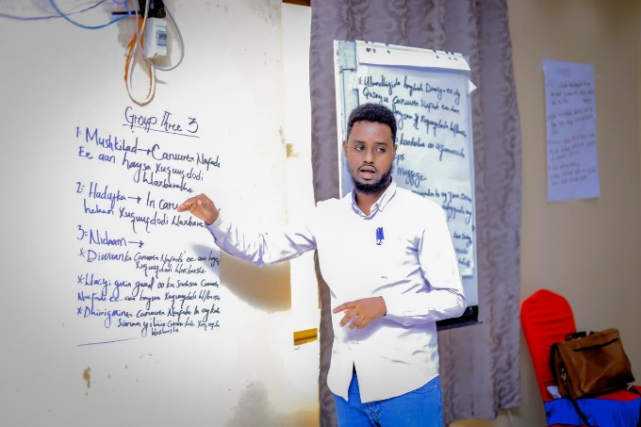
Implementation Rationale
The meeting was set to equip CSOs with the practical knowledge and tools to strengthen their advocacy efforts and improve their engagement with different stakeholders they work with. The meeting brought together 34 participants, 14F/20M, from community-based CSOs, youth and women’s organizations, disability rights groups, and marginalized communities.

This inclusive approach made sure that discussions were broad-based and truly reflected the diverse challenges and advocacy priorities of local communities. Peer discussions, training sessions, and interactive exercises were employed as the facilitator shared on best practices in advocacy, stakeholder engagement, and digital tools for campaign management.
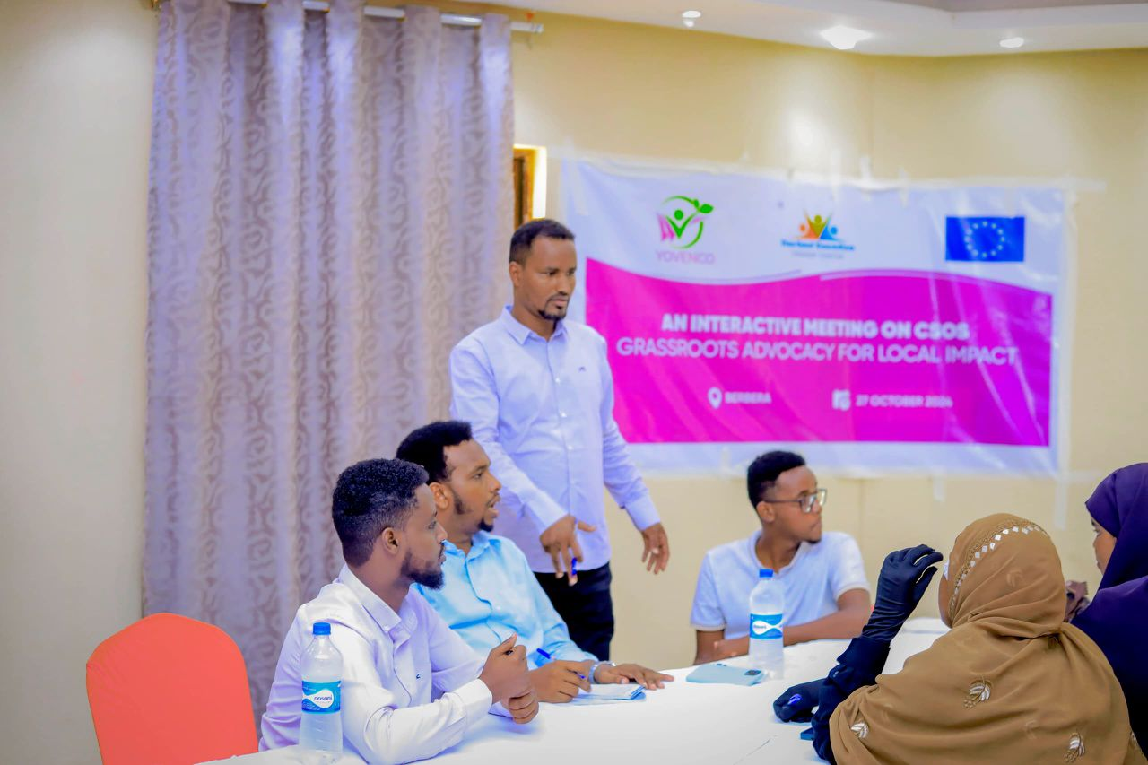
Key Learnings & Achievements
Among the key learnings from the session was the importance of tailored advocacy strategies that align with community priorities. Participants, in their turn, recognized the need for continuous capacity-building in digital advocacy, as technology plays an increasingly significant role in civic engagement. The discussions also highlighted the necessity of fostering trust and collaboration between CSOs and government authorities to create an enabling environment for the CSOs for policy influence. In realization of that, the participants underscored the value of CSOs networking and working collectively to amplify their voices and enhance their impact.
The interactive meeting greatly provided CSOs with the skills and knowledge to improve their advocacy work. Participants were provided with insights into advocacy methodologies, on strategic planning, and in policy engagement. This was coupled with hands-on experience through the identification and prioritization of local issues with targeted advocacy efforts. Participants developed preliminary advocacy action plans that addressed governance, service delivery, and social inclusion challenges. On top of that, communication and digital advocacy skills were strengthened, enabling CSOs to leverage media and digital platforms more effectively in their campaigns.
Conclusion
In conclusion, the interactive meeting was significant as it contributed to strengthening grassroots advocacy in Somaliland as it equipped CSOs with the necessary tools and strategies to engage in impactful policy advocacy.

Activity 3 related to Output 1.2

A 1.2.2 Consultation Meeting on District Development Forums Formation in Erigavo (YOVENCO)

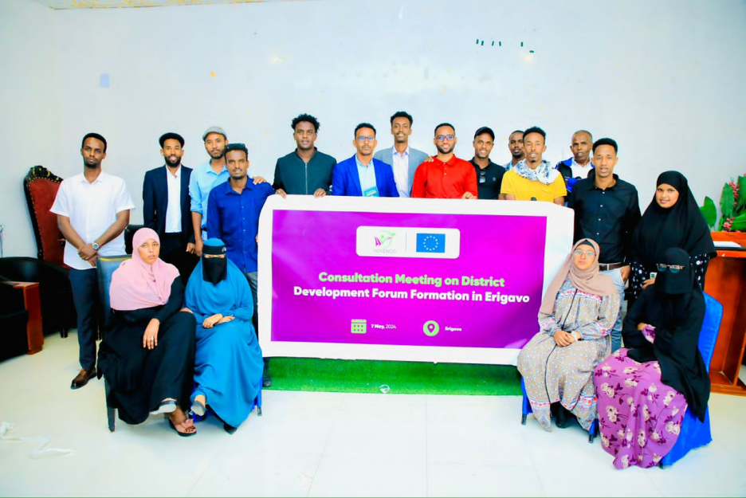

Introduction
YOVENCO conducted a Consultation Meeting on District Development Forum Formation in Erigavo on May 7, 2024 with 25 participants (17M, 8F) from community-based CSOs, community development activists, and the Erigavo local authority.
The consultation aimed to assess stakeholders' understanding of the District Development Forums (DDFs) and explore their ideas and priorities concerning the formation of these forums. The activity served as a foundational step in the establishment of DDFs across the six main districts in Somaliland, providing insights into the willingness and expectations of the target stakeholders.
The consultation introduced the concept of DDFs and their potential benefits for the Erigavo stakeholders. It provided an opportunity to discuss key community development priorities and challenges while generating a shared understanding of the roles and responsibilities of CSOs and local authorities in development efforts. Additionally, it served as a litmus test and baseline for the establishment of DDFs in other districts.
Erigavo was selected as the initial site for this consultation due to the varying capacities of different districts in Somaliland. While districts like Hargeisa and Berbera have prior exposure to similar structures, Erigavo represented an opportunity to assess how communities with less familiarity perceive and engage with such frameworks. This allowed the consultation to identify existing gaps and tailor future DDF implementations accordingly.

Summary of the Discussion

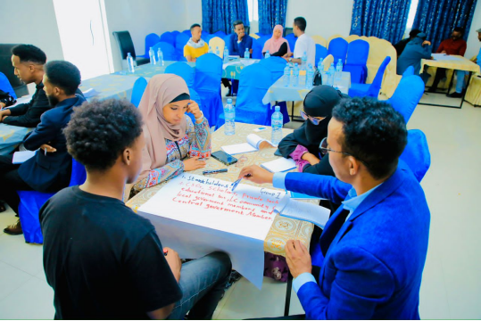
The consultation engaged participants in discussions regarding the structure, functionality, and impact of DDFs. Participants were introduced to the concept of DDFs as inclusive platforms facilitating dialogue and collaboration between local government, CSOs, and the community. It was clarified that DDFs do not function as decision-making bodies but rather as forums for discussion, problem-solving, and collective planning.
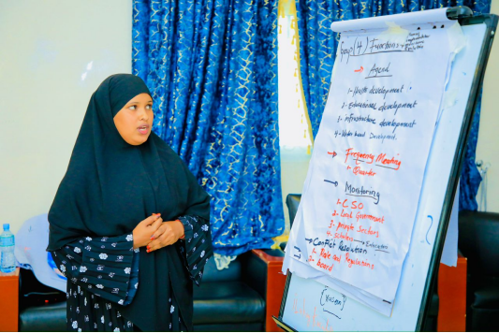
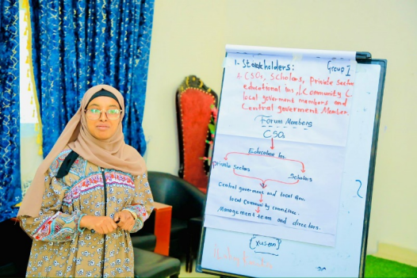
Through interactive discussions and group exercises, key development priorities were identified. These included the need for improved public service delivery, particularly in education and healthcare. Participants emphasized the importance of increased transparency in resource allocation by local authorities and greater citizen participation in governance and policy-making. The discussion also highlighted the need to strengthen CSO capacity for advocacy and mobilization.

Participants acknowledged the importance of collaboration between CSOs and local authorities in driving sustainable development. Concerns were raised about mistrust between CSOs and the government, highlighting the need for mechanisms to foster cooperation and information-sharing.
Key Outcomes and Insights

The following key are the key outcomes of the consultation session
The participants gained a clearer understanding of DDFs and their potential benefits.
The participants have identified key development priorities in the district and a set of key focus areas for the Erigavo DDF in relation with the priorities.
In the consultation, the stakeholders agreed on the importance of ensuring the DDF should be have a balanced representation, inclusivity, and structured communication.
Next Plans to officially establish the Erigavo DDF were discussed, with participants expressing willingness to contribute.

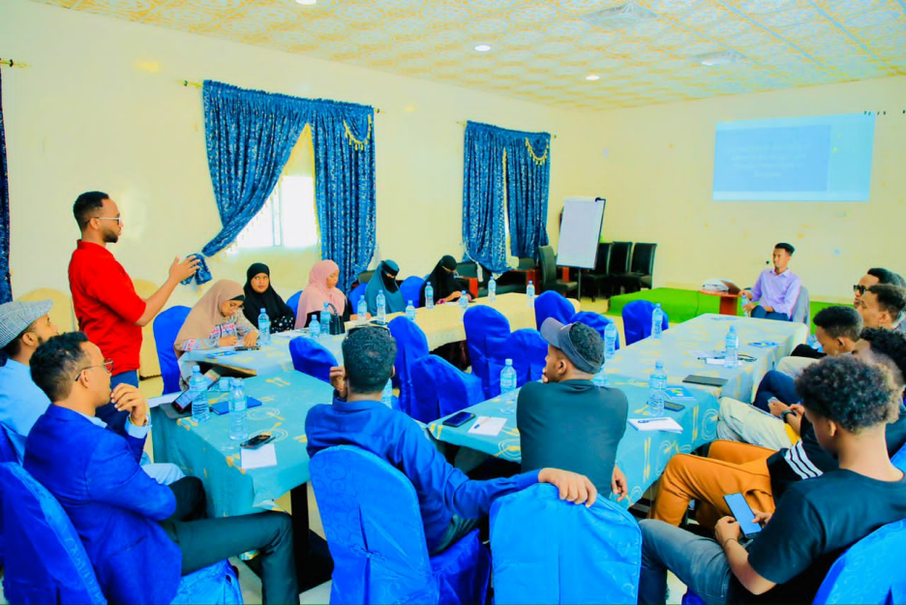

Challenges
There were several key challenges identified in the duration of the consultation, the challenges are as follows:
- Limited prior knowledge of participatory governance models among some stakeholders was evident.
- Concerns were raised over sustainability and funding for DDF activities
- The need for ongoing capacity-building for CSOs and community representatives.
Conclusion
The Erigavo consultation successfully laid the groundwork for the establishment of the District Development Forum. By fostering dialogue among key stakeholders and identifying critical priorities, this activity provided valuable insights that will inform the broader implementation of DDFs in other districts. YOVENCO remains committed to supporting the formation and effective functioning of these forums, ensuring that local governance is inclusive, transparent, and responsive to community needs.

Activity 4 related to Output 1.2

A 1.2.1 Townhall Meeting Report: Inclusive Governance: Empowering Women, Youth, and Marginalized Groups (YOVENCO)

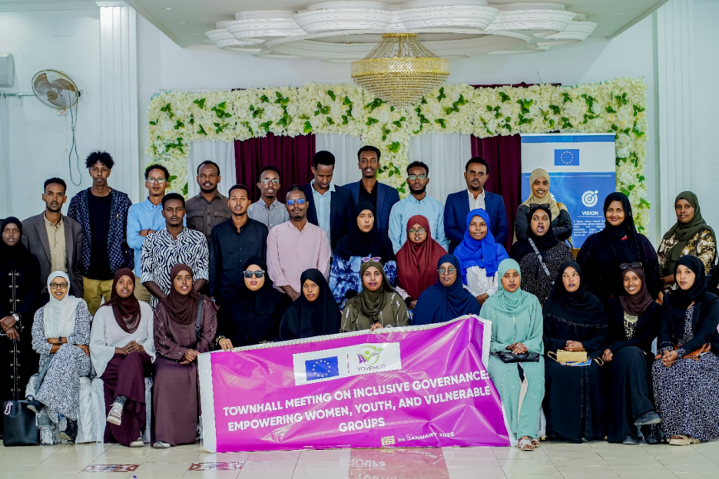

Introduction
The townhall meeting titled Inclusive Governance: Empowering Women, Youth, and Marginalized Groups has taken place in Hargeisa on the 26th of January 2025. The townhall meeting brought together a diverse set of participants, including youth-led organizations, representatives from civil society organizations (CSOs), the Hargeisa Deaf Club, minority organizations, disability inclusion activists and advocates, and women-led organizations. The meeting had 57 participants, of which 22 Male and 35 Female.
The primary objective was to promote inclusive governance by addressing the challenges faced by marginalized groups, sharing success stories, and identifying actionable strategies to enhance participation in governance. The meeting aimed to foster collaboration between marginalized communities and local authorities to develop governance frameworks that are equitable and just.

Structure of the Event
The meeting was structured into three main sections:
Presentation on Inclusion in Governance
Panel Discussion on Inclusive Governance: Empowering Women, Youth, and Marginalized Groups
Roundtable Discussions and Key Action Points
Presentation on Inclusion in Governance
The presentation provided an in-depth look at what inclusive governance means and why it is essential for development, social justice, and peace. Key points included:
Definition of Inclusive Governance: Ensuring that all groups, particularly vulnerable communities, have a voice in decision-making processes.
Challenges Faced by Marginalized Groups: Women face cultural and structural barriers, youth experience political exclusion and lack of opportunities, internally displaced persons (IDPs) suffer from discrimination, and persons with disabilities (PwDs) deal with stigma and inaccessibility.
The Importance of Inclusive Governance: It leads to better policies, equitable resource distribution, and sustainable development. It also strengthens social cohesion and prevents conflict by addressing the root causes of exclusion.
The presentation emphasized that “Inclusive governance is not just about fairness; it is about effectiveness. When all voices are heard, policies reflect the real needs of society.”

Panel Discussion: Perspectives on Inclusive Governance
The panel discussion featured distinguished speakers who shared their insights and experiences on the challenges and opportunities of inclusive governance:

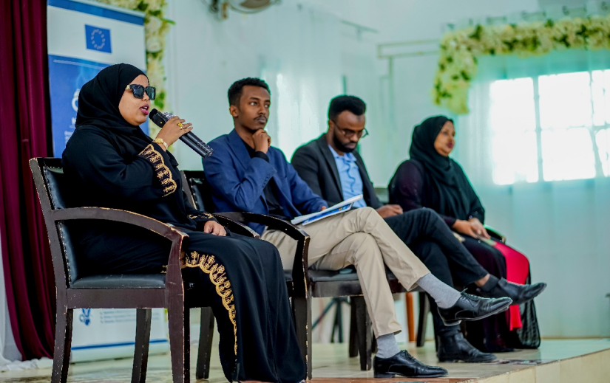

Hamda Abdi Sogsog – Female Blind Journalist

Hamda Abdi Sogsog highlighted the exclusion of people with disabilities from key decision-making bodies and leadership positions. She emphasized that their special needs are often overlooked in policymaking. Drawing from her personal experiences, she underscored the importance of persistence despite challenges.
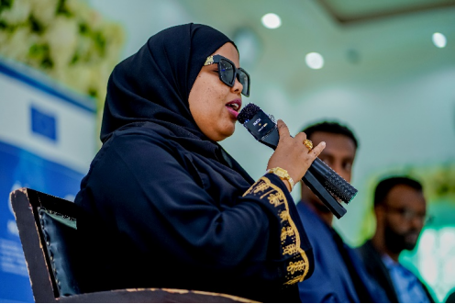
“People with disabilities should not be seen only as beneficiaries but as leaders shaping the future. We belong in governance, not as an afterthought but as an integral part of decision-making.”
Hamda called for policy and legal reforms to remove discriminatory provisions, such as the constitutional requirement that candidates for leadership positions be physically fit. She urged the new administration to appoint persons with disabilities to key government roles, starting with the vacant position of the President’s Special Advisor on Disability.
Yusuf Goodaad – Civil Society Leader, Adams Academy

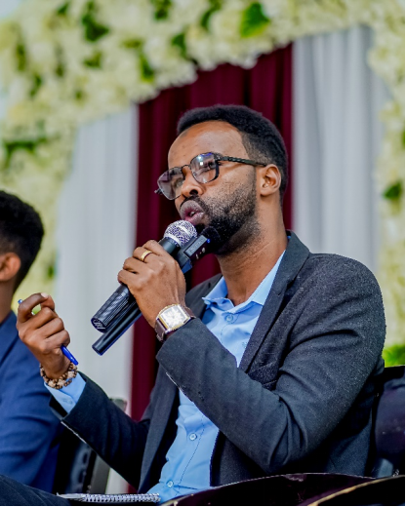
Yusuf Goodaad emphasized the need for initiative, collaboration, and courage in advocating for inclusive governance. He shared the example of the grassroots efforts that led to the election of Barkhad Batun, the first member of the House of Representatives from a minority clan, with a record majority.
“Change does not happen by waiting. We must actively demand our place in governance. The future belongs to those who fight for their rights.”
Yusuf urged youth to take an active role in demanding change and participating in decision-making processes. He stressed that inclusive governance requires the coordinated efforts of all stakeholders and that young people must engage beyond mere advocacy and step into leadership roles themselves.
Lucky Kassim – Founder, Somaliland Women’s Resource Center
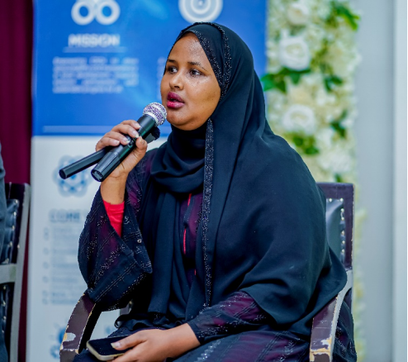
Lucky Kassim spoke about the unique barriers preventing women from attaining leadership roles in governance. She highlighted cultural constraints, limited access to resources, and inadequate social structures that do not prepare women for leadership.
“Women are not asking for favors in governance; we are demanding the space that rightfully belongs to us.”
She emphasized the role of empowerment, networking, and mentorship in overcoming these challenges. Lucky encouraged women to work together, build strategic alliances, and push for gender-sensitive policies that create more opportunities for women in governance.
Roundtable Discussions and Key Action Points
Following the panel discussion, participants engaged in roundtable discussions to explore practical steps for fostering inclusive governance. Key action points included:
Legal Reforms: Advocating for changes in policies that discriminate against persons with disabilities and minority groups.
Strengthening Women and Youth Networks: Encouraging networking and mentorship programs to empower marginalized groups.
Collaboration Between CSOs and Government: Ensuring continuous dialogue between civil society organizations and local authorities to promote inclusivity.
Capacity-Building Programs: Developing training programs to empower marginalized communities to participate effectively in governance processes.
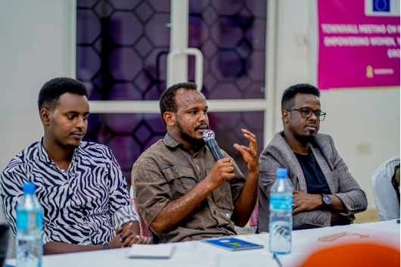
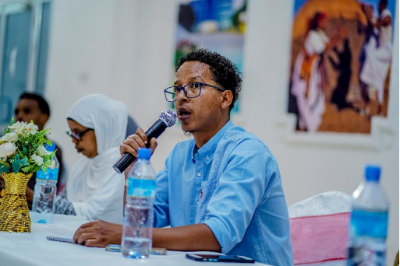
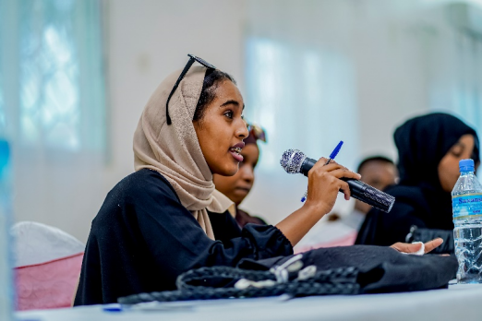
Roundtable Discussion in Photos
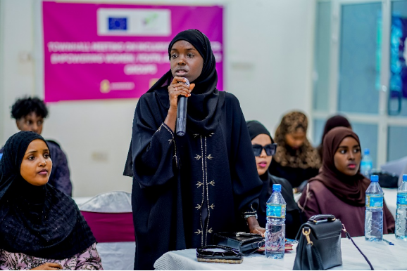

Conclusion
The townhall meeting successfully provided a platform for marginalized communities to voice their challenges and propose solutions for inclusive governance. The discussions reinforced the necessity of inclusive policies and the active engagement of all societal groups in governance. Moving forward, it is essential to maintain momentum through continuous advocacy, stakeholder collaboration, and the implementation of the action points identified during the meeting.

Activity 5 related to Output 1.2

A 1.2.2: Activity Report on Community Dialogue: Promoting Peace and Preventing. Conflict During Elections

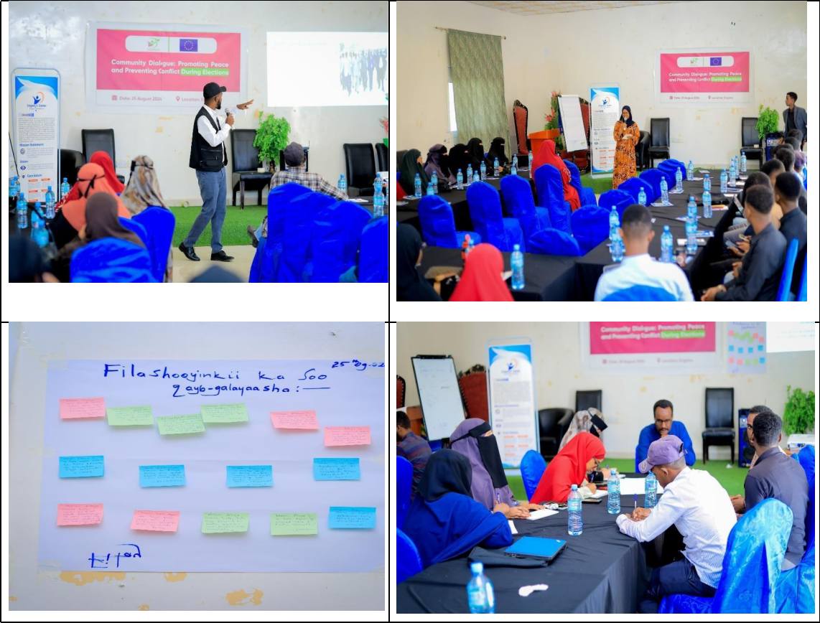

Background
On 25th August 2024, YOVENCO, in collaboration with the European Union (EU), organized a one-day Community Dialogue in Erigavo, Somaliland. This initiative was strategically timed as Somaliland approaches its electoral period, aiming to foster peace and prevent conflict. The dialogue's core focus was to empower youth, recognizing them as crucial actors in peacebuilding, and to motivate their active involvement in ensuring a peaceful electoral process.
The training participants were 45 (30F/15M), youth from diverse backgrounds, including youth-led initiatives, government institutions, youth activists and school teachers. This diversity enriched the dialogue, offering various perspectives, community groups and experiences that contributed to a comprehensive discussion on peace and conflict prevention.
The dialogue sought to achieve several key objectives:
- Raise Awareness: Educate youth on the critical role of maintaining peace during elections and the potential risks associated with electoral conflicts.
- Explore Conflict Causes: Identify and analyze potential causes of electoral conflict, and discuss strategies to prevent such issues.
- EncourageActiveParticipation: Promoteactive engagement of youth in fostering peaceful and fair electoral processes.
- Foster Dialogue: Cultivate a culture of constructive dialogue and non-violent conflict resolution within the community.

Session 1: Understanding the Link Between Elections and Conflict
- Discussion: Examined how electoral processes can generate tension and lead to conflict, considering historical and current contexts.
- Exploration: Reviewed Somaliland’s electoral history, including previous conflicts and lessons learned to understand potential risks.

Session 2: The Role of Youth in Peacebuilding

- Importance of Engagement: Discussed the critical role of youth in preventing violence and promoting peace.
- Strategies: Provided practical strategies for youth-led initiatives aimed at fostering peaceful electoral processes.
Session 3: Conflict Prevention Strategies
- Overview: Presented key measures for preventing conflict during elections, focusing on proactive and reactive strategies.
- Practical Tools: Offered hands-on tools and techniques for youth to implement in their communities to promote peace.
Interactive Dialogue
Open Forum: Allowed participants to share their personal experiences, concerns, and ideas regarding peace and conflict during elections.
Group Discussions: Focused on ways to enhance youth involvement in ensuring a peaceful electoral process.
Methodology

The event utilized an interactive methodology, combining:

- Presentations: Informative sessions from experts and facilitators.
- Group Discussions: Engaging participants in collaborative conversations to explore solutions.
- Case Studies: Analyzing real-life scenarios to apply theoretical concepts.
- Q&A Sessions: Allowing participants to ask questions and receive feedback.

This approach created an inclusive environment where participants actively engaged and contributed to the discussions.
Key Achievement
The dialogue achieved several positive outcomes:
- Increased Awareness: Participants gained a thorough understanding of the interplay between elections and conflict, and how to mitigate associated risks.
- Youth Empowerment: Equipped youth with practical knowledge and strategies for peacebuilding and conflict prevention.
- Commitment to Peace: Participants demonstrated a strong commitment to playing active roles in promoting peace during the elections.
- Actionable Insights: Produced concrete ideas and suggestions for youth-led peace initiatives in Erigavo and neighboring areas.
- Electoral Conflict Drivers: Identified factors such as misinformation, political rivalry, and insufficient youth involvement in decision-making as major contributors to conflict during elections.
- Peacebuilding Role of Youth: Emphasized the proactive roles that youth can play, such as mediating conflicts, educating peers on peaceful voting practices, and countering harmful rhetoric.
- Non-Violent Conflict Resolution: Discussed effective non-violent methods for resolving disputes, including promoting open dialogue and leveraging local conflict resolution mechanisms.

Conclusion
The community dialogue successfully underscored the vital role of youth in promoting peace and preventing conflict during elections. As Somaliland approaches the November 2024 elections, the insights and tools provided will help the youth of Erigavo contribute effectively to a peaceful and democratic process. Ongoing support from organizations like YOVENCO and the EU will be essential to sustain these efforts.

Activity 1 in relation to Output 1.3

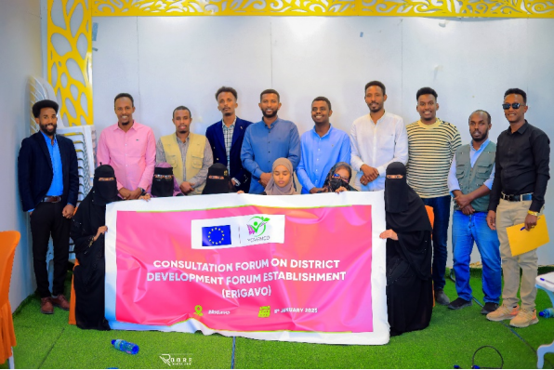
A 1.3.1 Activity Description: 6 Consultation forums on District Development Forum Establishment Across Major Districts (YOVENCO)
Image: Erigavo District
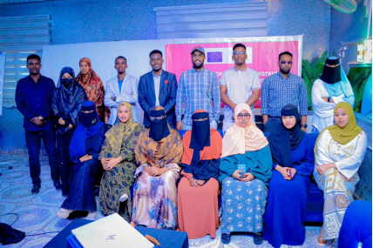
Image: Borama District
Ainabo District
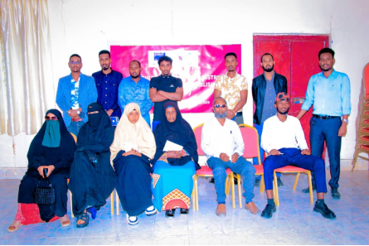
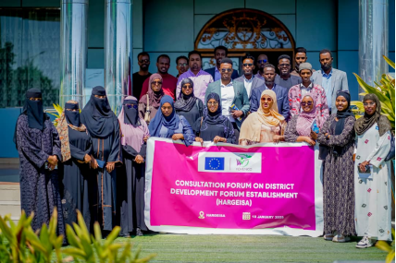
Image: Hargeisa District

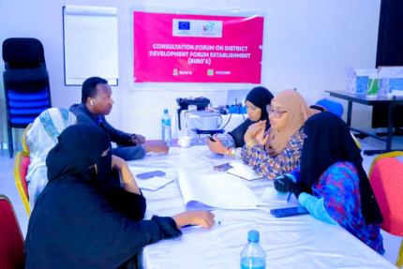
Image: Buro'a District
Introduction
YOVENCO Organization, with the funding support of the European Union, has organized five consultation forums aiming to establish district development forums in Erigavo, Buro’a, Ainabo, Borama, and Hargeisa districts, respectively; while the sixth consultation took place in Berbera, where an already established Berbera Economic Forum, a similar model of DDF, is operational. The Consultation forums brought together different stakeholders of local development, including, representatives from the local government, local CSOs, academia, private sector and community members.

The consultations served as an opportunity to lay out a clear plan toward establishing a DDF platform under the name “District Development Coordination Forum” dedicated for fostering local development through inclusive, community-informed, and priority-based decision-making. The forums also aim to coordinate the otherwise fragmented efforts of local development actors, ensuring more robust and united force driving local development.
While the forums successfully brought together core stakeholders, one of the key challenges identified was the relatively small size of the initial member base. Although the targeted organization, particularly those empowered through the project’s key capacity-building workshop were included, there remains a need to broaden participation, especially within the private sector, to ensure a more diverse and representative forum.
Membership Base & Composition

Table 1 Stakeholder Contributions and Level of Engagement in Borama District
Member Organization | Role & Contribution | Key Focus Areas | Level of Engagement
AYODA | Leading CSO, multi-sectoral development projects | Governance, community empowerment, economic development | High
SAYS | Leading CSO in multi-sectoral sustainability & development | Governance, community empowerment, economic development | High
SOSTA | Active CSO, youth-focused initiatives | Youth & women development, education, TVET and skills training | High
Moonlight | Emerging youth/women-led organization | Youth empowerment, education, innovation | Moderate
SOMRAR | Women-led organization focusing on social impact | Women empowerment, gender equity, social welfare | Moderate
Som-Green | Climate-focused initiative | Environmental conservation, renewable energy, climate advocacy | Moderate
Amoud University | Esteemed academic institution | Research, capacity building, policy development | High
Borama Local Government | Key governmental stakeholder and policy implementer | Governance, public services, local economic development | High

Table 2 Stakeholder Contributions and Level of Engagement in Erigavo District
Organization | Role & Contribution | Key Focus Areas | Level of Engagement
HANSOOR Organization | Leading CSO, member of SCAN network | Local development, governance, capacity building | High
Hilow Relief & Development Organization | Active CSO, member of SCAN network | Humanitarian aid, relief programs, community resilience | High
ACDO | Community development organization | Social services, infrastructure, economic development | High
SSWO (Sanaag Social Work Organization) | Emerging local organization | Social work, community empowerment, advocacy | Moderate
SDO (Sanaag Development Organization) | Emerging development organization | Youth Economic development, entrepreneurship, volunteering | Moderate
Sanaag University | Esteemed academic institution | Research, education, policy development | High
East Africa University (Erigavo) | Higher education institution | Academic training, research, knowledge dissemination | High
Erigavo Local Government | Key stakeholder and policy implementer | Governance, public services, local economic development | High

Table 3 Stakeholder Contributions and Level of Engagement in Hargeisa District
Organization | Role & Contribution | Key Focus Areas | Level of Engagement
TAAKULO | Leading multi-sectoral development CSO | Governance, community empowerment, economic development | High
Somaliland-Y Peer | Gender empowerment & development | Women's rights, gender equity, youth engagement | High
ADAMS Academy | Minority-focused organization | Education, advocacy, social inclusion | High
CAFAARIIGSI | Community development organization | Greening, sanitation, advocacy, charity | Moderate
SWRC (Somaliland Women Resource Center) | Women-led emerging organization | Women empowerment, capacity building, advocacy | Moderate
IPRT (Institute for Practical Research & Training) | Major emerging think tank | Policy research, governance, institutional development | High
Hargeisa Local Government | Key stakeholder and policy implementer | Governance, public services, local economic development | High

Table 4 Stakeholder Contributions and Level of Engagement in Buro'a District
Organization | Role & Contribution | Key Focus Areas | Level of Engagement
SOYDAVO | Multi-sectoral development organization | Community development, economic empowerment | High
SOYVO | Active CSO in various sectors | Social services, governance, education | High
NAFIS | Women-focused advocacy network | Gender equality, women's rights, policy advocacy | High
Nagaad | Women empowerment organization | Economic empowerment, gender inclusion | High
Disability Action Network | Support for persons with disabilities | Disability rights, inclusion, accessibility | Moderate
Barwaaqo Volunteers Organization | Women-led initiative | Social welfare, community mobilization | Moderate
ADO | Emerging development organization | Local development, social impact | Moderate
SEES | Youth-led volunteerism initiative | Youth engagement, volunteer programs, civic participation | Moderate
University of Buro’a | Esteemed academic institution | Research, education, policy development | High
Togdheer University | Higher education institution | Academic training, research, knowledge dissemination | High

Table 5 Stakeholder Contributions and Level of Engagement in Ainabo District
Organization | Role & Contribution | Key Focus Areas | Level of Engagement
SCA | Leading CSO, SCAN network member | Community development, humanitarian support | High
SWCDO | Active CSO, SCAN network member | Social welfare, focused on women affairs | High
DANJIRE | Emerging charity organization | Humanitarian aid, social support | Moderate
Alpha University | Academic institution | Research, education, training | High
Ainabo Local Government | Key stakeholder and policy implementer | Governance, public services, local economic development | High

Special Note: Sixth Consultation Forum – Berbera

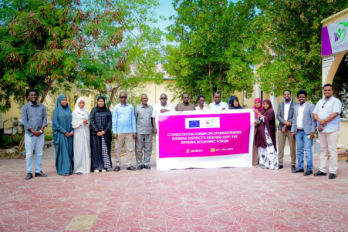
Image: Consultation Forum with key members of Berbera Economic Forum Platform

The sixth consultation forum, which was held in Berbera, was different compared to the previous consultation forums, given the existence of the Berbera Economic Forum (BEF, a platform that was established in 2012 by VNG International, with support from YOVENCO and the Berbera Local Government. BEF was designed to drive local development by coordinating different development actors, providing ongoing strategic guidance to the local government, and ensuring that local development plans were informed by evidence-based consultation.
Not only supporting the development plans often laid by the local government in Berbera is the area in which BEF’s operations are limited, but also the platform has actively contributed to the efforts of the local government concerning local economic development approach, by introducing micro-financing schemes that supports the growth of local economy.

Recognizing the long-standing presence and role of BEF, the project team engaged in discussion with the platform’s Managing Director to explore synergies between the forum's objectives and the ongoing initiative. Rather than establishing a parallel structure, a consensus was reached to strengthen and build upon the existing efforts of BEF.
The consultation forum in Berbera brought together existing BEF members, reaffirming their commitment while also opening the space for further collaboration. As part of this ongoing effort, YOVENCO and BEF agreed to work closely in the following areas:
- Providing technical and strategic support to improve the forum’s operational effectiveness through capacity support.
- Encouraging a more diverse and inclusive participation of local development actors through expansion of membership base.
- Supporting the improvement of existing policies to align with emerging development priorities through internal tailored support.

Key Achievements

To ensure the forums’ effectiveness, YOVENCO conducted a thorough mapping of potential members to meet the inclusive composition of the platform, with key focus on the added value, capacity, and the commitment to contribute to promoting accountability and transparency in district development initiatives through the established platforms.

Additionally, a proactive lobbying effort was undertaken prior to the consultation forum to secure the political commitment of local governments in the respective districts, acknowledging them as key stakeholders in ensuring the continuity and long-term sustainability of these platforms. This early engagement aimed to foster a sense of ownership among local authorities, strengthen institutional support, and enhance policy alignment to facilitate an enabling environment for civil society engagement.

During the consultations, three key technical committees were established in all districts, namely; the Planning & Development Committee, the Monitoring & Evaluation Committee, and the Resource & Training Mobilization Committee. These committees were strategically created for tailored focus on critical operations of the platforms in their respective districts, ensuring robust planning of development, continuous assessment of impact, and mobilization of necessary resources for capacity-building and operational effectiveness.
To enhance coordination and governance, an administrative interim committee was formed to oversee the transition period, consisting of three member organizations alongside the local government in each district. This committee, elected by forum members themselves, serves as a bridge between stakeholders during the transition period, facilitating collaboration, streamlining decision-making processes, and ensuring that the initiatives led by the technical committees are effectively coordinated and implemented.

This will realize the long-term impact of increased local ownership and accountability, improved resource mobilization for platform sustainability, strengthened coordination among civil society actors and local government institutions, and solid monitoring mechanisms to track progress and measure impact.

Sustainability and Next Steps

Since these established DDFs center on facilitating long-term collaboration between the CSOs and Local Authorities, their sustainability will largely depend upon the project’s final year engagement strategy. This strategy will involve channeling the remaining project activities toward strengthening the forums, ensuring they are well positioned to have lasting impact upon project’s closure.
These interventions include, but not limited to;
- Establishing clear policies and operational frameworks for the forums, to ensure solid institutional development of these forums.
- Addressing skill and knowledge gaps among forum members through targeted training and other initiatives, ensuring strengthened capacities of forum members.
- Expanding stakeholder engagement participation through interface meetings and community dialogues, particularly from the private sector, resulting enhanced resource mobilization and sustainable business community support for the forums.
By implementing and prioritizing these interventions during the final year, the project aims to embed resilience within the forums, ensuring they continue to drive meaningful and inclusive local development long after the project’s conclusion.

Activity 2 in relation to Output 1.3

A 1.3.2 Activity Description: Workshop on Local Development Plans & Budgets in Borama & Ainabo (YOVENCO)
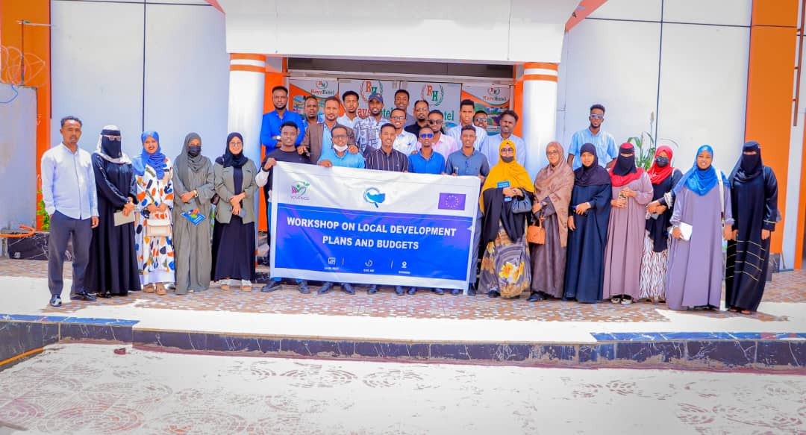
Photo Group of the participants of the workshop
Introduction
In alignment with the project’s goal to bridge the gap on CSOs perceived lack of access to information of the government about public planning and programming as well as about external funding and projects, and potential hindrance by the non-conducive environment and by civil society's low capacity; a series of workshops were conducted, in collaboration with the Department of Planning and Budget of local governments in Hargeisa, Berbera, Buro'a, and Erigavo, aiming to build the capacities of CSOs along with local authorities in targeted needs including, the Public Expenditure Management Cycle and District Development Forums.
In a continuation of a series of workshops designed last year by YOVENCO Organization, YOVENCO Organization organized a workshop on Local Development Plans & Budgets in Borama and Ainabo, targeting the staff of the departments of the respective district’s Local Governments including the departments of social affairs, finance, and planning, along with members of the CSOs active in Borama and Ainabo districts. The primary focus areas were to strengthen the understanding of the local development actors on local development planning, budgeting processes, and tools for promoting accountability and transparency.
The specific objectives of the training were to enhance the understanding of CSOs and local government planning staff regarding the local development planning and budgeting processes, introduce tools and methods for their effective implementation, and identify best practices and challenges related to participatory local governance. The training participants were 40 in total, 25M,15F.
Methodology:
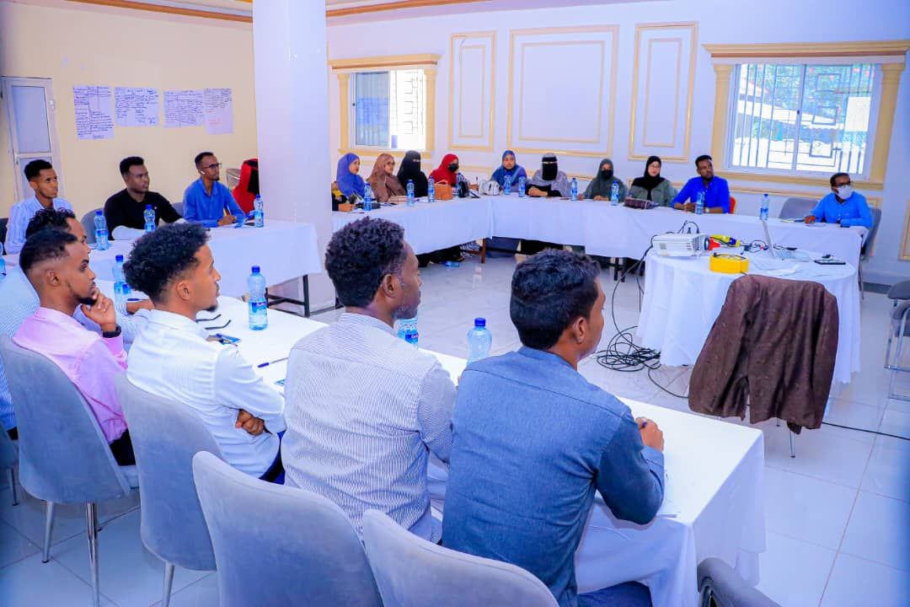
The training program was designed, with a greater focus on the Public Expenditure Management (PEM) cycle and the preparation of the District Development Framework (DDF). The content was catagorized into key components:
Image: Participants of the Local Development Plans & Budget in Borama
- Public Expenditure Management Cycle:
  - Conceptual understanding of PEM and its steps.
  - Identification of the DDF as the main output of Step 1: Planning.
  - Activities and tasks in DDF preparation, including timelines and responsibilities.
  - Principles guiding the preparation of the DDF.
- District Development Framework (DDF):
  - Reinforcement of the DDF as a pivotal output of the Planning phase.
  - Detailed overview of activities and tasks in DDF preparation.
  - Specific timelines and responsibilities associated with different stages of DDF preparation.
  - Application of principles in the practical preparation of the DDF.
Key Focus Areas:
- Conceptual Empowerment:
  - The training highlighted the significant stages of the PEM cycle, providing participants with a critical foundation.
  - This boost of understanding has improved the abilities of local development actors to confidently make well use of the process and the relevant tools.
- Strategic Focus on DDF Preparation:
  - By highlighting the DDF as a crucial tool to spearhead local development founded with the key principle of participatory process, the training empowered participants with a hands-on experience on the preparation, and establishment of DDFs.
  - The training positioned the participants to clearly explore key activities and principles of the development of DDF documents.
- Practical Application and Skill Development:
  - The trainer showcased several examples in demonstration to the participants to ensure that the objectives of the training are met through fostering discussion and hand-on experience.
  - This approach has given the participants the opportunity to engage with training content more broadly and inquire the trainer on the specifics.
- Strengthening Collaborative Governance:
  - The training has established seeds for closer collaboration between the civil society actors and the local authorities on the shared prospect of local development delivery.
  - Participants fostered an understanding of important relationships between stakeholders, culminating in an environment of coordinated efforts in planning and budgeting processes.
Activity Achievements & Results
Our program focused on empowering participants with a deep understanding of the Public Expenditure Management (PEM) Cycle, emphasizing its role in participatory community development planning. The training facilitated collaboration between civil society groups (CSOs) and local authority, fostering informed stakeholders committed to transparency, accountability, and participatory practices.
A key aspect of our strategic training was the emphasis on the District Development Framework (DDF) within the PEM cycle. Participants gained practical insights, enabling them to actively contribute to local development initiatives. By emphasizing specific activities, timelines, and responsibilities associated with DDF preparation, participants acquired a clear sense of purpose and strategic perspective deemed to be effective in the full utilization of acquired skills.
Beyond individual skill enhancement, our training aimed to instill a collaborative mindset among participants. Understanding stakeholder relationships and coordinated efforts in planning and budgeting processes became integral. The impact of this collaborative governance focus extended beyond the training room, influencing day-to-day interactions and enhancing overall effectiveness in local governance initiatives.
The training signified the beginning of an era in which participants are capacitated to better contribute to the ongoing local development activities. The anticipated impact lies in the deepened understanding of the PEM cycle, heightened skills in DDF preparation, and an appreciation for collaborative governance. Participants were prepared to position themselves as catalysts for positive change, actively contributing to sustainable and participatory local development in Somaliland. This outcome reflects not just incremental improvements but a fundamental shift in the capabilities of CSOs and local government departments.

Activity 3 in relation to Output 1.3

A 1.3.2 Activity Description: Two Workshop on Conflict Resolution, Leadership and Strategic Planning for CSOs and Local Authorities in Buro’a & Berbera (YOVENCO)

Introduction
YOVENCO, with the support of the European Union, organized a workshop on conflict resolution and strategic planning in Buro’a and Berbera, respectively. The training aimed to strengthen the ability of civil society organizations (CSOs) to manage challenges that arise in their engagement with communities. By improving their skills in handling conflicts and planning strategically, CSOs can build stronger relationships with communities and other stakeholders. Participants of the workshops totaled 55 participants, 30M,25F.
Among the objectives of the training were to promote accountability and transparency by equipping CSOs and community-based organizations with practical approaches to improve these aspects; facilitate conflict-sensitive decision-making by enhancing participants' skills in collaborative and inclusive decision-making by integrating diverse community perspectives while ensuring that their approaches to problem-solving remained conflict-sensitive; and finally, strengthen leadership and strategic planning by building the capacity of CSOs and local community centers in these areas.
Training Content & Methodology

- Conflict Resolution; Understanding Conflict in Human Relationships

As conflict is a natural part of human interaction, people engage in conflicts because they have a stake in relationships, outcomes, or both. While conflict could be productive or dysfunctional, managing it effectively rather than eliminating it entirely is the key.
Participants became cognizant of the reality that unmanaged conflict will have high costs, recognizing the ability of constructive approaches to transform differences into opportunities for growth.
        - Positive vs. Dysfunctional Conflict
During the session, participants grasped the difference between productive and dysfunctional conflict. Productive conflict as the type of conflict that spikes teamwork and focuses on resolving issues rather than resorting to attacking individuals. It promotes cooperation and aims for solutions that benefit everyone involved. Far from that, dysfunctional conflict is heavily personal and emotionally driven, often escalating tensions instead of leading to common resolution. When conflict is unproductive, it can create deeper divisions rather than fostering understanding, a grave risk to working for the community.
        - Approaches to Conflict Management
The training touched upon different strategies for handling conflict in an effective manner. These strategies include;
- Avoidance, particularly when the issue is minor or when giving time allows emotions to settle before addressing the problem.
- Competing, which is necessary when quick, decisive action is required for making difficult but essential decisions.
- Compromising remains helpful when both parties strongly disagree and need a temporary solution that allows progress while keeping discussions open for future resolution.
- Collaboration is the most effective approach because all parties work together to find a solution that satisfies everyone. This approach further strengthens relationships and paves the way for long-term resolutions rather than short-term and short-lived solutions.
        - Understanding and Managing Conflict
Participants also learned how to analyze and manage conflict effectively by clearly defining the problem, identifying key issues, setting clear goals, and considering any past conflicts that might have effect on the situation dealt with. Recognizing early indicators of escalation, such as frustration, emotional reactions, and the likelihood for issues to spread beyond the original disagreement, are among the strategies that helps prevent conflict from worsening that the participants learnt.
Participants understood that to avoid conflict to descend into worse, personal attacks, threats, and rigid thinking must be avoided. Instead, active listening, open communication, and a focus on practical solutions create a pathway to resolution shall prevail in conflict-sensitive dealings.
- Strategic Planning for Small Communities
Strategic planning is crucial for small communities as it helps organizations define their goals, allocate resources effectively, and build a roadmap for sustainable development. During the second session of the training, participants were introduced to key elements of strategic planning, including:
- Understanding the needs, strengths, and challenges of the community to develop targeted interventions through community assessment.
- Establishing clear, measurable objectives that align with the long-term vision of the community.
- Engaging with local authorities, CSOs, and CBOs to create inclusive and participatory decision-making processes through effective stakeholder engagement plan.
- Implementation and Monitoring by developing action plans, setting timelines, and regularly evaluating progress to ensure desired outcomes.
- Which lastly contributes to building the bridge toward impact on Community, CSOs, and CBOs
Conclusion
The participants gained knowledge from this training which is instrumental in driving positive change in communities. Conflict resolution skills enable CSOs and CBOs to mediate disputes effectively in their day-to-day dealings with many stakeholders including the community, fostering social cohesion and preventing disruptions that hinder development. Also, by implementing strategic planning with focus on small communities, organizations are positioned to ensure their initiatives are result-oriented, addressing real community needs with a focus on sustainability. These skills will be vital for the local organizations as they are posed to be more effective in delivering services, advocating for policies, and mobilizing resources.

Output 2: Women, Youth, Marginalized, and Vulnerable people, PWDs, and minority clans take a leading role in the promotion and support of entrenching the engendering policy and decision-making in local governance and social accountability in Somaliland.

Activity 1 related to output 2.1

A 2.1.2 Tailored Capacity-Building Training for Hal-Dhawr, Cafaariigsi, and YODEV Organizations

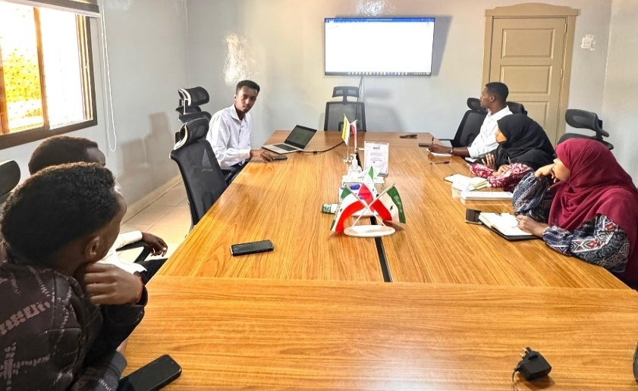
(YOVENCO)
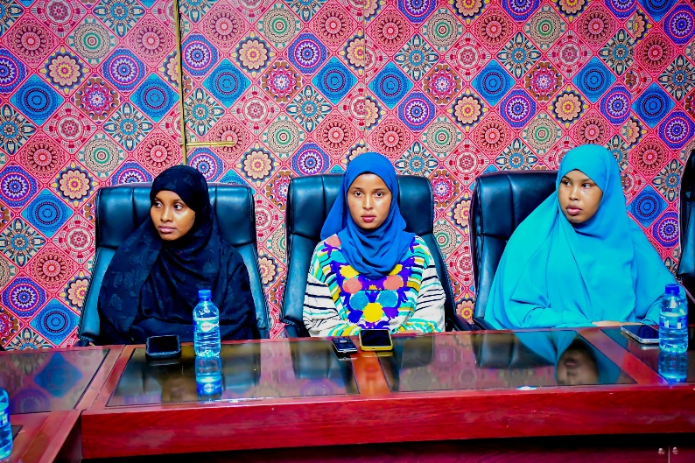

Introduction
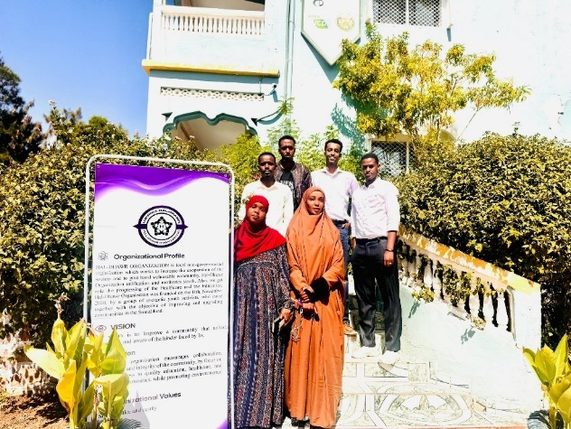
YOVENCO successfully implemented a tailored capacity-building training program for three youth-led organizations: Hal-Dhawr, Cafaariigsi, and YODEV. Hal-Dhawr and Cafaariigsi are based in Hargeisa, while YODEV operates from Berbera. These organizations were selected based on their specific capacity-building needs, identified through a Capacity-building Assessment Toolkit and recommendations from stakeholders. The training sessions, conducted in July and September 2024 and January 2025, aimed to equip the organizations with the skills and knowledge necessary to enhance their leadership capacities, governance structures, and operational effectiveness.
Organizational Profiles
Hal-Dhawr Organization: Hal-Dhawr is a local non-governmental organization dedicated to youth and community development in Somaliland. Established in November 2020, its primary focus areas include education, healthcare, youth empowerment, and community collaboration. The organization implements multiple programs aimed at fostering social cohesion and improving the quality of life for disadvantaged groups through training and capacity-building initiatives.

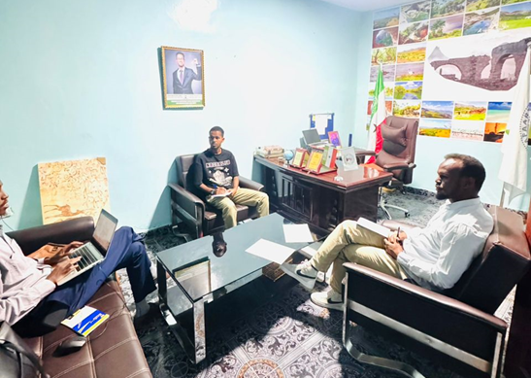
Cafaariigsi Organization: Cafaariigsi is a non-governmental, non-profit, and non-partisan organization founded in 2018 and based in Hargeisa. It is dedicated to addressing the complex needs of vulnerable populations through community engagement, environmental conservation, youth empowerment, and civic awareness. Through its holistic approach to sustainable development, the organization strives to create lasting positive change in the communities it serves.
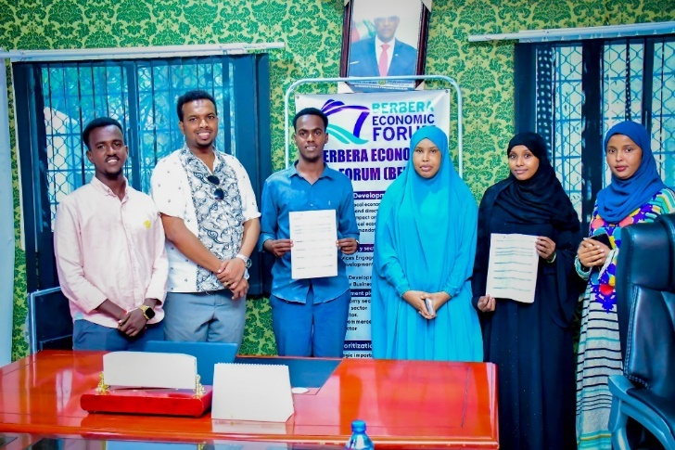

YODEV Organization: YODEV (Youth Development Organization) is a youth-led initiative operating in Berbera. The organization promotes education, leadership training, and socio-economic empowerment among young people in the region. YODEV provides mentorship programs and training sessions to equip youth with the necessary skills for effective community participation, advocacy, and leadership.

Training Design and Delivery
Capacity Assessment: Prior to conducting the trainings, YOVENCO carried out a comprehensive capacity assessment using its Capacity-building Assessment Toolkit. The assessment focused on identifying key gaps in governance, financial management, human resource management, advocacy, and operational effectiveness within each organization. The results of the assessment guided the development of customized training modules tailored to the specific needs of each organization.
Tailored Training Modules

Based on the findings from the assessment, YOVENCO designed a structured two-day training program for each organization. The training covered the following key areas:
- Organizational Governance and Leadership: Understanding governance principles, board roles, decision-making processes, and accountability mechanisms.
- Non-Profit Financial Management: Budgeting, financial planning, record-keeping, grant management, and donor compliance.
- Communications and Advocacy: Developing effective communication strategies, engaging with stakeholders, and strengthening advocacy efforts.
- Workplan Development and Reporting: Creating strategic and operational workplans, monitoring progress, and ensuring effective reporting mechanisms.
- Human Resource Management: Strengthening HR policies, recruitment practices, performance evaluation, and staff development.
Training Methodology

The training sessions were delivered using a participatory approach, combining theoretical instruction with practical application. Key methodologies employed included:
- Interactive Lectures: Facilitators provided in-depth explanations of core concepts.
- Group Discussions: Participants engaged in discussions to share insights and challenges.
- Case Studies: Real-life scenarios were analyzed to enhance problem-solving skills.
- Practical Exercises: Hands-on activities were conducted to reinforce financial and workplan development concepts.
Training Resources and Tools
To support the ongoing application of learned skills, YOVENCO provided participants with essential resources, including:
- Customized workplan and budget templates.
- Reporting templates (narrative and financial).
- Communications and advocacy plan template.
- Human resource management guidelines.
- Financial management manual.

Technical Assistance
Following the training, YOVENCO consultants provided an additional four days of technical assistance to each organization. This post-training support was designed to help organizations address any challenges in implementing the learned skills and effectively utilizing the provided tools. During these sessions, participants received one-on-one mentorship, feedback on workplans, and guidance on financial management best practices.

Achieved Results
The tailored capacity-building training successfully enhanced the operational capacities of the participating organizations. Key outcomes included:
- Enhanced Skills and Knowledge: Participants demonstrated an improved understanding and ability to apply the training concepts effectively.
- Increased Confidence and Competence: Organization members expressed greater confidence in their leadership and management roles.
- Improved Policy and Manual Adoption: Organizations began incorporating the provided policies, templates, and tools into their operational frameworks.
- Strengthened Financial Management: Organizations exhibited better financial planning, budgeting, and reporting capabilities.
- Effective Workplan Implementation: Participants developed actionable workplans that aligned with their organizational goals.
- Expanded Advocacy Efforts: Organizations enhanced their engagement with stakeholders and improved their advocacy strategies.
Challenges and Lessons Learned
While the training was highly successful, a few challenges were noted:
- Time Constraints: Some participants required additional time to fully grasp complex financial and governance topics.
- Varying Levels of Capacity: Differences in organizational maturity levels required more personalized technical support.
- Sustainability of Capacity-Building Efforts: Continued follow-up is necessary to ensure the long-term impact of the training.
In conclusion, the tailored capacity-building training effectively strengthened the operational capacities of Hal-Dhawr, Cafaariigsi, and YODEV. Through enhanced governance, leadership, financial management, and advocacy skills, these organizations are now better equipped to contribute meaningfully to their communities and governance processes in Somaliland. YOVENCO remains committed to supporting their continued growth and impact through ongoing technical assistance and future training initiatives.

Activity 2 related to output 2.1

A 2.1.3 Activity Report: Voter Education Public Campaign (2nd - 12th November 2024) (YOVENCO)

- Introduction
YOVENCO, in collaboration with several social media influencers and leading media houses, launched a public voter education campaign from 2nd to 12th November 2024. The campaign was focused on improving public awareness of the voting process ahead of Somaliland's combined Presidential and Political Parties elections scheduled for 13th November 2024. The campaign utilized a mixed-method approach that incorporated both physical and digital outreach in an effort to ensure comprehensive voter education, which includes hard-to-reach and marginalized and digitally less-informed communities.
- Campaign Content and Implementation
The campaign aimed to educate the public about the election process, highligh key aspects such as voting dates, locations, and legal procedures. The campaign also sought to discourage electoral fraud and malpractices by reinforcing lawful participation, communicating ways and means of reporting such malpractices for authorized institution. Special emphasis was placed on the inclusion of marginalized groups such as disabled, minority, youth and women, in order to ensure they are informed and empowered to cast their votes.
While maximizing outreach, YOVENCO Organization has adopted a hybrid approach. Hundreds of posters, which were printed, were distributed by posting them across key community sites, ensuring that even those without digital access received accurate voter information. In parallel fashion, digital platforms, mainly Facebook handles, were leveraged by disseminating short videos and voter education messages via social media influencers and national media outlets. Through these combined methods, many of the electorate received clear, reliable guidance on their voting rights and responsibilities.
- Key Achievements
The campaign effectively achieved its intended objectives, as it contributed to an increased voter engagement and awareness. Social media analytics indicated that thousands of citizens engaged with voter education content online, thus highlighting its widespread reach. On the ground, the extensive distribution of posters made sure that critical election information reached those in remote areas. Predictions were made regarding low voter turn-out of approximately below 45% due to years long election disputes which encouraged many voters from the democratic engagement, but the campaign helped increase the turn-out, particularly among the cities. Many previously hesitant or uninformed voters, particularly among marginalized groups, reported feeling more confident in participating in the elections.
One thing of a significant role was the inclusion of trusted media houses and well-known influencers that played a crucial role in message dissemination. Their great following ensured that the campaign’s messages were well-received among the electorate, particularly young people. As a result, the campaign not only spread awareness but also fostered greater electoral participation, strengthening the democratic process in Somaliland.
- Conclusion
The voter education campaign achieved its purpose and fulfilled its goal of informing and mobilizing voters ahead of the elections. The combined use of digital and physical outreach allowed the campaign to bridge information gaps across diverse communities.
- References: Social Media Links and Media Partners
The following platforms were actively used for campaign dissemination:
- Hassan Gallaydh (Nationwide): Facebook Link
- Horn Cable TV (Nationwide): Facebook Link
- Khadar Dhambaal (Maroodijeeh region): Facebook Link
- Suxufi Wacays Yare (Awdal region): Facebook Link
- Awdal Media Group (Awdal region): Facebook Link
- Mohamed Sharbi Yare (Togdheer region): Facebook Link
- Bulsho TV (Nationwide): Facebook Link
- Abdijibaar Mohamed (Nationwide): Facebook Link
- Roore Media (Sanaag region): Facebook Link
- Xoogsade Media (Sahil region): Facebook Link

Activity 1 related to output 2.2

A 2.2.1.1 Public Campaign: Toward Disability-Inclusive Public Infrastructure and Services. (YOVENCO)
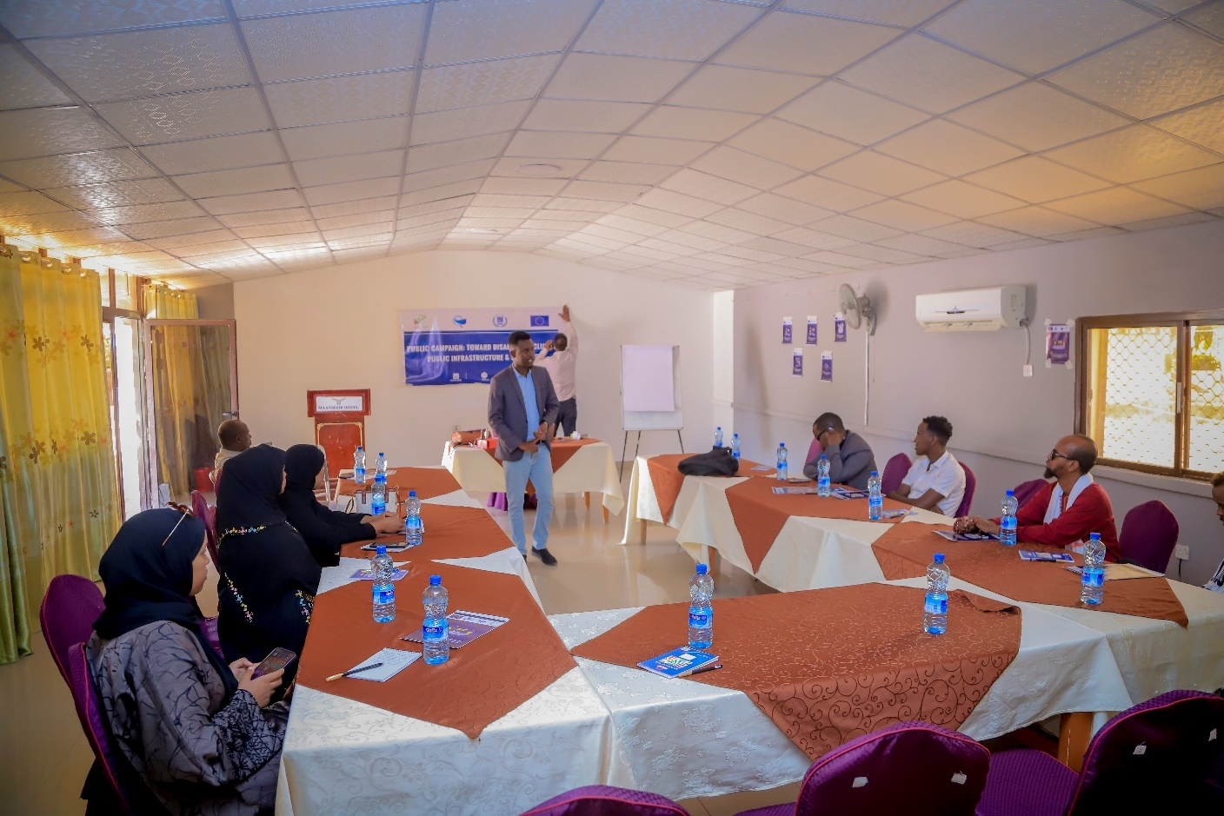
Figure 4 Launching Session of the Public Campaign
Introduction
In the wake of ongoing development centered on re-constructing local government premises across the districts of Hargeisa, as well as the rehabilitation of primary and intermediate schools, spearheaded by the local government of Hargeisa, YOVENCO Organization has organized a public campaign on the promotion of disability-inclusive public infrastructure and services. The session hosted 12 members of disability focused organizations, 8M/4F. Oftentimes, people with disability struggle to access government buildings including those newly built due to the absence of proper awareness of such exclusionary practices. Many disabled people opt not to seek government services on their own because those services remain inaccessible, not just physical accessibility but also informational accessibility.
Because of these existing practices of exclusion and with the fact that Hargeisa local government has initiated a wave of reconstructing its buildings, the project implemented a much-needed public campaign aimed at spreading awareness of disability inclusion in public infrastructure and services, and bringing the attention of the local authority for action.
The public campaign was carried out on close collaboration with the Somaliland Disability Forum, the focal organization of disability issues that also brings various disability-led organizations into its forum, which invited members of the disability who were vital voices in the campaign.
Implementation Approach
Having the immense role of digital media in mind, the campaign utilized social media influencers which have a greater following on Facebook. Not only digital media was the medium of information sharing, but also there were printed messages put up across the main roads of the city carrying significant messages on disability inclusion.
Core public campaign messages included the following;
- Somali: “Dhismayaasha Dowliga ahi waa in ay yeeshaan marrin ku habboon dadka naafada ah"
English: "Government buildings must have appropriate access for people with disabilities."
- Somali: "Duudsiinta xuquuqda dadka naafada ah ee helista xogta iyo addeeggu waxa uu la mid yahay duudsiinta xuquuqda caafimaad iyo ta waxbarasho"
English: "Denying the rights of people with disabilities to access information and services is equivalent to denying their rights to healthcare and education."
- Somali: "Goobaha addeegyada aasaasiga ah waa in ay ka hawlgalaan shaqaale u carbisan baahiyaha gaarka ah ee dadka naafada ah"
English: "Essential service locations must employ staff trained to meet the special needs of people with disabilities."
- Somali: "Waa in aynnu higsanno hannaan addeeg bixin oo cid kasta ba gaadhi kara, iyadoo aannay ahmiyad lahayn laxaad ama laxaad li'i"
English: "We must aim for a service delivery system that is accessible to everyone, regardless of ability or disability."
Achievement & Results
- The campaign enhanced the understanding of the disability-led organizations on the timely need for advocating improved disability access to public premises and local authorities services through robust service delivery mechanisms that are inclusive and disabled-friendly.
- The campaign liaised with and engaged directly with the Somaliland National Disability Forum to roll out a campaign that is better informed, enforced, and embraced by the existing disability forums.
- The campaign involved actual human voice rather than primarily and squarely relying on technology, thereby contributing to more genuine advocacy toward promoting disability rights.
- The campaign helped to shed light on the issue of improving disability access to services and governmental building through inclusive construction practices, and accessible information sharing and service delivery systems.
Conclusion
The public campaign has been successful as it has created public awareness about the challenges faced by people with disabilities in accessing public infrastructure and services is raised and increased; influenced Local government policies and practices toward greater accessibility and inclusion for the benefit of disability groups; and strengthened the advocacy action and capacity of Disability-led CSOs working on disability rights to advocate for inclusive practices.

Activity 2 related to output 2.2

A 2.2.1 Activity Report on Public Campaigns for Involving Women’s Organizations, Youth Organizations, and Media in the Transformative Process of Engendering Social Change, in particular by challenging stereotypes in Burao and Hargeisa.
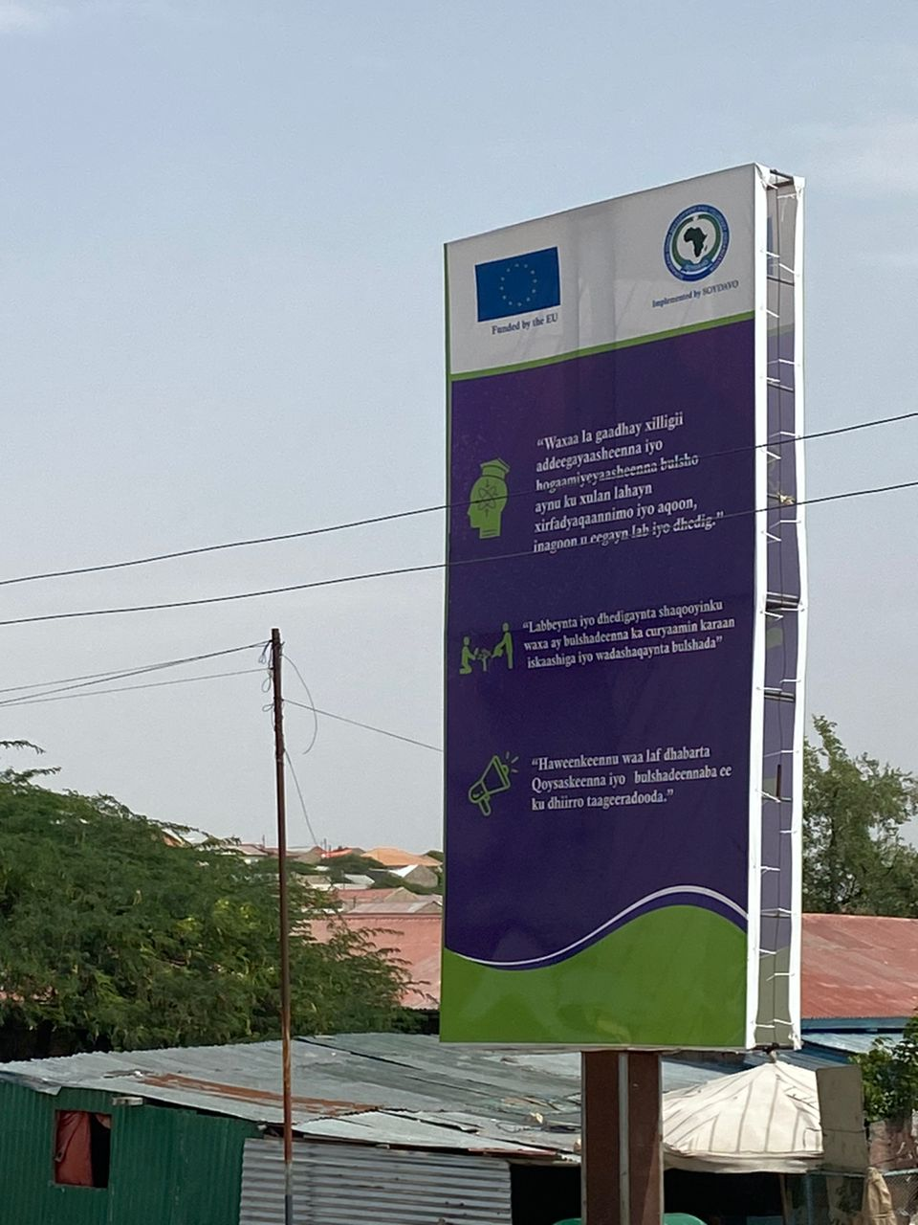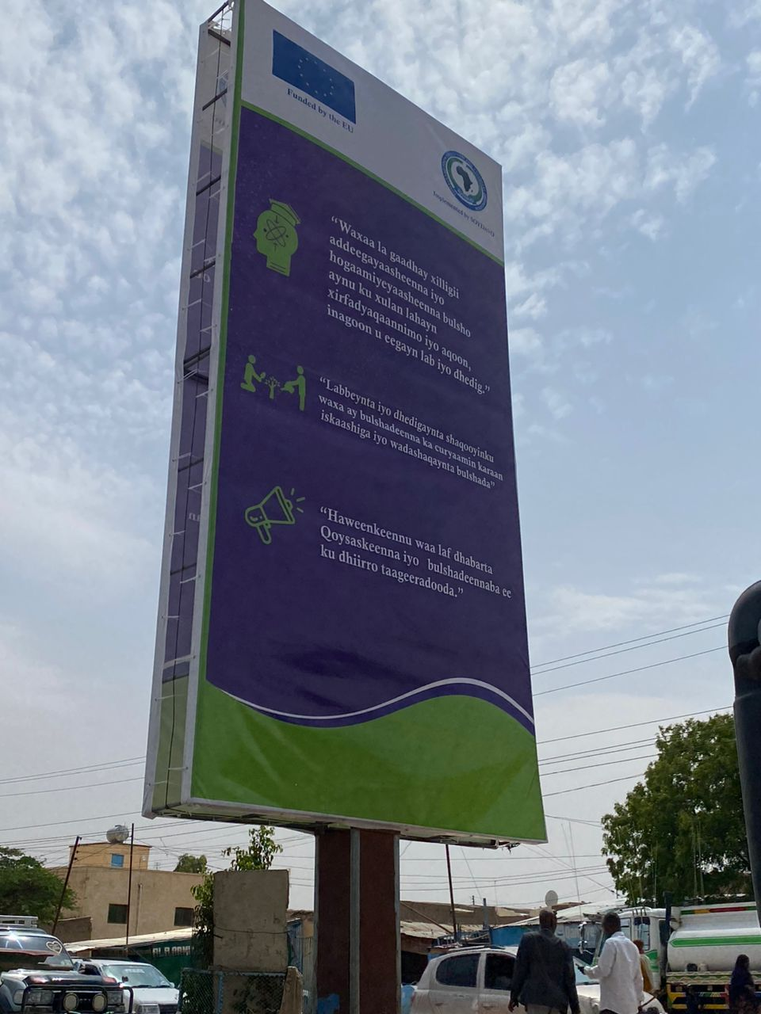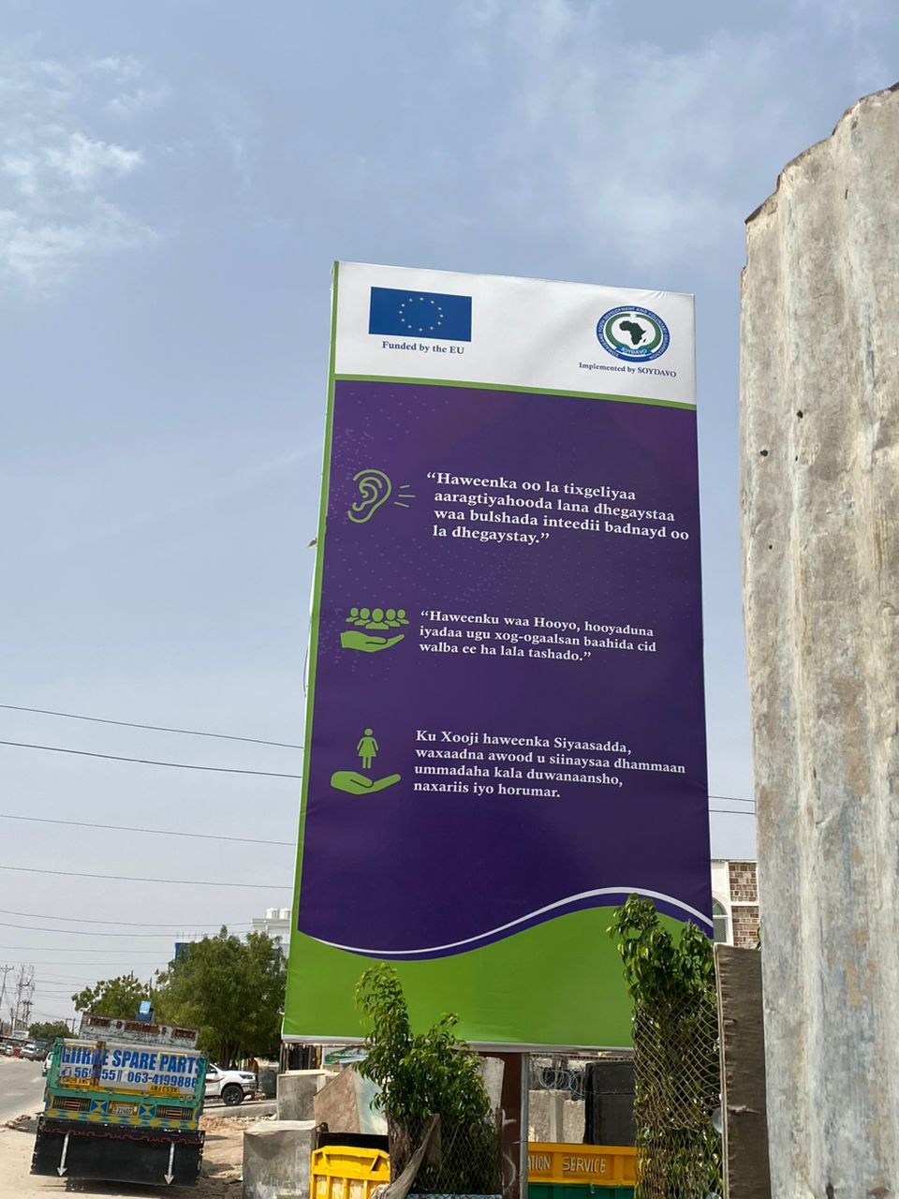
Background:
These public campaigns are aimed at improving gender equality, fighting stereotypes and increasing the political participation of women. The campaigns were a joint effort which brought together women and youth groups, local authorities, and the media. This report presents the objectives, methodology, outputs, anticipated results and ways forward for future projects.
The public campaigns were intended to negate long-held gendered stereotypes and to promote the inclusion of women in education, employment and leadership roles as well as their political participation. Among the activity objectives were to challenge the prevailing gender stereotypes and to change society's views on gender roles, foster equal participation for both genders in education, employment, and leadership, elevate women's engagement in politics and leadership positions, and engage local leaders, influencers, educational institutions and civil society organizations to boost the campaign.
Implementation Rationale:
During the campaign, we put up posters with statements titled 'Overcome stereotypes, 'Fight for equality between genders' and 'Strengthen women's participation in politics' on major roads in Burao and Hargeisa. Besides, stand banners were set up in the campaign office with campaign messages to make messages stronger. The campaigns have been using social media platforms, billboards, and local media for expanded communication.
Through a mix of social media engagement, billboards, banners and partnerships with local media, the campaign distributed messages related to women's rights.
Public campaigns in Burao and Hargeisa are the key steps that help to confront stereotypes, promote acceptance, and improve women's political involvement. It was successful in meeting its short-term goals, and continuity of the initiatives is inevitable to ensure a lasting paradigm shift and ultimately the achievement of gender equality in the region.
Activity Achievements:
The campaigns managed to make great strides by making people more aware and starting to change the point of view of society. The opinions and reactions to social media platforms indicated a notable decrease in the support for traditional gender stereotypes and a notable increase in the recognition of different gender identities and roles in society.
Besides that, the level of female participation in community politics was clearly up to a higher level; a very important aspect being the increased number of women running for political office and taking up leadership positions. This expanded female participation in the political process is proof of these campaign's success.
One of the cornerstones of the campaigns was the shrewd construction and distribution of media material. These types of content were diverse, including videos, posters, and social media promotions, and all of these significantly contributed to reaching more audiences. Not only did it appeal to a wide demographic but it also set forth the dialogue for gender roles and identities.
Among the expected results include the positive shift of social attitudes and revolutionary thinking about gender roles and equality; Growing involvement of women in politics and leadership positions; and Consistent production and distribution of media content that serves the purpose of amplifying the campaign message.
Learnings:
To build on the success of this campaign, it is recommended to:
    - Keep the relationship with local media for the benefit of the target audience.
    - Jointly initiate local schools and institutions that offer education to span the inequality teaching in the curriculum.
    - Assign follow-up surveys and studies soon after the campaign which could tell nothing about the long-term impact of the campaign on attitudes and behaviors.
    - Plan the workshops and seminars to encourage women to move into modalities of leading and decision-making roles.
Output 3: The Somaliland Media and Population take an active role in participation and decision-making in the governance of local authorities

Activity 1 related to output 3.1

A 3.1.1 Activity Report of Training of trainers on Civic education, advocacy and awareness-raising activities at the grassroots level to increase citizen participation in civic activities in Burao. (SOYDAVO)
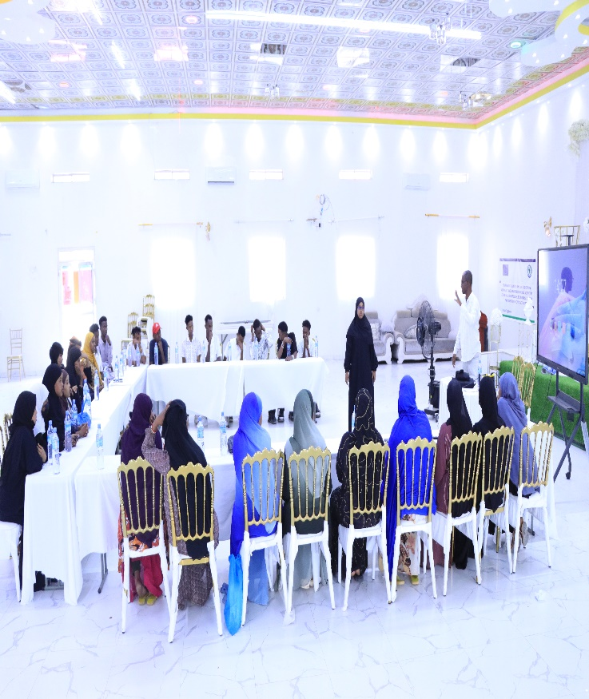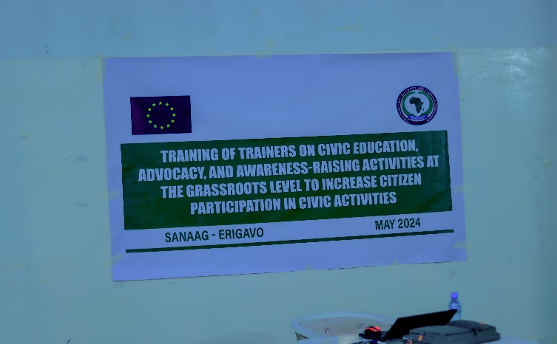

Background:
To actively promote democracy and enhance voter participation among the electorate, the project conducted a community training on electoral awareness. The session, which was participated by 30 participants (11M, 19F), aimed to educate voters about their rights, the election process, registration, and the act of voting itself. While recognizing a significant gap in knowledge, particularly among vulnerable groups such as youth, women, internally displaced persons (IDPs), persons with disabilities (PwDs), and minority communities, the initiative equipped trainers with essential information and skills regarding election affairs, by ensuring they could effectively disseminate crucial electoral knowledge. As a result, the training programs bolstered efforts to ensure trainers were well-prepared to educate citizens on active electoral participation.
Objectives:
The first goal of the training was to make trainers aware of the best practices and information that they needed to effectively teach different strata of the population concerning voting matters. Specifically, to improve their knowledge of legal provisions for voter rights and the election process, best practices for engaging particular constituency groups, improve their ability to facilitate teaching/training and provide extensive informational materials for educational endeavours. Further, the training sought to describe reasons for involving communities in voting with particular emphasis on the use of youths and volunteers in voting promotion exercises, general information on elections and the significance of citizen voting, knowledge of factors that hinder participation in elections and ways of overcoming them and lastly introduction to successful techniques in registering voters and winning the vote.
Methodology:
Somali presentations were used in the training to enhance communication during the training sessions. Facilitators included the use of overhead transparencies and discussion meetings where people work in groups and share ideas. This allowed trainers to become aware of specific effective communication practices, approaches to handling multifaceted target audiences, kinds of sessions that could be delivered to educate voters, etc. The training program also involved a workshop in the form of group and working sessions in which the participants were probed with questions on the issues facing the Commonwealth regarding the participation of communities in the election and how the Commonwealth needs to sensitize the communities to participate in the elections and democratization processes. The Participants were divided into two Groups where they had to debate and record their outcomes using the participatory approach where items used included; flipcharts, notebooks and pens.
Achievements:
- The participants showed a lot of interest and active participation during training sessions.
- They engaged these discursively, contributing helpful ideas and getting to work on creating reactive voter education strategies.
- Most of the group activities helped in sharing knowledge amongst the members, thus creating a good forum for the acquisition of knowledge.
- Some of the highlights of the group discussions revolved around the education barriers, system breakdowns, security risks, environmental problems, transportation and communication hitches, issues on diversity, bias, especially in the contracts and timelines, and awareness and campaign constraints.
- Finally, the groups’ recommended strategies included demystifying barriers to voting, educative and mobilization campaigns, making regular campaigns, sensitizing voters on elections, community-based intercessory campaigns, targeting influencers in the community, targeting vulnerable voters, creating an enabling environment for voters during elections, and electoral conflict resolution forums.
Expected Results:
From these training sessions, several results are expected of the target groups and the wider population: greater knowledge of the target groups and others’ voting rights and duties, improved knowledge of the electoral process, improved voter registration practices, increased voter turnout, and improved electoral democracy. Also, the day-to-day monitoring and evaluation will create an understanding of the performance of our training endeavours and the need to change or implement new training measures.
Suggestions:
From the observation made during training sessions, the participant was highly interactive with the programme. They participated in the discussions, gave their observations, and assisted in the development of strategies that would be more suitable for the achievement of the objective of voter education. Such methods that were adopted included group tasks that entailed the capabilities of sharing knowledge and stimulating the group to ensure that the members were more engaged. The following were some of the education problem areas that were identified during the group discussions: Education systems challenges Failure within the education system Security issues Environmental Issues Transportation and communication problems Difficulty in inclusion, be it by gender, race or disability Favouritism and corruption Time issues Difficulty in awareness and campaigns. Furthermore, to elaborate their recommendations, the groups offered more ideas such as solving voter access problems, turn-out campaigns, routine campaigns, acquainting the voters with the poll, community-level interventions, mobilizing influential personalities, and focusing on special voter groups, creating a favourable environment for the voters of elections and ways to solve disputes.

Activity 2 related to output 3.1

A 3.1.1 Training of Trainers on Civic Education, Advocacy, and Awareness-Raising Activities in Burao and Erigavo: Report on Achievements and Impact
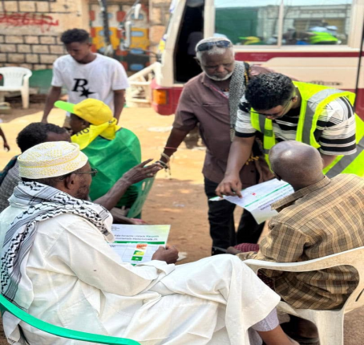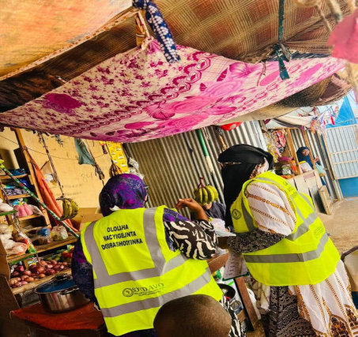
Introduction
The Training of Trainers in the Development of Participatory Communication for Enhanced Citizen Participation in Elections initiative aimed to address the major challenge regarding low voter participation in elections, equipping selected individuals with the necessary skills to educate their communities on the importance of voting. The training which was conducted in Erigavo and Buro’a targeted twenty participants, who were empowered to become agents of change in their respective communities. This initiative followed a structured pathway, ensuring that knowledge dissemination would lead to tangible improvements in the community’s electoral engagement.
The objectives of the training contributed toward enhancing participants' understanding of their voting rights, electoral procedures, and effective communication strategies for voter education. Through effective integration of both theoretical concepts and practical demonstrations, the sessions provided an actual learning experience that encouraged active participation. Trainers were supplied with educational materials such as stickers and other visual aids, which facilitated awareness outreach efforts and reinforced key messages within communities.
Methodology and Delivery Plan
One of the primary strategies employed in this initiative was direct community engagement. The initiative facilitated door-to-door campaigns, organized focused discussions, and led group meetings spearheaded by the trained trainers, creating spaces for dialogue on electoral participation. These sessions were particularly effective in addressing voter apathy, misinformation, and misconceptions that have historically contributed to low voter turnout in certain areas. The discussions generated a heightened awareness of the electoral process, giving citizens greater confidence in their ability to participate meaningfully in elections.
Key Achievements
The immediate results of the training were evident in the increased confidence of the participants in conducting voter education and advocacy activities. Many of them reported feeling better equipped to engage with their communities and clarify voting procedures. The training also led to the publication and distribution of educational materials, which were shared widely among community members, further reinforcing the messages conveyed during the outreach sessions.
Beyond these immediate achievements, the initiative is expected to contribute to a long-term increase in voter turnout and the validity of votes cast. By building a network of trained individuals who can continue educating others, the program establishes a sustainable model for civic engagement. This effort not only strengthens democratic participation but also fosters a culture of governance rooted in inclusivity, awareness, and active citizenship. The skills and experiences gained by the trainers are likely to extend beyond the electoral process, enabling them to mobilize communities for other civic and democratic initiatives in the future.
Overall, the TOT program successfully translated its objectives into concrete outcomes, demonstrating a clear theory of change. By equipping individuals with the knowledge and tools to educate their communities, the initiative laid the foundation for greater electoral participation and long-term democratic engagement.

Activity 3 related to output 3.1

A 3.1.1.2 Activity Report on Talk Show Sessions: Advancing Somaliland’s Democratization Process
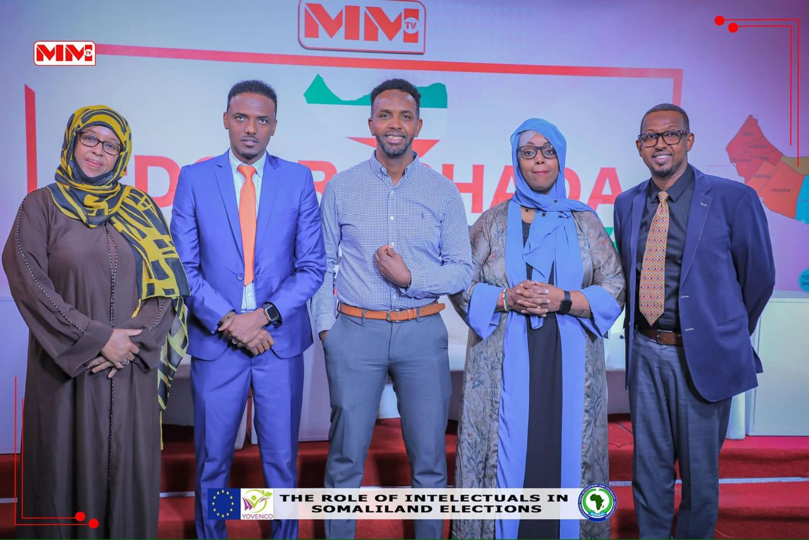
Introduction
Two sessions of a talk show that focused on Somaliland’s democratization process in the light of the recent 2024 Presidential Election, its challenges, and opportunities were conducted on November 21st hosted by the MM TV office Hargeisa, and December 10th, 2024, at Daalo Hotel on Bur’ao. These events were organized to bring together high-level delegates from the Togdheer and Maroodijeex regions, along with key social stakeholders, to discuss the role of democracy in fostering peace and stability in Somaliland. The delegates discussed the rough trajectory in which Somaliland’s recent election took, involving recurrent disputes, deadly clashes, violent demonstrations, and long deadlock; they examined the events that culminated such a trajectory and explored the ways forward in ensuring how such situations can be avoided.
The discussions were significant by raising awareness about Somaliland’s democratic transition. Participants actively exchanged views on governance, electoral processes, and democratic tenets.
The objectives of these talk shows included improving public perceptions toward democracy and highlighting its importance in governance. It sought to demonstrate how democratic elections contribute to national stability. Also, the initiative aimed to create a forum for dialogue, allowing citizens to discuss both the prospects and challenges of democratization while encouraging active participation in governance. A key goal was also to strengthen interactions between government officials and the community, fostering trust and shared decision-making.
Key Achievement
The program maximized community engagement in democratic discourse. Held in conference halls at MM TV and Daalo Hotel, the sessions adopted a discussion-based format that encouraged active participation. Attendees were grouped at tables to facilitate peer discussions, while invited speakers provided insights on democratization. To make the sessions more relatable, cultural interludes were incorporated, linking democratic values to local traditions. A question-and-answer session allowed direct interaction between the audience and speakers, ensuring an inclusive and dynamic exchange of ideas.
The program achieved notable success. Participants demonstrated a strong understanding of the issues discussed and actively contributed to open discussions with government officials. The session effectively bridged traditional norms with democratic values, reinforcing unity and shared responsibility. Also, the sessions were broadcast on SAAB and MM TV, extending the reach of the discussion beyond the event itself. Viewers responded positively which indicated that the televised format helped disseminate democratic awareness to a wider audience.
In sum, the program uncovered the realities of Somaliland’s democratic process. It increased public awareness of democratic principles as the initiative is likely to enhance citizen participation in governance and decision-making.

Activity 4 related to output 3.1

A 3.1.1.3 Activity Report of a community conversation on awareness-raising activities at the grassroots level to increase citizen participation in elections in Burao.
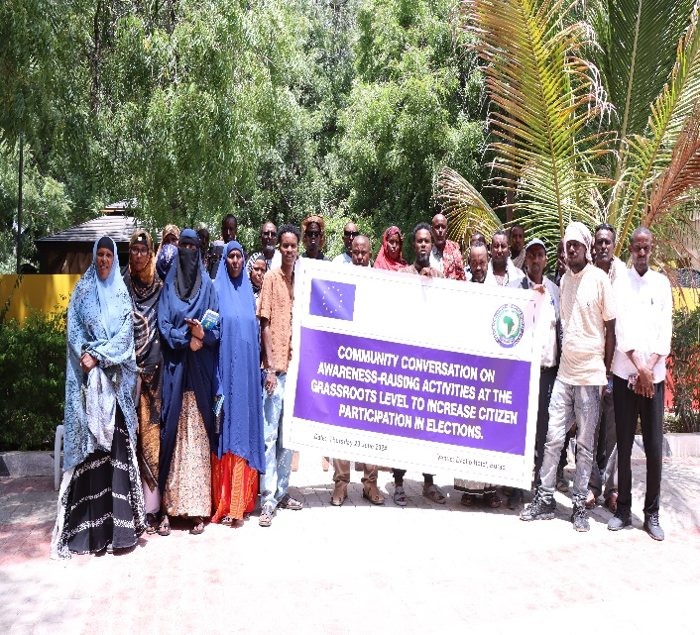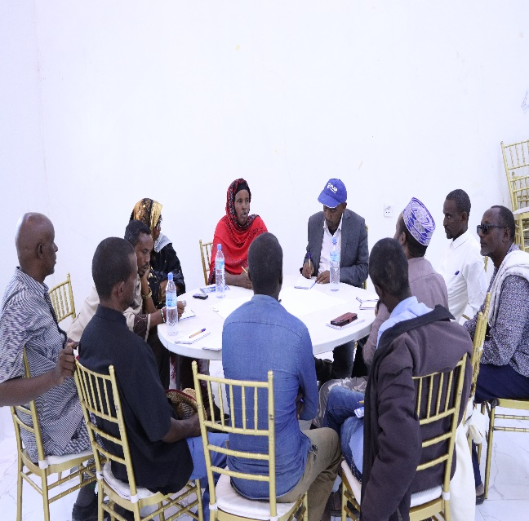

Background:
The necessity of increasing people’s engagement in the election process serves as the foundation for a democratic state. The community conversation targeted 25 participants of whom 15 were males and 10 females. Noting the importance of improving voter turnout and increasing the community’s participation in the election process at the grassroots level, awareness-raising activities were initiated. This activity was likewise geared not only to inform but also to mobilise citizens in the exercise of their right to vote.
The enthusiasm of the community to educate the public and encourage votes during elections is evidence that such grassroots movements can indeed be transformative. By providing citizens with knowledge and encouraging discourse, the goal is to create a fair and receptive democracy that listens to every person and values each vote.

The first aim of this session was to encourage people to vote and get to know the rules of the election, why voting is important, and how people’s actions can affect the functioning of the authorities. Also, it was important to encourage people to take an active participation in society and become responsible citizens.
To achieve what we sought, the session used a three-pronged strategy based on group discussions and brainstorming. By practising these methods with participants, equipped with trained volunteers and community leaders, the participants were empowered to discuss such topics as electoral rights, the function of local government, and the ways to deal with the obstacles of voting. Interactive ideas focused on participants’ experiences, critical opinions, and developing ideas for addressing issues altogether.
Activity Achievements:
The participants were exceptionally engaged throughout the whole of the session and showed a lot of interest in the topic. They were involved in the deliberations, participated in providing valuable opinions and engaged in the formulation of innovative approaches to enhancing voter awareness. These were the reasons why the group activities facilitated the exchange of knowledge as well as increased the active participation of the participants hence enhancing the formation of the team learning atmosphere.
As for the future, expect numerous results from our initiatives in raising awareness. These include being able to register eligible voters and getting them to vote during the coming elections especially those who have not been volunteering in their voting rights. In addition, this will find an enhanced capacity of communities to come together and demand effective local and national governance. In other words, a dream is to nurture an enlightened citizenry that transcends political campaigns and engages in democracy on a lifelong basis.

Activity 5 related to output 3.1

A 3.1.3 Activity Report of Community Conversation on Civic education, advocacy and awareness-raising activities at the grassroots level to increase citizen participation in civic activities in Burao.
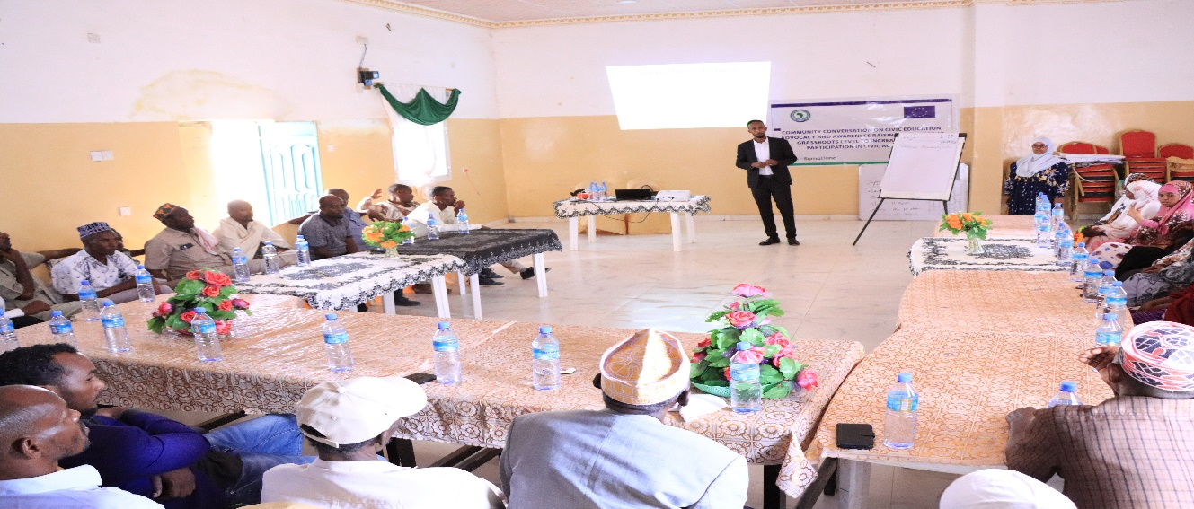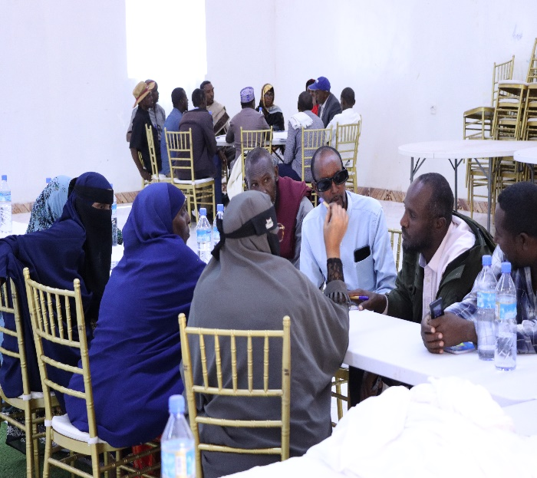

Background:
In the face of the demand for conflict resolution and mediation skills within the community, a community conversation activity was held in Burao, a city in Somaliland. The activity, weswas meant to give trainers the required skills to handle the conflicts and disputes constructively, thus, the dialogue and the reconciliation were created. It was a component of a wider movement to foster peace and harmony within the community, resolving the problems that give rise to conflict and finding permanent solutions. The activity comprised workshops, role-playing exercises, and group discussions to strengthen the ability of local leaders and community members to face conflicts peacefully and constructively. The main aim was to establish a network of expert peacekeepers and mediators who could, in turn, contribute to the development of a more peaceful and harmonious community.
The primary objective of the community conversation activity was multifaceted. Firstly, it sought to empower trainers with practical conflict resolution and mediation skills tailored to the specific context of Burao. Secondly, it aimed to deepen their understanding of the underlying causes of conflicts within the community, enabling them to address root issues effectively. Additionally, the activity aimed to instil a sense of responsibility among trainers to actively promote peaceful dialogue and reconciliation in their respective spheres of influence.
Methodology:
To achieve these objectives, the activity employed a comprehensive methodology designed to maximize engagement and learning. It began with a participatory brainstorming session, where trainers were encouraged to share their experiences and insights regarding conflicts in Burao. This was followed by structured group discussions facilitated by experienced mediators, allowing participants to delve into specific conflict resolution strategies and techniques. Role-playing exercises were integrated to provide practical, hands-on experience, enabling trainers to apply their newfound skills in simulated conflict scenarios.
Activity Achievements:
Throughout the activity, participants demonstrated remarkable engagement and commitment to the learning process. The brainstorming sessions proved instrumental in fostering a collective understanding of the diverse challenges in resolving community conflicts. Group discussions facilitated the exchange of ideas and best practices, enriching participants' knowledge and skill sets. The role-playing exercises, particularly, were highly effective in immersing trainers in realistic conflict scenarios, where they could apply theoretical knowledge in a supportive environment.
As a result of the community conversation activity, trainers are expected to emerge with a heightened capacity to manage conflicts and disputes within their communities. Armed with practical skills and insights gained from the activity, they are better equipped to navigate complex interpersonal dynamics and promote constructive dialogue among community members. This, in turn, is anticipated to contribute to a more harmonious and resilient community fabric, where conflicts are addressed proactively and peace is upheld as a shared value.
Suggestions:
Looking forward, sustaining the momentum generated by the community conversation activity requires continued investment in capacity-building initiatives and support structures. Ongoing mentorship and peer learning opportunities can serve to reinforce trainers' skills and confidence in conflict resolution and mediation. Furthermore, there is a need to integrate these efforts into broader community development initiatives, ensuring that conflict resolution becomes an integral component of local governance and social cohesion efforts. By nurturing a cadre of skilled mediators and fostering a culture of dialogue and reconciliation, Burao can pave the way for enduring peace and prosperity in the region.

Activity 1 related to output 3.2

A 3.2.1 Community Conversation for Enhancing Peace and Cohesion in the Sanaag Region
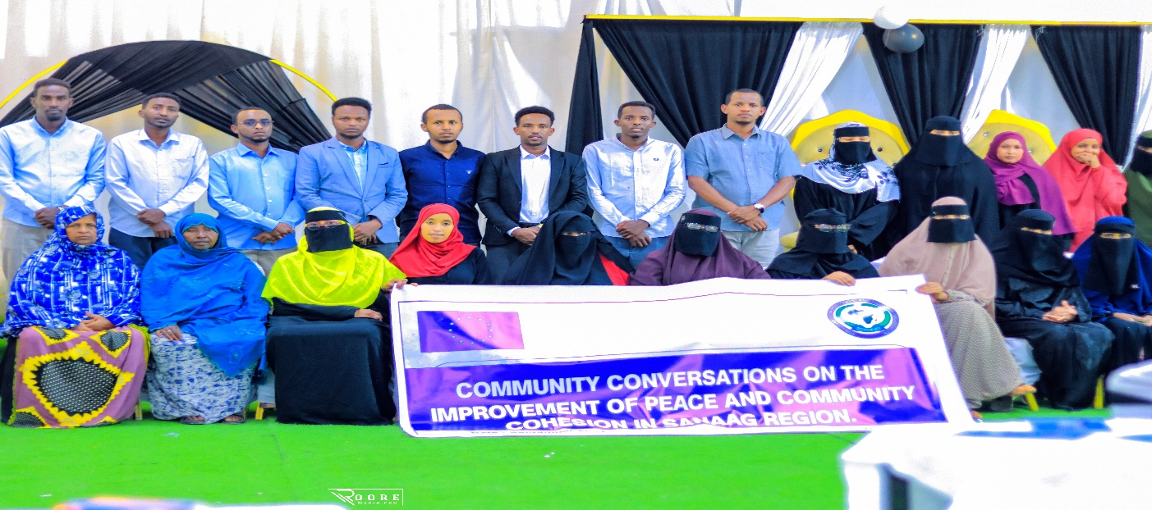
Introduction
The Sanaag region has long experienced recurrent clan disputes, with the latest incidents occurring near Erigavo which disrupted community life and created insecurity, particularly for vulnerable groups such as women and children. In response to these ongoing conflicts, a community dialogue was organized by SOYDAVO to address the root causes of violence and encourage reconciliation among warring clans. The objective was to create a platform for open and constructive discussions that could lead to sustainable peace and greater regional unity.
The community conversation aimed to engage key stakeholders, including clan elders, religious leaders, women, youth, and civil society representatives, in a dialogue that would help de-escalate tensions and foster a culture of peaceful coexistence. The initiative sought to mitigate ethnic animosities and promote locally driven solutions through dialogue. Another crucial aspect was the inclusion of traditionally marginalized groups in peacebuilding discourse, ensuring that all voices, including those of women and youth, were acknowledged and valued.
The initiative faced several challenges, among them was the hostility between some clan factions made open discussions difficult, while poor transport and communication infrastructure hindered participation from remote areas. Some attendees expressed skepticism about the sustainability of peace agreements, citing past instances where similar efforts had failed. The involvement of actors with political or economic stakes in the conflict also posed a risk to the neutrality of the process.
The implementation approach involved a structured group discussions where participants shared their perspectives on the underlying causes of the conflict and proposed recommendations for resolution. Conflict mapping exercises were conducted to analyze patterns of violence and identify potential areas for intervention. Additionally, traditional conflict resolution practices, informed by religious and cultural customs, were revisited to explore their applicability in the current context.
Key Achievements
The initiative successfully facilitated dialogue between rival clans, leading to a consensus on ceasing hostilities and taking further steps toward reconciliation. A key achievement was the formation of independent peace committees within each clan to oversee conflict resolution efforts. Notably, women and youth were actively involved in the discussions, marking a significant shift from past peace initiatives where their participation was minimal. Participants reached a deeper understanding of the conflict’s root causes, such as competition over resources, historical grievances, and political tensions, and expressed a strong willingness to collaborate in pursuit of lasting peace.
Moving forward, the agreements reached during the dialogue are expected to contribute to a decline in violent incidents among the warring clans. The newly established community peace committee is anticipated to play a vital role in preventing future conflicts through continued negotiations and mediation efforts. The inclusion of women and youth is seen as a critical step toward building resilient and an inclusive community structures. Additionally, there is growing optimism about cross-clan cooperation in managing shared natural resources, which could further enhance regional stability.
To ensure the long-term success of the peace initiative, it’s vital that our intervention covers further meetings to be conducted with community leaders to assess progress and address emerging concerns. Capacity-building programs for local peace committees should be expanded to enhance conflict resolution skills. Strengthening collaboration with local government and external partners will be crucial in maintaining momentum and securing resources for continued peace efforts.

Activity 2 related to output 3.2

A 3.2.2 Community Consultation Workshop on Electoral Challenges for Minorities and Persons with Disabilities in Burao

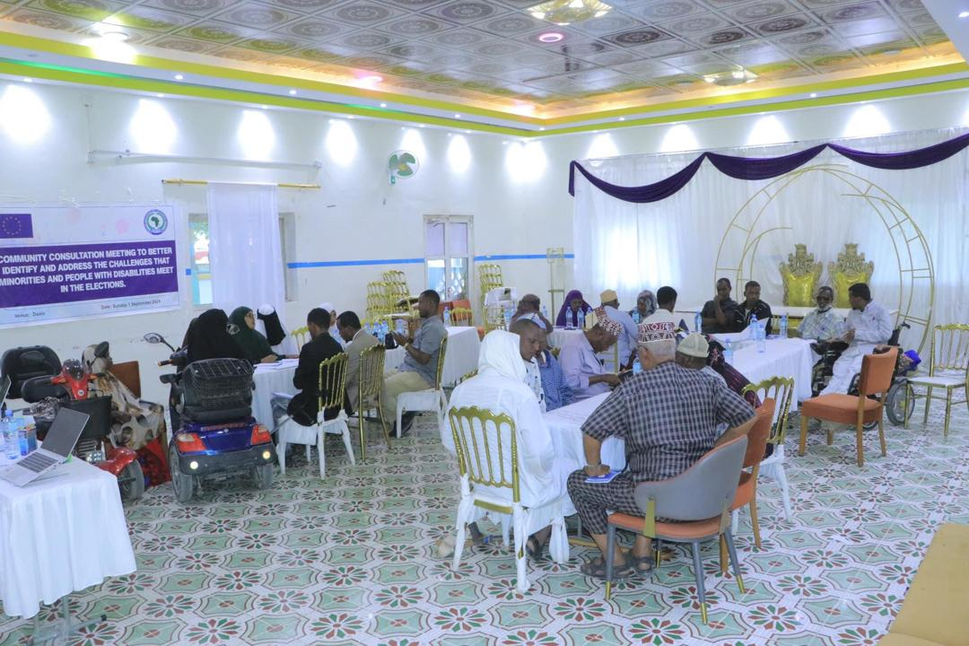
Image: Workshop on minority & disability inclusion in Bur'oa
Introduction
The consultation workshop sought to address the structural barriers limiting the electoral participation of minorities and persons with disabilities in Burao, aligning with a transformation pathway that progresses from problem identification to stakeholder engagement, advocacy, and systemic reform. By directly engaging affected communities, electoral stakeholders, and advocacy groups, the initiative aimed to promote inclusive electoral processes through institutional dialogue and policy recommendations.
The workshop convened 30 participants, including representatives from disability unions, community leaders from four districts, and marginalized groups. The discussions highlighted critical challenges, including the absence of polling stations designed for persons with disabilities, limited voter education initiatives targeting minorities, and the lack of legal provisions ensuring their representation in electoral decision-making. Participants identified these gaps as key contributors to their political exclusion and called for targeted interventions to enhance electoral accessibility and representation.

Key Achievement
Among the achievements of the workshop was the empowerment of marginalized voices through direct engagement with the National Elections Commission (NEC), civil society organizations, and other stakeholders. The consultation helped communicate a press statement issued via SAAB TV, amplifying the concerns of these groups and ensuring visibility at the policy level. Through this advocacy initiative, participants urged key electoral actors to prioritize disability-inclusive electoral frameworks, voter education programs for minorities, and legislative measures to guarantee representation.
The process also laid the groundwork for active engagement with stakeholders and securing continued political commitment while agreeing on an advocacy roadmap to sustain momentum toward inclusive electoral reforms. The recommendations identified from this workshop will inform future electoral policy discussions in Somaliland, strengthening the case for disability-inclusive institutional reforms that uphold the political rights of marginalized communities. By fostering dialogue between affected groups and decision-makers, the workshop contributed to a broader agenda of democratic inclusivity and governance accountability.

Activity 1 related to output 3.4

A 3.4.1 Cultural Events Lobbying, advocacy and awareness campaigns, including the use of media on transparency, accountability, gender equality and environmental stability in Burao.

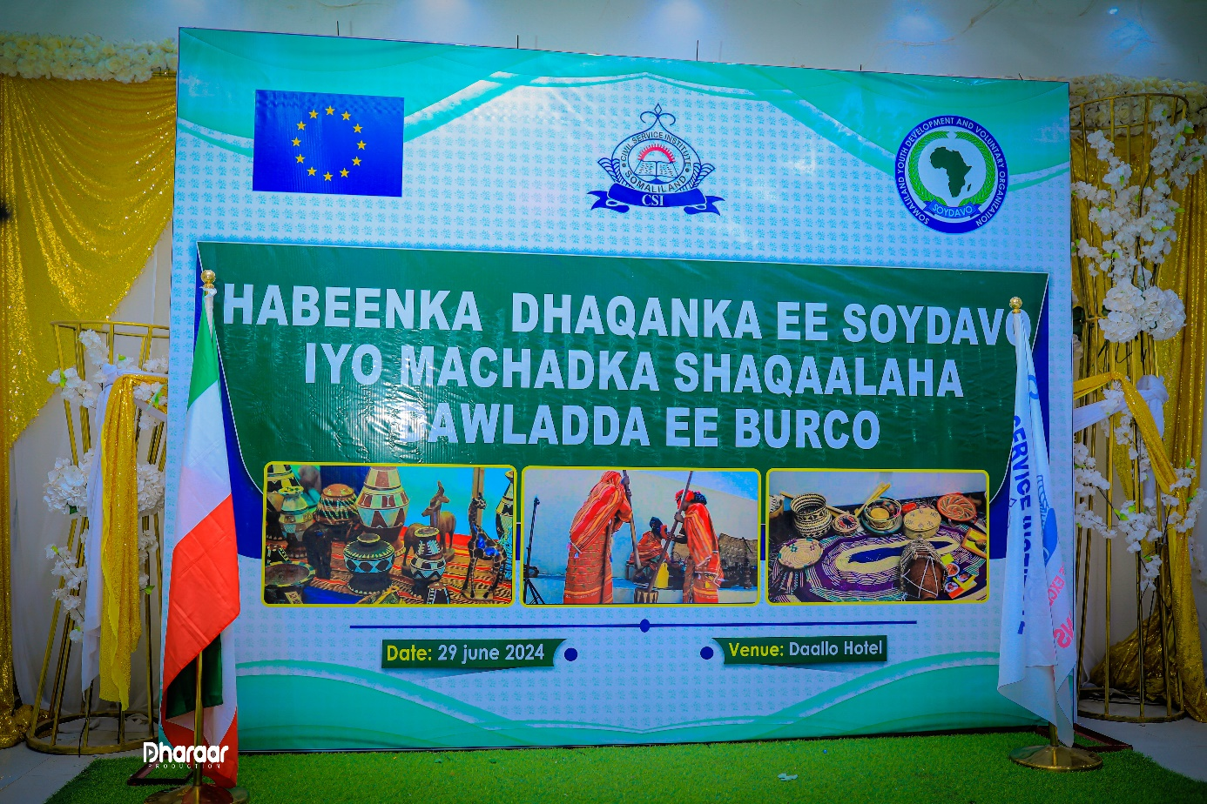
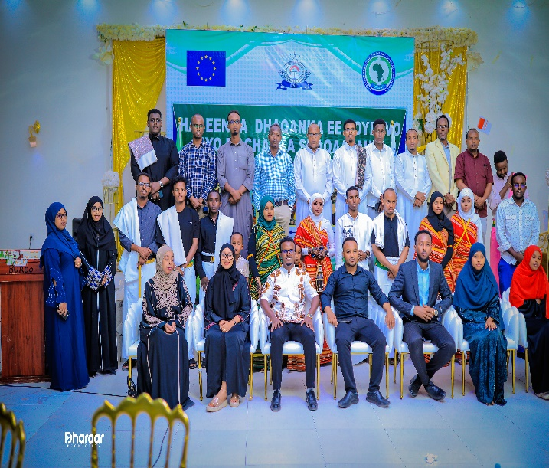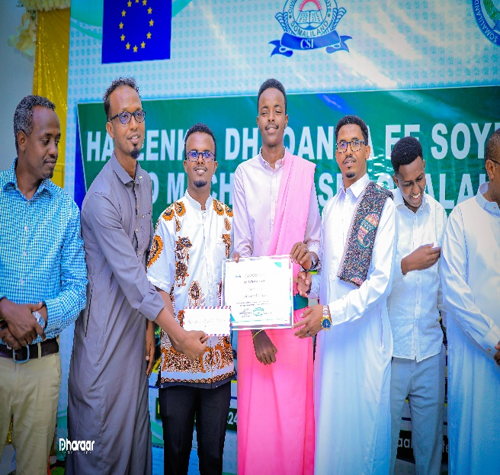

Introduction
On 30 June 2024, CSI Burao and SOYDAVO came together to host cultural night event to celebrate the Somali heritage and arts. The event attracted young poets from Buro’a who displayed their artistic skills through poems, cultural exhibitions, and traditional dances. A rich display of traditional Somali clothing, cuisine, and cultural artefacts followed.

The objectives of the session were to promote accountability and transparency through the use of the talent of young poets, who also happen to be students at Civil Service Institute in Buro’a.
The event recognized the best three poets based on their performance which captivated the audience and showcased the rich tradition of Somali poetry. This recognition did not just encourage the young talent and contributed to the preservation of our rich Somali traditions, but also augmented the crucial need of using poetry to push the community needs forward.
The collaboration between CSI Burao and SOYDAVO in organizing this event highlighted the sense of partnership regarding jointly advancing the Somali culture.
The Cultural Night went beyond entertainment; it embraced Somali culture by cementing its identity and heritage. It honored the young poets on the rise, appreciated their artefacts, and spread the word about the immense need to preserve and promoting Somali traditions. The collaboration between CSI Burao and SOYDAVO exemplified the power of community and cultural solidarity.

Results
- Young poets were recognized and encouraged to further their poetic efforts and gear up the accountability and transparency efforts aimed toward achieving accountable and transparent local service delivery.
- The event cemented the need for cross-collaboration between the academia and the CSOs in advancing the community interests jointly.
- Group of dedicated cultural teams have been approached by the project which are ready to make their crucial input in the advocacy and awareness role that the project intends to play moving forward.
- The project contributed toward the efforts of cultural preservation and promotion which are cornerstone of the project being perceived as local driven initiative.

Activity 2 related to output 3.4

A 3.4.2 Awareness raising workshop on the importance of media in promoting transparency, accountability and increasing voter participation in elections in Burao (SOYDAVO)
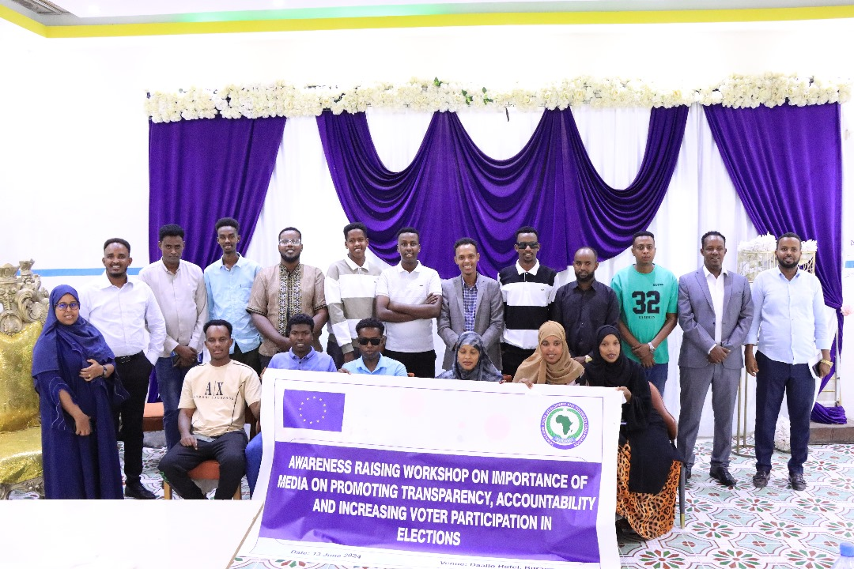
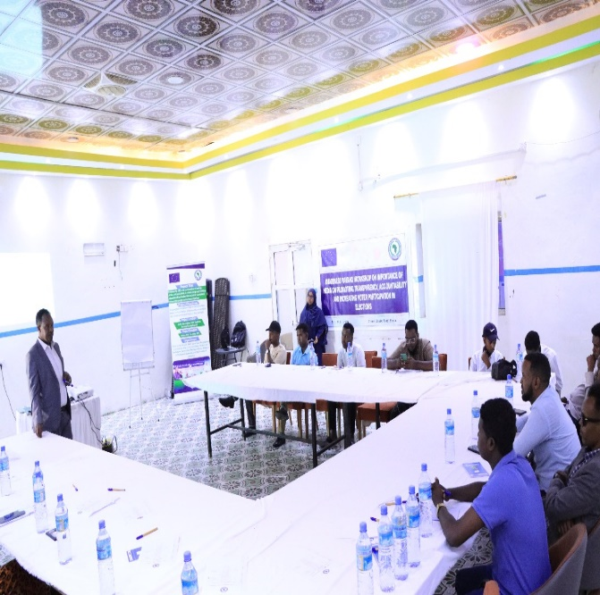
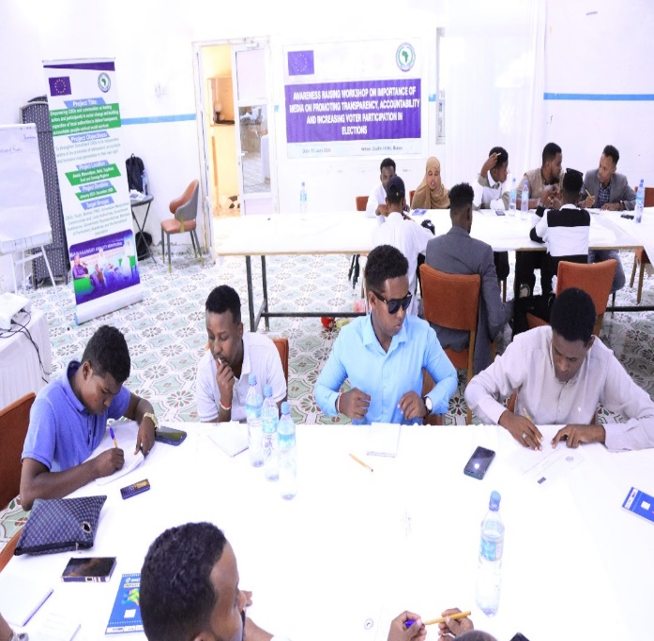

Introduction:
The workshop organised in Burao was to provide the local journalists with basic information about media during the election particularly; the concerns of transparency, accountability, and voter turnout. It included media roles in democratic states, journalists’ freedom, and standards in voting processes. All participants received information and practical tips in group discussions and presentations. Participants’ comprehension ranged between moderate and high in the pre-training assessment, but expressed eagerness and willingness to implement acquired knowledge after the training. Nonetheless, suggestions are availing of subsequent sessions to reinforce learning and offer other relevant materials that will keep people engaged in the fight for democracy through media.
Findings & Key Achievement
Based on the training sessions, several findings emerged regarding the knowledge and skills of the participants. Some participants had a limited understanding of the media and elections while others lacked specific skills in the functions of media, the role of journalists in elections and professional and ethical standards in election reporting. However, overall, the participants displayed enthusiasm and a willingness to learn and apply the concepts taught during the training.
The training successfully strengthened local journalists’ capacity to promote transparency, accountability, and voter participation in elections. Participants gained a clear understanding of media’s role in democratic governance, journalists’ rights and responsibilities, and professional ethics in election reporting.
Through interactive discussions, experience sharing, and group exercises, journalists developed practical strategies for ethical and unbiased election coverage. The session resulted in:
- Improved awareness of media rights and responsibilities in elections.
- Strengthened journalists’ ability to report objectively on electoral processes.
- Commitment from participants to uphold professional and ethical standards in election reporting.
The engagement of 20 journalists in Burao, including three women, contributed to diversifying media perspectives in election coverage. The training reinforced the importance of informed reporting in fostering public trust and electoral integrity.

Recommendations:
Based on the findings, the following recommendations are proposed:
- Conduct follow-up training sessions to reinforce and build upon the knowledge and skills acquired during the initial training.
- Provide additional resources and materials to further enhance the participants' understanding of media in elections and related topics.
- Encourage participants to actively engage in media and election activities within their respective audiences to gain practical experience.
- Foster networking opportunities for participants to collaborate and share experiences with other local journalists.

In conclusion, the training on the Importance of media in promoting Transparency, accountability and increasing voter participation in elections in Burao was successful in enhancing participants' understanding of media and elections. By equipping participants with this knowledge, they are to promote transparency and accountability in elections for the needs and aspirations of their Audiences and contribute to positive change. Continued support and capacity-building efforts are essential to sustain and amplify the impact of the training.

Activity 3 related to output 3.4

A 3.4.1 Cultural Events on Commemorating Somaliland’s Election and Democracy in Burao (SOYDAVO)

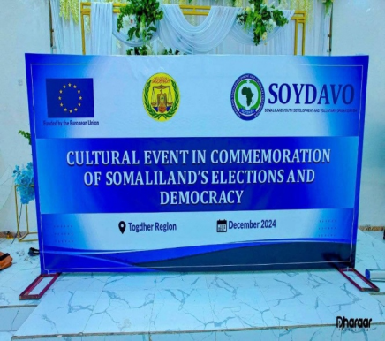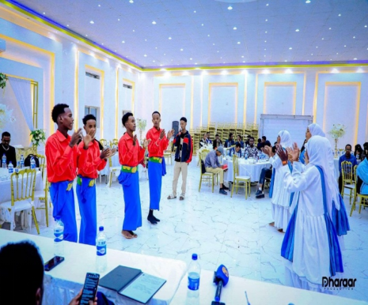

Introduction
On November 13, 2024, Somaliland showcased its democratic prowess in the Horn of Africa through a peaceful presidential election and smooth transfer of power. This has underscored the country’s commitment to governance through inclusion and unity. To celebrate this achievement, SOYDAVO organized a cultural event to highlight the interplay between democracy, culture, and national identity. The event has provided an opportunity to reflect on Somaliland’s democratic progress while embracing its rich traditions and cultural heritage.
Among the objectives of the event was to celebrate the successful election while demonstrating how cultural heritage reinforces democratic values. It aimed to foster national pride and unity by showcasing traditional practices that connect Somaliland’s historical legacy with its present democratic milestones. Through performances of traditional games and artistic performances, the event emphasized the role of culture in strengthening democratic governance and social cohesion.
Key features & Performance
The event featured different cultural displays, including traditional dances and games that reflect Somaliland’s cultural and historical narratives. Among these activities was “Jaandheer,” a game symbolizing teamwork, as well as poetry performances that combined artistic expression with historical storytelling. Attendees also participated in craft demonstrations and interactive performances, ensuring that the event was both entertaining and educational. The methodology used was designed to engage participants while illustrating how cultural heritage contributes to sustaining democracy.
Key Achievement
The event successfully achieved its objectives by bringing together citizens from different backgrounds to celebrate the nation’s democratic journey. It provided a platform for promoting and preserving traditional games and activities, ensuring that cultural knowledge is passed down to future generations. Furthermore, the active involvement of community members reinforced an understanding of how cultural heritage enriches democratic practice. The event not only strengthened social bonds but also deepened the appreciation of Somaliland’s political and cultural identity.
In conclusion, the event is expected to contribute to stronger community connections and increased patriotic sentiment. It serves as a foundation for future initiatives that utilize cultural education to foster civic engagement and social cohesion.

2.3 Logframe Matrix Updated
The Logical framework (logframe) matrix should be used as a reporting tool of the expected results (impact, outcomes, outputs) during implementation. Values on indicators aimed at measuring the results will be regularly updated in the column foreseen for monitoring and reporting purposes (see “Current value”). Columns for intermediary targets could be added, if needed.

Results chain | Indicator | Baseline  (value & reference year) | Target  (value & reference year) | Current value*  (reference year)  (* to be included in interim and final reports) | Sources of data | Assumptions
To strengthen Somaliland CSOs to be independent actors in the promotion of transparent, accountable and inclusive local governance in their own right. | 1: The number of Somaliland CSOs that promoting transparent, accountable and inclusive local governance disaggregated by vulnerability category and location | Baseline for impact indicator 1 | 1. 30 CSOs | TBD | 1. Project Reports  2. Attendance Records  3. FGDs, Interviews  4. GPRS Images and videos  5. Pre and Post Training Surveys  6. Training Materials | 1. The newly elected local authorities require capacity-building support and training to enable them to deliver people-centred services and that there are CSOs targeting women, youth and the marginalised who are advocating for their inclusion in planning, budgeting and decision making.  2. Somaliland CSOs have been actively involved in various segments of Somaliland’s development in peace building, political participation, governance, democracy, human rights and security.  3. Somaliland enjoys relative peace and stability
 | 2: The number of local authorities that Somaliland CSOs are supporting to entrench transparent, accountable and inclusive local governance disaggregated by vulnerability category and location | Baseline for impact indicator 2 | 6 Local Authorities | TBD | 1. Project Reports  2. Interviews  3. FGD  4. GPRS Images and videos
 | 3: The number of frameworks and mechanisms implemented to promote inclusivity, transparency, and accountability in local governance in local authorities in Somaliland | Baseline for impact indicator # | 1. 6 Development Forums  2. 1 Policy Frameworks | TBD | 1. Project Reports  2. Local Government Reports  3. Transparency Index reports  4. GPRS Images and videos
Outcome 1: To enhance local governance through the participation of CSOs in public decision-making processes and social accountability | 1.1 Number of CSOs engaged in the enhancement of local governance through increased public participation | 1.1 | 1.1 30 CSOs | 28 | 1. Social Media Pages  2. Pubic Engagement Action Reports  3. Project/ Activity Reports  4. GPRS Images and videos
 | 1.2 Number of local authorities using participatory planning tool | 1.2 | 1.2 6 Local Authorities | 6 | 1. Local Government Action plans  2. Local Government Assessment Reports  3. FGDs  4. GPRS Images and videos
 | 1.3 Number of women, youth, internally displaced persons (IDPs), minority clan groups and persons with disabilities (PwDs) CSOs participating in the planning and decision making in local authorities | 1.3 | 1.3 20 CSOs | 10 | 1. CSO activity reports  2. Project reports  3. FGDs, Interviews  4. GPRS Images and videos
Outcome 2: To increase local CSO capacities to engage in gender equality | 2.1 Number of CSO whose capacity has been enhanced to engage in gender equality | 2.1 | 2.1 12 CSOs | 13 | 1. Project Reports  2. CSO activity Reports  3. Public Engagement Reports and Action Points  4. GPRS Images and videos
 | 2.2 Number of CSO engaged in sustained advocacy on gender equality and environmental stability | 2.2 | 2.2 20 CSOs | 13 CSOs | 1. Project/ Activity Reports  2. FGDs, Interviews  3. GPRS Images
Output 1: Somaliland CSOs Empowered to promote and support transparency, accountability and policy-making in the local government | 1.1 Number of CSOs empowered to promote and support transparency, accountability and policy-making in the local government | 1.1 | 1.1 30 CSOs, with 10@region | 28 | 1. CSO activity reports  2. Project reports  3. FGDs, Interviews  4. GPRS Images and videos
 | 1.2 Number of CSO and Local Government Development Forums established | 1.2 | 1.2. 6 Development Forums | 6 | 1. CSO activity reports  2. Project reports  3. FGDs, Interviews  4. Local Government Reports
 | 1.3 Frameworks developed to support policy development | 1.3 | 1.3 1 framework | 1 Framework | 1. Local Government Reports and Plans  2. Project Reports  3. GPRS Images and videos
 | 1.4 Study findings and recommendations on evidence-based advocacy and participatory community monitoring of public services at local level | 1.4 | 1.4 1 CSO Study findings and recommendations | 1 study | 1. CSO Study Report
Output 2: Women, Youth, Marginalised, and Vulnerable people, PWDs and minority clans take a leading role in the promotion and support of entrenching the engendering policy and decision making in local governance and social accountability in Somaliland. | 2.1 Number of CSO strengthened to focus on people with disability, and other vulnerable groups | 2.1 | 2.1 12 CSOs | 2.1 13 CSOs | 1. CSO Activity Reports  2. FGDs, Interviews  3. GPRS Images and videos
 | 2.2 Number of Women, Youth, Marginalised, and Vulnerable people, PWDs and minority CSOs involved in the process of engendering social change, in particular by challenging stereotypes; | 2.2 | 2.2 30 CSOs | 20 CSOs | 1. CSO Activity Reports  2. FGDs, Interviews  3. GPRS Images and videos
 | (…) | (…) | (…) | (…) | (…)
Output 3: The Somaliland Media and Population take an active role in participation, and decision-making in the governance of local | 3.1 Number of citizens taking an active role in participation, and decision-making in the governance of local authorities | 3.1 | 3.1 1,500 citizens | 925 citizens | 1. Public Engagement Reports and Action Points  2. Project Reports  3. FGDs, Interviews  4. GPRS Images and videos
 | 3.2 Number of community-led initiatives at neighbourhood level | 3.2 | 3.2 20 community-led initiatives, with 5 @ region | 3 | 1. Community Activity Reports  2. Project Reports  3. FGDs, Interviews  4. GPRS Images and videos
 | 3.3 Number of women, youth and vulnerable groups led CSOs engaged in sustained advocacy on gender equality and environmental stability | 3.3 | 3.3 20 CSOs | 13 CSOs | 1. CSO Activity Reports  2. FGDs, Interviews  3. GPRS Images and videos

2.4 Activity Matrix
What are the key activities to be carried out to produce the intended outputs?  (*activities should be linked to corresponding output(s) through clear numbering) | Means  What are the political, technical, financial, human, and material resources required to implement these activities, e.g. staff, equipment, supplies, operational facilities, etc.  Costs  What are the action costs? How are they classified? (Breakdown in the Budget for the Action) | Assumptions  External, necessary, and positive conditions for implementing the intervention that are outside of its management's control.
A 1.2.1  1 Townhall  Meeting | Means:  - Facilitator  - visibility materials  - Stationery  - Venue  The Cost of the one activity is 2980 Euro | - Stakeholder Commitment  The political climate
A 2.1.2 3 Tailored Capacity Building | Means:  - Training Facilitator  - visibility materials  - Stationery  - Venue  - Lunch  - Refreshment  - Perdeim  The total cost for one training is 1680 Euro and 3 trainings = 3 trainings* 1680 Euro= 5,040 Euro | - Availability of Expertise  - The political climate
A 1.1.1 1 Capacity-building Trainings | Means:  - Consultant  - visibility materials  - Stationery  - Venue  - Lunch  - Refreshment  - Perdeim  The total cost for one training is 2,180 Euro and 3 trainings = 3 trainings* 2,180 Euro= 4,360 Euro | - Availability of Expertise  - CSOs commitment  - The political climate
A 1.2.2 4 Consultations | Means:  - Stationery  - Venue  - Lunch  - Refreshment  - Perdeim  The total for one community conversation is 1480Euro and 4 consultations = 4 consultations* 1480Euro = 5,920 | The political climate
A 1.2.3 Facilitation of 4 interactive meetings | Means:  - Facilitator  - visibility materials  - Stationery  - Venue  - Lunch  - Refreshment  - Perdeim  The total cost for one training is 1528 Euro and 4 meetings = 4 meetings* 1528 Euro= 6,112 Euro | - Stakeholder Commitment  - The political climate
A1.3.2 4 Workshops @region | Means:  - Training Facilitator  - visibility materials  - Stationery  - Venue  - Lunch  - Refreshment  - Perdeim  The total cost for one training is 2248 Euro and 3 trainings = 4 trainings* 2248 Euro= 8,992 Euro | - Availability of Expertise  - CSOs commitment  - The political climate
A 2.1.3 4 Public Campaigns | Means:  - Printing of 4 Billboards  - Printing and designing of banners  - Social Media Influencers  The total cost for one Public Campaign is 1500 Euros and 4 Public Campaigns= 4 campaigns * 1500 Euros= 6,000 Euros | - The political climate
A 2.2.1 3 Public  Campaign | Means:  - Printing of 4 Billboards  - Printing and designing of banners  - Social Media Influencers  The total cost for one Public Campaign is 1500 Euros and 4 Public Campaigns= 3 campaigns * 1500 Euros= 4,800 Euros | - The political climate
A 2.2.2  4 Community Conversations | Means:  - Facilitator  - Stationery  - Venue  - Lunch  - Refreshment  - Perdeim  The total for one community conversation is 1980Euro and 4 community conversations = 4 conversations* 1980Euro = 7,920 | - The political climate
A 3.1.2 2 Talk  Shows | Means:  - Facilitator  - visibility materials  - Venue  The cost of one talk show is 2000= 2 talk shows *2000= 4,000 Euro | - The political climate
A 3.2.2 3 Workshops | Means:  - Training Facilitator  - visibility materials  - Stationery  - Venue  - Lunch  - Refreshment  - Perdeim  The total cost for one training is 2248 Euro and 3 trainings = 3 trainings* 2248 Euro= 6,744 Euro | - Availability of Expertise  - CSOs commitment  - The political climate
A 3.3 Establishment of 10 community-led initiatives | Means:  - Selection Committee  - Advertisement  The cost of each initiative is 1000= 10 community initiatives *1000= 10,000 Euro | - The political climate
A3.4.1 1 Cultural Events (bi-annual) | Means:  - Event Presenters  - visibility  - Venue  - Lunch  - Refreshment  The total for one cultural event is 3000 Euro | - The political climate  - The social and cultural context
A 3.4.2 3 Workshop | Means:  - Training Facilitator  - visibility materials  - Stationery  - Venue  - Lunch  - Refreshment  - Perdeim  The total cost for one training is 2280 Euro and 3 training = 3 * 2280 Euro = 6,840 Euro | - Availability of Expertise  - CSOs commitment  - The political climate

2.5 Updated Action Plan

Year 3
 | Half-year 1 |  |  |  |  |  | Half-year 1
Activity | Month 1 | 2 | 3 | 4 | 5 | 6 | 7 | 8 | 9 | 10 | 11 | 12 | Implementing body
Project Review Meeting |  |  |  |  |  |  |  |  |  |  |  |  | YOVENCO/SOYDAVO
Preparation Activity 1: Capacity building of civil society organisations for participation in local governance and in accountability processes, including in planning and decision-making of local authorities |  |  |  |  |  |  |  |  |  |  |  |  | YOVENCO
Execution Activity 1.1 3 CSO Capacity building Trainings |  |  |  |  |  |  |  |  |  |  |  |  | YOVENCO
Preparation Activity 1.2: Training of civil society organisations and other relevant stakeholders on promotion of transparency and accountability mechanisms; |  |  |  |  |  |  |  |  |  |  |  |  | YOVENCO
Execution Activity 1.2.1 1 Townhall Meeting
Execution Activity 1.2.2 4 Consultations |  |  |  |  |  |  |  |  |  |  |  |  | YOVENCO
Execution Activity 1.2.3 Facilitation of 4 interactive meetings |  |  |  |  |  |  |  |  |  |  |  |  | YOVENCO
Preparation Activity 1.3 Capacity building of civil society organisations to support local authorities in policy development/reforms, local development plans and budgets using participatory approaches; support to the establishment of frameworks to enhance a more permanent collaboration between CSOs and local authorities in the implementation of development project Consultations |  |  |  |  |  |  |  |  |  |  |  |  | YOVENCO
Execution Activity 1.3.2 4 Workshops |  |  |  |  |  |  |  |  |  |  |  |  | YOVENCO
Preparation Activity 2.1 Strengthening CSOs focusing on people with disability, and other vulnerable groups |  |  |  |  |  |  |  |  |  |  |  |  | YOVENCO
Execution Activity 2.1.2  3 Tailored Capacity Building |  |  |  |  |  |  |  |  |  |  |  |  | YOVENCO
Execution Activity 2.1.3 4 Public Campaigns |  |  |  |  |  |  |  |  |  |  |  |  | YOVENCO
Preparation Activity 2.2 Involving women’s organisations, youth organisations, and media in the transformative process of engendering social change, in particular by challenging stereotypes |  |  |  |  |  |  |  |  |  |  |  |  | SOYDAVO
Execution Activity 2.2.1 4 Public Campaigns |  |  |  |  |  |  |  |  |  |  |  |  | SOYDAVO
Execution Activity 2.2.2 4 Community Conversations |  |  |  |  |  |  |  |  |  |  |  |  | SOYDAVO
Preparation Activity 3.1 Civic education, advocacy and awareness raising activities at grassroots level to increase citizen participation in civic activities |  |  |  |  |  |  |  |  |  |  |  |  | SOYDAVO
Execution Activity 3.1.2 2 Talk Shows |  |  |  |  |  |  |  |  |  |  |  |  | SOYDAVO
Execution Activity 3.1.3  3 Community Conversations |  |  |  |  |  |  |  |  |  |  |  |  | SOYDAVO
Preparation Activity 3.2 Organising community consultations, developing and implementing participatory planning processes between the local population, the authorities and civil society actors; |  |  |  |  |  |  |  |  |  |  |  |  | SOYDAVO
Execution Activity 3.2.2  3 Workshops |  |  |  |  |  |  |  |  |  |  |  |  | SOYDAVO
Preparation Activity 3.3 Establishment of community-led initiatives at neighbourhood level. |  |  |  |  |  |  |  |  |  |  |  |  | SOYDAVO
Execution Activity 3.3 Establishment of 10 community-led initiatives |  |  |  |  |  |  |  |  |  |  |  |  | SOYDAVO
Execution Activity 3.4 Lobbying, advocacy and awareness campaigns, including use of media on transparency, accountably, gender equality and environmental stability. |  |  |  |  |  |  |  |  |  |  |  |  | SOYDAVO
Execution 3.4.1 1 Bi-annual Cultural Events |  |  |  |  |  |  |  |  |  |  |  |  | SOYDAVO
Execution Activity 3.4.2 3 Workshops |  |  |  |  |  |  |  |  |  |  |  |  | SOYDAVO

3. Beneficiaries/affiliated entities, trainees, and other cooperation

The project, under the lead of YOVENCO Organization, has successfully trained many emerging youth-led, social services-focused organizations, built close working relationships with existing local development initiatives such as The Berbera Economic Forum, strengthened ties with local government authorities, particularly in the formation of DDFs, and established relations with the newly formed Ministry of Local Government Affairs.

4. Visibility

YOVENCO and SOYDAVO had a planning meeting on the EU project communication and visibility to ensure the visibility of the project at the inception stage of the project. Throughout the reporting period, the visibility of the EU contribution to this action was ensured in several ways including the following:
- Including the donor's name and logo on all materials related to the action, such as signage, brochures, campaign posts, banners, and project factsheet.
- Acknowledged the donor's contribution to the action in project-related meetings, consultations, conversations, and all other activities. This has helped to raise awareness of the donor's support to the action.
- Published regular updates on the action's progress and highlighted the donor's role in YOVENCO’s semi-annual newsletter.
- The implemented project activities were shared on YOVENCO and SOYDAVO’s social media channels acknowledging the EU as the donor of this project as well as including the EU’s logo in the shared pictures and videos.

5. Conclusion

In sum, the project activities planned for the reporting period were all completed without a considerable challenge that hindered the project's progress towards achieving the outcome indicators, except for the delay of the funds which prompted to revise and adjust the work plan in the first half of the year, accordingly.

