27 January 2024
EMPOWERING CSOS AND COMMUNITIES AS LEADING ACTORS AND PARTICIPANTS IN SOCIAL CHANGE AND BUILDING CAPACITIES OF LOCAL AUTHORITIES
Annual Narrative Report
Table of Contents
1. Description 2
2. Assessment of the implementation of the action activities and its results 2
2.1 Executive summary of the action 2
2.2 Results and Activities 3
A. RESULTS (IMPACT, OUTCOMES, OUTPUTS) 3
B. Activities 5
2.3 Logframe Matrix Updated 47
2.4 Activity Matrix 51
2.5 Updated Action Plan 56
3. Beneficiaries/affiliated entities, trainees and other cooperation 60
4. Visibility 60
5. Conclusion 61

Description

  - Name of coordinator of the grant contract: YOVENCO
  - Name and title of the contact person: Khadar Mariano, Project Manager
  - Name of beneficiary(ies) and affiliated entity(ies) in the action: SOYDAVO
  - Title of the action: Empowering CSOs and communities as leading actors and participants in social and change and building capacities of local authorities to deliver transparent, accountable, people-centered social services
  - Contract number: NDICI CSO/2022/437-611
  - Start date and end date of the reporting period: 12/12/2023- 31/12/2023
  - Target country(ies) or region(s): Somaliland
  - Final beneficiaries &/or target groups (if different) (including numbers of women and men): CSOs, youth, women, PWD, vulnerable/marginalized communities, and local authorities,

Assessment of the implementation of the action activities and its results

2.1 Executive summary of the action

During the reporting period, the project empowered Somaliland's CSOs and local authorities, laying the groundwork for a more transparent, accountable, and inclusive local governance landscape. Key capacity-building initiatives and robust advocacy mechanisms were established, enabling CSOs to flourish as effective actors. This foundation paves the way for future interventions where empowered CSOs can drive positive change within their communities, contributing to national reform efforts.
The progress towards impact indicators is strong. The project gathered baseline data, raised awareness among stakeholders, strengthened capacities, fostered partnerships, and built collaboration platforms like the Somaliland CSOs Accountability Network and a digital performance-tracking platform. Public campaigns and cultural events furthered gender-transformative action and equality promotion.
However, the full impact depends on the effective use of these mechanisms in the next two years. Additionally, close monitoring and targeted support will be crucial to ensure they function optimally and empower CSOs to play their vital role in enhancing accountability, transparency, and inclusivity in local governance.

2.2 Results and Activities

A. RESULTS (IMPACT, OUTCOMES, OUTPUTS)
Impact – To strengthen Somaliland CSOs to be independent actors in the promotion of transparent, accountable and inclusive local governance in their own right

The project’s initial phase successfully delivered key capacity-building initiatives for CSOs and local authorities. Additionally, it established robust systems and mechanisms that will play a crucial role in supporting CSO-led advocacy in promoting transparent, accountable, and inclusive local governance. During this reporting period, project activities prioritized the creation of an enabling environment for CSOs to flourish as effective actors in the local governance landscape. This lays the foundation for a series of interventions, where empowered CSOs can drive transparency, accountability, and inclusivity within their respective localities and contribute to broader national reform efforts. However, the ultimate realization of the project's impact indicators hinges on the effective operationalization of the established mechanisms over the next two years. This necessitates close monitoring and targeted support to ensure these systems function as intended and bring about CSOs that play their significant role as fully engaged actors in the enhancement of accountability, transparency, and inclusive local governance.

Outcome 1 – To enhance local governance through the participation of CSOs in public decision-making processes and in social accountability.

The project has made progress and is on track to achieve Outcome 1 indicators. During the reporting period, there were no major challenges that hindered or changed the outputs and activities related to this outcome. As such, all the related activities were carried out as planned, primarily focusing on gathering baseline data by researching the current state of local governance in Somaliland, with particular attention to the presence and effectiveness of transparency and accountability mechanisms, raising awareness among CSOs, CBOs, and the public on the crucial role of their participation in local governance processes, enhancing the capacities of both CSOs and local authorities, establishing partnerships between CSOs and local authorities, creating platforms for collaboration like the Somaliland CSOs Accountability Network and a digital performance-tracking platform for local authorities.

All of the activities undertaken in Outcome 1 have improved the participation of the CSOs in the public decision-making process. The CSOs have already started sharing their perspectives and ideas with the respective local authorities in their district, and the local authorities have demonstrated their willingness to accept the contribution of the CSOs in their work. With the various collaborative mechanisms, platforms, and forums of the project established, the intervention aims to enhance local governance through the creation of an environment conducive to collaboration and CSOs’ participation in the decision-making process.

Outcome 2 – To increase local CSO capacities to engage in gender equality.
The project made significant progress towards outcome 2 indicators. During the reporting period, several different methodologies were employed to increase local CSOs capacities to engage in gender equality. Some of the activities contributed towards this outcome included public campaigns on gender-transformative action aimed to raise awareness and enhance the capacities of CSOs and activists to campaign for gender equality at the local level, as well as public campaigns targeting the general public on gender equality. Furthermore, cultural events in which community groups discussed gender issues and how to change community norms and biases were carried out.

Output 1: Somaliland CSOs Empowered to promote and support transparency, accountability and policy-making in the local government

During the reporting period, numerous activities to empower Somaliland CSOs to promote and support transparency, accountability, and policy-making in the local government were carried out. The project conducted a baseline assessment and a participatory community monitoring study to establish the current level of CSOs and local governments' capacities in terms of accountability, transparency, and inclusive policy-making. The baseline assessment highlighted the need for capacity enhancement in the following areas: participation capacities and enabling environment, transparency and accountability, planning and decision-making, public participation, inclusivity, and policy development. To raise the awareness of CSOs on the importance, accountability, and policy-making process in the local government, the project implemented several activities. These activities included interactive meetings and community consultations on the importance of accountability in local government and interactive meetings with CSOs, CBOs, and local authorities on strengthening local governance through CSOs and CBOs partnership and collaboration with local governments. Additionally, based on the CSOs capacity gaps identified by the baseline assessment, capacity-building training sessions on accountability and transparency in local governance were carried out. Furthermore, four workshops on local government development plans and budgets were conducted for CSOs and local authorities. The project also successfully established a Somaliland CSOs Accountability Network and developed a digital platform to track the performance of local authorities to promote transparency and accountability.

The project has successfully conducted all activities associated with Output 1 planned for the reporting period. And the project is on track to achieve all output indicators.

Output 2: Women, Youth, Marginalized, and Vulnerable people, PWDs, and minority clans take a leading role in the promotion and support of entrenching the engendering policy and decision-making in local governance and social accountability in Somaliland.
During the reported period, the project implemented different activities to promote gender and disability inclusion in Somaliland. The project developed a Capacity Assessment Toolkit to assess the capacity development needs of CSOs focusing on people with disability, and other vulnerable groups. Subsequently, two organizations focusing on people with disabilities were assessed, using the toolkit, and then provided with a tailored capacity-building based on the particular needs of the respective organizations. Additionally, a range of community conversations strengthened civil society organizations for the inclusion of people with disabilities and other vulnerable groups. Moreover, public campaigns on gender-transformative action and further campaigns collaborative campaigns were carried out on the occasion of the 16 days of activism against gender-based violence.

So far the project, strengthened ten CSOs to focus on people with disability, and other vulnerable groups and other ten organizations are involved in the promotion and support of entrenching the engendering policy and decision making in local governance and social accountability in Somaliland. This means that the project is on track of achieving the output indicators.

Output 3: The Somaliland Media and Population take an active role in participation, and decision-making in the governance of local.

During the reporting period, the project promoted the active participation of the Somaliland population and the media in the decision-making and governance. To facilitate this, several activities were implemented to foster the active participation of the Somaliland population and media in the local governance. These activities consisted of community consultations, community conversations, cultural events, and televised talk shows. The project made good progress in the reporting period and reached 350 citizens and 6 CSOs meaning that the project is on track to achieve the output indicators during the implementing period.

B. Activities
Output 1: Somaliland CSOs Empowered to promote and support transparency, accountability, and policy-making in the local government.

Activity related to Output 1.1
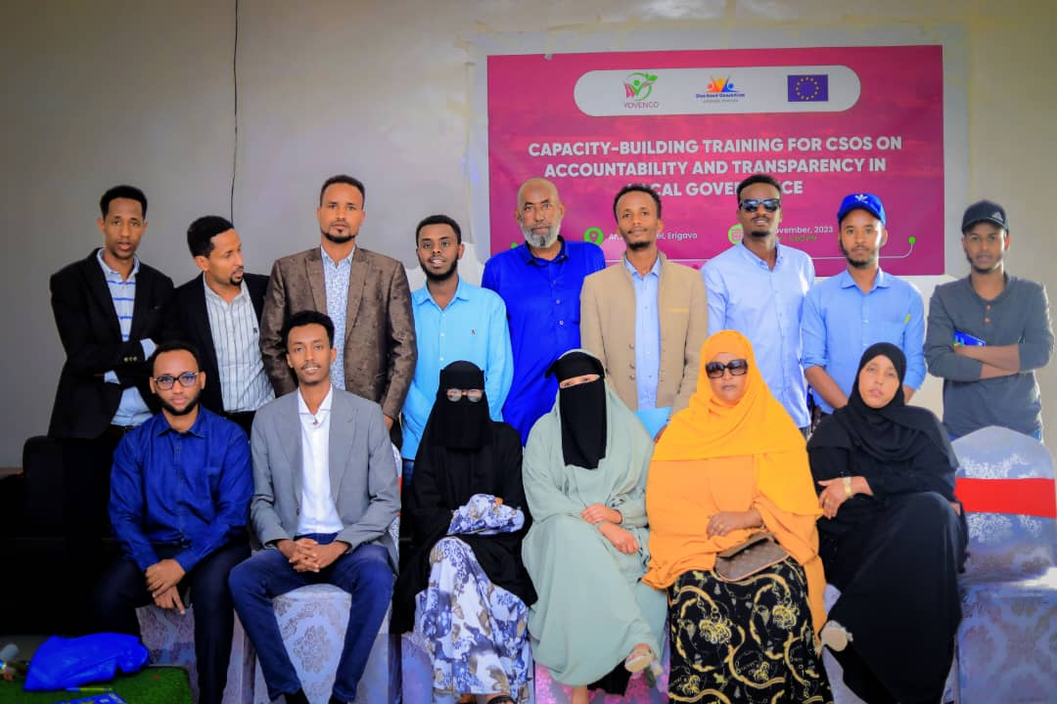
A 1.1 Activity Description: 3 CSOs Capacity-Building Training Sessions of Accountability & Transparency in The Local Government (YOVENCO)
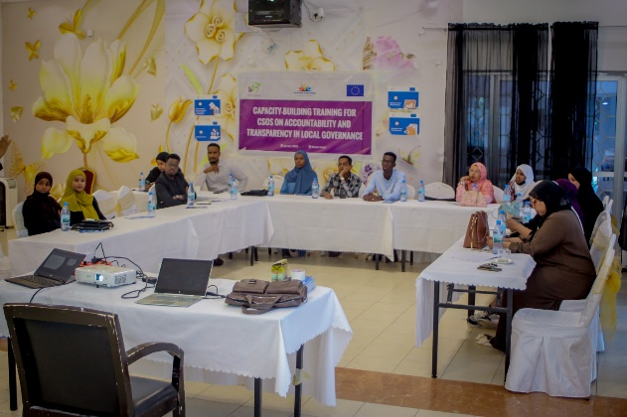
Figure 2 CBT Session in Erigavo
Figure 1 CBT Session in Hargeisa
Introduction:
Civil society organizations (CSOs) play a crucial role in promoting good governance and accountability at the local level. In Somaliland, their contributions to development are particularly significant, given the decentralized nature of the government and the importance of community engagement. However, CSOs perceive a lack of access to information of the government about public planning and programming. Civil society development in Somaliland is also hindered by the non-conducive environment and by civil society's low capacity, where CSOs fundamentally lack strategic planning and other capacities. Towards addressing these concerns and empowering CSOs in their vital role, a series of capacity-building trainings were conducted in Hargeisa, Buro'a, and Erigavo on Accountability and transparency in Local Government.
Participants engaged in a discussion on concepts of local governance, accountability, and transparency. The goal was to elevate the awareness and understanding of CSOs, ensuring they were well-versed in the principles and practices that underpin effective community development.
A pivotal aspect of the training initiative focused on elevating the skills and competencies of CSOs. The program touched upon various aspects such as advocacy, communication, networking, monitoring, and evaluation, providing participants with a robust toolkit for active participation in local governance and accountability processes.
Recognizing the practical needs of CSOs, the training equipped participants with significant tools and resources. This strategic provision aimed to support their active engagement in local governance and accountability processes, translating theoretical knowledge into actionable strategies.
The capacity-building training and the subsequent workshops were facilitated by an expert consultant of governance who has been involved in the sphere of governance for the past 10 years, with extensive hands-on experience on the topics in discussion.
Methodology & Participation Overview:
The impact of the training was seen through the active participation of representatives from highly engaged organizations in each region. Thirty individuals, representing approximately 15 diverse organizations, congregated to partake in these transformative sessions. This collective effort aimed not only to enhance individual capacities but also to foster a collaborative network that could catalyze cooperative culture between the stakeholders of development at the local level.
Key Training Content:
The training program covered a wide range of topics relevant to effective CSO engagement in local governance. These included:
- Principles of good governance: Transparency, accountability, participation, and rule of law.
- Decentralization and local government structure in Somaliland: Understanding the division of power and responsibilities between different levels of government.
- Laws governing local government: Knowledge of relevant legal frameworks and regulations.
- Relationship between central and local government: Comprehending the role of regional councils in bridging the gap.
- Role of village councils: Recognizing the importance of grassroots engagement in local decision-making.
- Communication flow between local government and citizens: Fostering open and transparent communication channels.
- Financial management functions of district councils: Understanding how local governments manage their budgets.
- Responsibility matrix: Identifying key actors and their roles in holding local governments accountable.
Activity Achievement & Results
Equipping CSOs with the necessary knowledge, skills, and resources, these capacity-building initiatives serve as stepping stones to a more robust and inclusive local governance system in Somaliland. Empowered CSOs can effectively advocate for the needs of their communities, hold local authorities accountable, and contribute to the development and implementation of policies that reflect the aspirations of the people. This ultimately leads to stronger communities, improved service delivery, and a more transparent and accountable local government.
Capacity-Building as a refresher:
The capacity-building training for CSOs was a pivotal pre-refresher to subsequent workshops on local development plans and budgets. The local government planning and budget professionals joining forces with the CSOs in the subsequent workshops created a harmonious platform for collaborative discourse.
Disseminating knowledge through Discussion:
The capacity-building training provided key insightful knowledge on local government, facilitating a conversational approach in introducing the principles of good governance, decentralization, and the local government structure in Somaliland. Exploring pertinent laws governing local government operations provided a solid foundation for the subsequent workshops.
Empowering Oversight:
The dissemination of knowledge extended to a Responsibility Matrix, outlining the distinct roles and accountabilities of each stakeholder within the local governance framework. Armed with this comprehensive understanding, organizations emerged not only as advocates for change but also as vigilant watchdogs, ready to enforce accountability and provide oversight on local governments.
Cohesive Collaboration:
The subsequent workshops on local development plans and budgets facilitated an exchange of information and insights on the accountability and transparency between CSO participants. This has fostered understanding of the setbacks before ensuring effective, responsive, transparent and accountable local authorities. By bridging the knowledge gap and cultivating a shared vision, the CSOs embraced a collaborative culture where key stakeholders are needed to be included in the process.
Achievements
- Participants demonstrated an improvement in their understanding of local governance concepts, principles, and practices. This was evident in their active participation in discussions, and insightful questions.
- Participants gained practical skills in advocacy, communication, networking, monitoring, and evaluation through the training, questions raised, and discussion on relevant issues at hand.
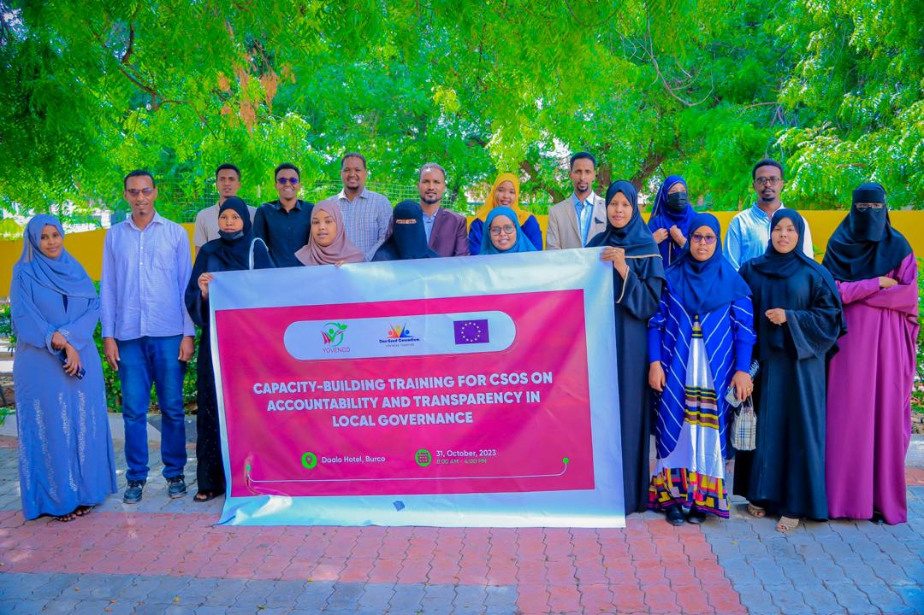
- These skills were further honed during the subsequent workshops on local development plans and budgets, where participants actively engaged with local authorities and community members.
- The provided tools and resources, such as responsibility matrix and communication flow diagrams, were readily adopted by participants and could be integrated into their work.
- These tools distributed have the potential to improve communication and collaboration between CSOs, local government officials, and community members.
- Participants reported feeling more confident and equipped to engage with local authorities on a meaningful level and hold them accountable for their actions.
Conclusion
The success of these trainings underscores the importance of ongoing capacity building for CSOs in Somaliland. By providing them with the necessary support, we can empower them to play their vital role in promoting good governance, accountability, and sustainable development at the local level.
Activity 1 related to Output 1.2
A 1.2.2 community consultations on the importance of accountability in local government in Hargeisa and Berbera (YOVENCO)
Introduction
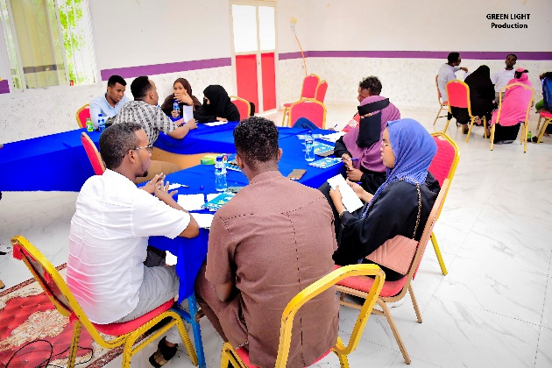
Social accountability is an integral pillar of democratic institutions as it ensures meaningful engagement of citizens in the delivery of services to the communities. It garners valuable insights as to the priorities that the community thinks to be fulfilled, the resources and the way they are allocated, and whether the resources have been exhausted in a manner in which the community’s satisfaction is achieved.
Figure 2 Group Discussion in Berbera

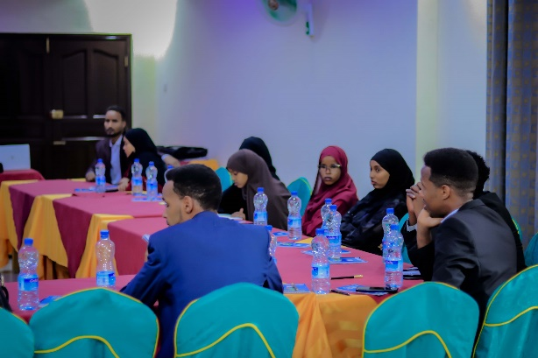
In an effort to spark accountability driven by the community in the services of local government, YOVENCO organization, in close partnership with the European Union, has organized two community consultations on the importance of accountability in local government in Hargeisa and Berbera, on the 16th and 18th of March, respectively. Participants of the consultation were drawn from community-based organizations in Hargeisa and Berbera, which have a keen interest in the work of local governments and how they could be made an oversight to.
Figure 3 Some of the participants of the consultation in Hargeisa
The consultations aimed to foster community-based accountability in the services of local governments, raise awareness among community members about the importance of accountability in local government, gather community feedback and insights on their expectations of accountability in local government, identify challenges that hinder accountability in local government, and explore potential solutions to improve accountability in local government.
The consultations were instrumental in unfolding the areas in which community-based accountability is lagging behind in the work of local governments in Hargeisa and Berbera. They were equally crucial in sparking the thinking of the community into the state of accountability in local governments and how it could be facilitated to bring about local government services which are accountable to the community.
During the sessions, a presentation on social accountability and its significance was presented in both consultations. The presentation provided insights about the importance of social accountability, its benefits and impacts, key examples of social accountability mechanisms employed by different countries in the world, the role of civil society groups in drawing support for community-based accountability, and more.
Finally, the participants of the consultation engaged in discussion on the current state of accountability systems in local governments, and whether their local governments have the needed mechanisms of social accountability in place so that the communities are involved in the process of service delivery. The discussions explored challenges, shortcomings, and recommendations going forward to bring about accountability mechanisms built-in for the community.
Presentation
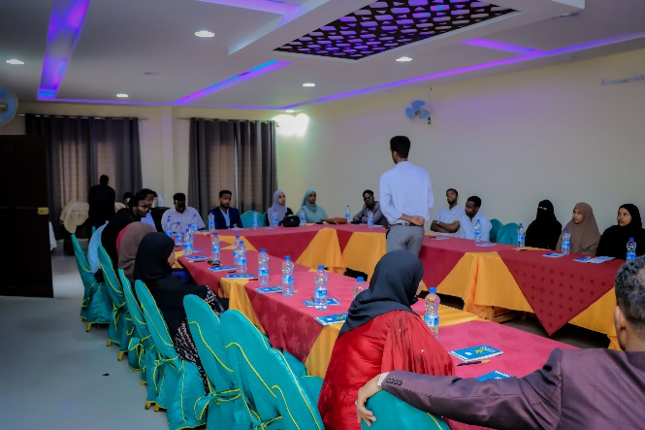
Figure 4 Presentation ongoing in Hargeisa
A presentation on social accountability and its significance was presented in both consultations. The presentation provided insights about the importance of social accountability, its benefits and impacts, key examples of social accountability mechanisms employed by different countries in the world, the role of civil society groups in drawing support for community-based accountability, and more.

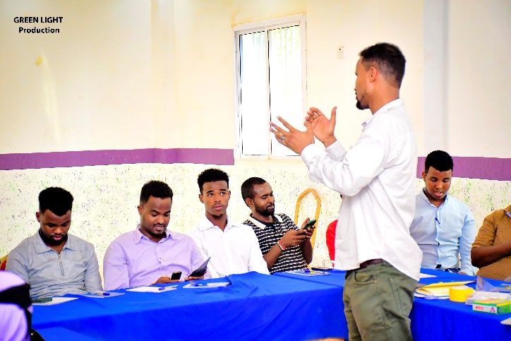
The presentation served as a ground-breaking to spark the discussion, signal the importance of social accountability in local government, and link the real practical examples of other countries in the region and beyond which have employed community-based accountability mechanisms to improve the services from public institutions to their respective communities.
The presentation was curated in a way that is engaging, igniting discussion, and shedding the light on the areas of utmost concern in relation to social accountability in local governments.
Figure 5 Presentation ongoing in Berbera
The presentation also highlighted the areas where accountability should be onboarded.
Results & Lessons learnt
Challenges
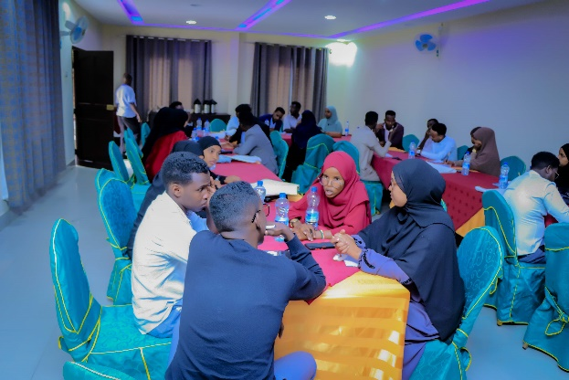
There are several challenges to achieving social accountability in the work of local governments in Hargeisa and Berbera that arose from the discussions. Some of these challenges include:
Figure 6 Group Discussion ongoing in Hargeisa
- Weak institutional and legal frameworks: Local governments in Hargeisa and Berbera often operate in environments with weak institutional and legal frameworks, which can hinder their ability to effectively carry out their duties and be held accountable to their constituents.
- Limited resource allocation for accountability actions: Local governments in Hargeisa and Berbera are resource-constrained when it comes to funding accountability programs, with limited financial and human resources available to carry out community engagement responsibilities. This can make it difficult for them to effectively engage with communities and respond to their needs.
- Limited access to information: Access to information is essential for social accountability, but in Hargeisa and Berbera, there are limited mechanisms for citizens to access information about local government activities and decision-making processes.
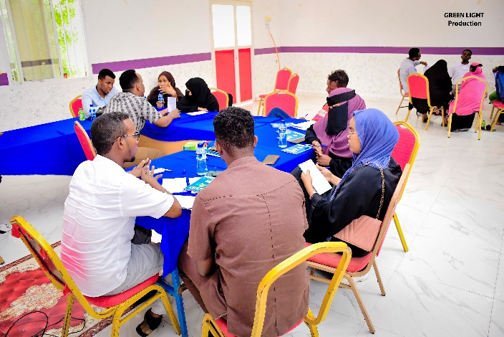
- Low levels of civic engagement: Some of the communities in Hargeisa and Berbera have low levels of civic engagement and limited opportunities to participate in decision-making processes. This can make it difficult for local governments to effectively engage with communities and respond to their needs.
Figure 7 Group Discussion ongoing in Berbera
- Traditional power structures: Traditional power structures are not set in a way that incorporates inputs from the community and can influence local government decision-making processes and limit the ability of citizens to hold their leaders accountable.
- Limited capacity and skills: The workforce in the local governments in Hargeisa and Berbera lack the necessary skills and capacity to effectively inform their duties and respond with insights and feedback from the community. This can be due to a lack of training and professional development opportunities, as well as limited access to resources and technical expertise.
- Weak civil society organizations: Civil society organizations play an important role in promoting social accountability by providing a voice for citizens and holding governments accountable. However, in Hargeisa and Berbera, civil society organizations are of the capacity enough to perform their duties without restrictions, making it difficult for them to effectively engage with local governments and promote accountability.
- Limited trust and cooperation: Building trust and cooperation between local governments and communities is essential for promoting social accountability. However, there is a history of mistrust and conflict between local governments and communities, making it difficult to build the necessary relationships and partnerships.
- Limited access to justice: Access to justice is a key element of social accountability, as citizens need to be able to hold their governments accountable through legal means. However, there is limited access to justice, due to a lack of legal infrastructure, corruption, and other factors.
Recommendations
Based on the challenges identified above, here are some recommendations for promoting social accountability in the work of local governments in Hargeisa and Berbera that arose from the discussions:
- Strengthen institutional and legal frameworks: local governments should prioritize efforts to strengthen institutional and legal frameworks to ensure that local governments have the necessary authority and resources to carry out their duties effectively and be held accountable to their constituents. This can include enacting legislation that promotes transparency and accountability, as well as investing in capacity-building for local government officials.
- Increase resources for accountability in the local governments: local governments should work to increase resources for accountability programs in Hargeisa and Berbera, including financial and human resources, to enable them to effectively engage with communities and respond to their needs.
- Improve access to information: Local governments and civil society organizations should work to improve access to information for citizens in Hargeisa and Berbera, including through the use of technology and other innovative approaches. This can help to promote transparency and accountability and enable citizens to hold their governments accountable.
- Foster civic engagement: Local governments and civil society organizations should work to foster greater civic engagement in the communities, including by creating opportunities for citizens to participate in decision-making processes and providing education and training on citizenship and civic responsibility.
- Address traditional power structures: Efforts should be made to address traditional power structures in the communities including changing the autocratic behaviors that may limit the ability of citizens to hold their governments accountable. This can include promoting gender equality and empowering marginalized groups to participate in decision-making processes.
- Increase capacity and skills: Local governments should invest in capacity-building for local government officials in Hargeisa and Berbera, including providing training and professional development opportunities to improve their skills and capacity to effectively carry out their duties.
- Strengthen civil society organizations: Efforts should be made to strengthen civil society organizations in the communities, including by providing financial and technical support to enable them to effectively engage with local governments and promote social accountability on behalf of communities.
- Build trust and cooperation: Efforts should be made to build trust and cooperation between local governments and communities locally, including by promoting dialogue and partnerships between them and addressing existing grievances.
- Improve access to justice: Local governments should work to improve access to justice by local communities, including by investing in legal infrastructure and providing support to enable citizens to hold their governments accountable through legal means.

Activity 2 related to Output 1.2
A 1.2.3.1 Strengthening Local Governance through Accountability: An Interactive Meeting on the Role of CSOs and CBOs (YOVENCO)

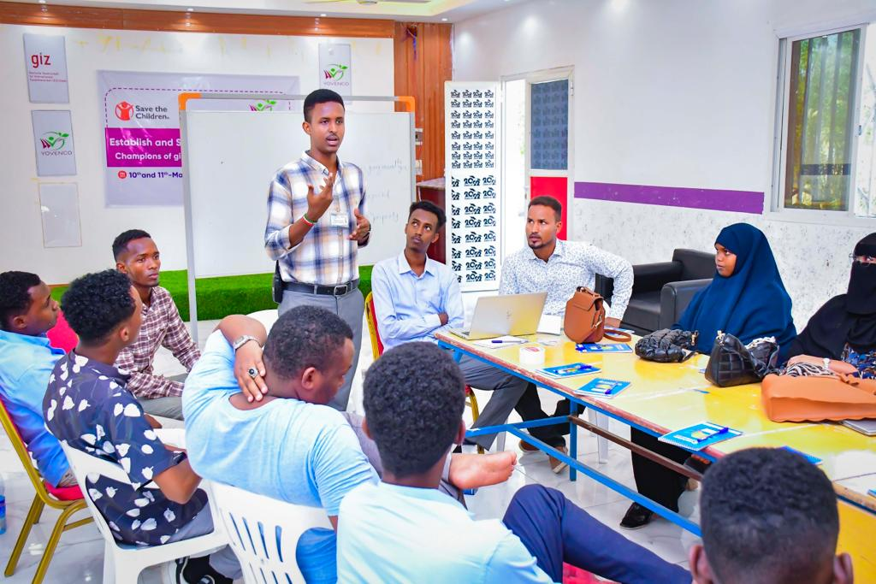
On the 17th of May, 2023, YOVENCO Organization has organized an interactive meeting under the title “Strengthening Local Governance through Accountability: An Interactive Meeting on the Role of CSOs and CBOs”. The meeting brought together community-based CSOs, community committees, community-based youth organizations, community-based women’s organizations, disability-focused organizations, and marginalized groups. The objectives behind the meeting were to bring about discussion on the role of CSOs in promoting and facilitating accountability mechanisms in the work of local governments; explore the challenges and opportunities for CSOs in this area of local governance, and identify areas of potential engagement for CSOs to play a more effective role in promoting and facilitating accountability mechanisms in the work of local governments.
Figure 8 Director of Planning at Berbera Municipality attending Interactive Meeting in Berbera
In delivering the intended results, the facilitator of the meeting has demonstrated a presentation explaining the important role of CSOs and CBOs in local governance in order to spike the participants thinking into discussing how CSOs and CBOs can promote and facilitate accountability in local government’s work. The presentation has covered wide topics and has provided clear-cut examples of initiatives that have made a significant impact on the same trend globally.
Upon the quick presentation by the facilitator, the participants of the meeting engaged in a discussion around sharing their experiences of working with CSOs on fostering accountability mechanisms and discussing the challenges and opportunities that they have faced. Similarly, the discussion unveiled the areas of potential CSOs and CBOs engagement with local governments.
Finally, the meeting participants have all noted the significance of CSOs and local governments working together for enhanced service delivery, improved accountability, and extended cooperation between civil society and the public institutions such as local authorities.
Lessons Learnt
Challenges before effective accountability in local governance focusing on the role of CSOs and CBOs:

- Inadequate resources: CSOs and CBOs often lack the resources they need to effectively promote accountability. This can include funding, staff, and training.
- Lack of political will: Local governments are not willing to be held accountable to CSOs and CBOs. This can be due to a number of factors, such as corruption, a lack of transparency, or a desire to maintain control.
- Retention of Information: Local governments retain information about their activities, making monitoring their performance difficult for CSOs and CBOs.
- Shrinking trust between local government and CSOs: Local authorities seem not to trust CSOs and CBOs, making it difficult for them to contribute to the work of local governments and enforce accountability in their work.
- Limited know-how: Limited knowledge about how to monitor government performance, advocate for change, or build capacity serves as a challenge before the work of CSOs and CBOs in ensuring accountability in the work of local governments.
- Culture of impunity: There is a culture of impunity, which means that those in power are not held accountable for their actions. This can make it difficult for CSOs to hold the government accountable.
- Limited public awareness: There is a limited sort of public awareness about the importance of accountability. This can make it difficult for CSOs to build public support for their work on accountability.
Opportunities that CSOs have to promote and facilitate accountability mechanisms:

- The growing strength of civil society: In recent years, there has been a growing strength of civil society in Somaliland. This means that there are more CSOs working on accountability issues and on a large extent that of governance, and that these CSOs are becoming more effective.
- The increasing availability of information: The internet and other communication technologies have made it easier for CSOs to access and share information about government activities. This can help CSOs to hold the government accountable.
- The growing demand for accountability: There is a growing demand for accountability among citizens in Somaliland. This means that CSOs have a growing audience for their work on accountability.
- The increasing support from donors: Donors are increasingly interested in supporting CSOs that are working on accountability issues. This can provide CSOs with the resources they need to be more effective.
- The growing number of partnerships: There are a growing number of partnerships between CSOs, local governments, and other stakeholders. These partnerships can help to strengthen the capacity of CSOs to promote and facilitate accountability mechanisms. The ALGASSL and LGI serve as important hubs for this partnership-building.
- The development of new accountability tools: There are a number of new accountability tools being developed that can help CSOs to hold the government accountable. These tools include citizen report cards, social audits, and participatory budgeting.
Recommendations

- Increased resources for CSOs and CBOs: This could include funding from donors, governments, or foundations. It could also include training and technical assistance.
- Greater political will from local governments: This could be achieved through dialogue and negotiation between CSOs and local governments. It could also involve public pressure on local governments to be more accountable.
- Improved access to information: This could be achieved through freedom of information laws or other measures that make it easier for CSOs to access information about government activities.
- Enhanced trust between local governments and CSOs: This could be achieved through dialogue, cooperation, and joint projects. It could also involve building relationships between CSOs and local government officials.
- Increased knowledge and skills of CSOs and CBOs: This could be achieved through training and capacity-building programs. It could also involve sharing knowledge and experiences between CSOs and CBOs.
- Breaking the culture of impunity: This could be achieved through legal reforms, prosecutions, and other measures that hold those in power accountable for their actions.
- Raising public awareness: This could be achieved through education and awareness campaigns. It could also involve involving the media in promoting accountability.
Activity 3 related to output 1.2
A 1.2.3.2: Strengthening Local Governance through CSOs-Local Government Cooperation (YOVENCO)

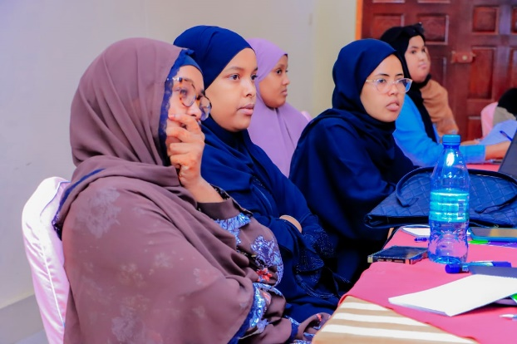
On the 17th of May, 2023, YOVENCO Organization has organized an interactive meeting under the title “Strengthening Local Governance through CSOs-Local Government Cooperation”. The meeting brought together community-based CSOs, community committees, community-based youth organizations, community-based women’s organizations, disability-focused organizations, and marginalized groups. The objectives behind the meeting were to discuss the significance of local community partnerships with the work of local government; explore the challenges before community-based partnerships with the local government and opportunities for strengthening the CSOs’ involvement in local governance; identify areas of potential engagement for CSOs to play a more effective role in the work of local government.
Figure 9 Attendees of the Interactive Meeting in Hargeisa
In delivering the intended results, the facilitator of the meeting employed a conversational approach where participants were given the opportunity to share as much information as possible with a set of guiding questions. This has enabled the participants of the meeting to engage in a discussion around building effective community-based partnerships for improving the work of the local governments, discussing the benefits of such partnerships, such as improved communication and coordination between CSOs and local governments, ensuring increased citizen participation in local decision-making, and more effective delivery of public services. Also, the participants discussed the challenges that CSOs and local governments face in working together, such as lack of trust, different priorities, and limited resources as well as discussing opportunities for strengthening CSOs' involvement in local governance, such as providing training and capacity-building, improving access to funding, and creating more opportunities for CSOs to participate in decision-making.
Finally, the meeting participants shed light on the areas of potential engagement for CSOs to play a more effective role in the work of local government by discussing the different areas where CSOs can contribute to local governance, such as service delivery, advocacy, and monitoring and evaluation. By identifying specific projects or initiatives where CSOs could partner with local governments, a greater deal of cooperation between local governments and CSOs could be registered.
Lessons Learnt
Community-based committees (CBCs) that work with local governments face a number of challenges, including:

- Limited funding support: CBCs are often underfunded, which can make it difficult for them to carry out their work. They have to rely on volunteers, which can limit their capacity to get things done. Members of the committees are largely underfunded with allowances only being given to senior leadership.
- Limited resources: CBCs also lack access to resources to move around. This can make it difficult for them to communicate with community members, gather data, and develop and inform projects’ planning in a meaningful manner.
- Limited capacity: CBCs lack the capacity to carry out their work effectively. This is due to a lack of training, experience, or knowledge.
- Absence of Regular capacity-building support from local government: CBCs receive limited capacity support they need from the local government. This may be due to a lack of understanding of the role of CBCs by the local authorities, or a lack of political will to support them.
- Limited trust from community members: CBCs are not fully trusted by community members. This may be due to a history of corruption or mismanagement, a lack of transparency and accountability, or a failure to represent the community satisfactorily.
Recommendations

- Local governments could create a dedicated unit or office to facilitate CSO-local government partnerships.
- CSOs could develop training programs and resources to help their members build capacity to work with local governments.
- Local governments could provide funding to CSOs to support their work on local governance issues.
- CSOs and local governments could create joint task forces or working groups to address specific issues.
- CSOs and local governments could regularly exchange information and share best practices.
- Increase funding support: CBCs need more funding to be able to carry out their work effectively. This funding could come from the government, donors, or other sources.
- Provide access to resources: CBCs need access to resources, such as transportation, office space, and equipment. This would help them to communicate with community members, gather data, and develop and inform projects’ planning.
- Provide capacity-building support: CBCs need training and support to build their capacity to carry out their work effectively. This could be provided by the government, donors, or other organizations.
- Increase cooperation with local government: CBCs need to work more closely with local governments to get the support they need. This could involve developing joint plans, sharing resources, and coordinating activities.
- Build trust with community members: CBCs need to build trust with community members by being transparent and accountable, and by representing the community's interests effectively. This could involve holding regular meetings, listening to community feedback, and reporting on their work.
- Increase funding support: CBCs need more funding to be able to carry out their work effectively. This funding could come from the government, donors, or other sources.
- Provide access to resources: CBCs need access to resources, such as transportation, office space, and equipment. This would help them to communicate with community members, gather data, and develop and inform projects’ planning.
- Provide capacity-building support: CBCs need training and support to build their capacity to carry out their work effectively. This could be provided by the government, donors, or other organizations.
- Increase cooperation with local government: CBCs need to work more closely with local governments to get the support they need. This could involve developing joint plans, sharing resources, and coordinating activities.
- Build trust with community members: CBCs need to build trust with community members by being transparent and accountable, and by representing the community's interests effectively. This could involve holding regular meetings, listening to community feedback, and reporting on their work.

Activity 4 related to Output 1.2
A 1.2.4 Activity Description: Founding Meeting of Somaliland CSOs Accountability Network (SCAN) (YOVENCO)

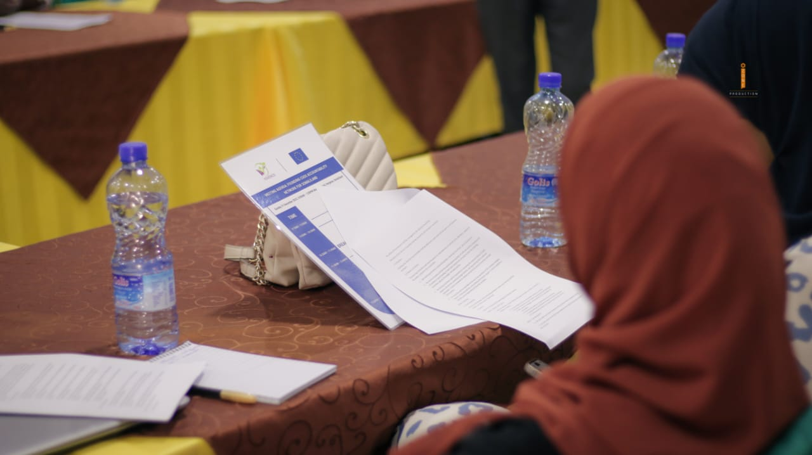
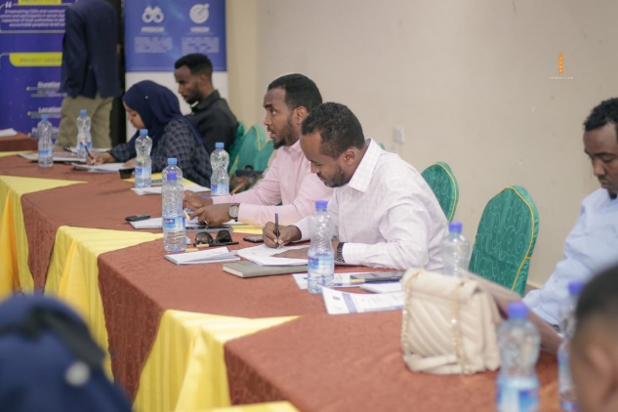
The underlying principle of this initiative rests on the belief that an empowered civil society plays a pivotal role in holding local authorities accountable, fostering people-centered policies and actions, and facilitating open communication channels between the community and local authorities. The action's core strategy involves building the capacities of Civil Society Organizations (CSOs) to support the formation of a CSO Accountability Network/Taskforce. The emphasis is placed on prioritizing CSOs/CBOs with enhanced capacities to lead efforts in promoting accountability and people-centered public service delivery through community participation.
In alignment with the project’s planned interventions, the CSOs Accountability Network Formation Meeting convened on December 31, 2023, at Maansoor Hotel, Hargeisa, representing a significant milestone in Somaliland's civil society landscape. Representatives from diverse civil society organizations (CSOs) across all regions gathered to establish the pioneering CSOs Accountability Network (SCAN). Attendees were meticulously chosen based on regional representation, with a conscious effort to incorporate gender and minority groups.
The following were among the selected founding member organizations listed in the below table, with each having valid registration certificates, and active presence in their respective regions;

 | S/N |  | Organization | Geographical Representation
 |  |  | Adam Academy | Marodijeh
 |  |  | Somaliland Y-Peer | Marodijeh
 |  |  | Moonlight | Awdal
 |  |  | YODEV | Sahil
 |  |  | SCA | Sool (Ainabo)
 |  |  | SWRC | Maroodijeh
 |  |  | SNDF | National
 |  |  | SWCDO | Sool (Ainabo)
 |  |  | HANSOOR | Sanaag
 |  |  | HRDO | Sanaag
 |  |  | SOYVO | Togdheer
 |  |  | SAYS | Awdal
 |  |  | TAAKULO | Togdheer
 |  |  | SOYDAVO | Togdheer
 |  |  | YOVENCO | Sahil

2.1 Results & Activities
2.1.1 Strategic Framework and Objectives:
The meeting aimed to achieve two primary objectives. Firstly, to inaugurate a Functional CSOs Accountability Taskforce and secondly, to foster deliberation and consensus-building on the Taskforce's mandate, structure, and operational procedures. Members engaged in comprehensive discussions regarding the network's name, logo, constitution, scope of work, mandate, and operational jurisdiction. A unanimous decision led to the establishment of the "Somaliland CSOs Accountability Network (SCAN)."
SCAN's overarching purposes were delineated to strengthen the collaborative capacity of CSOs in monitoring, advocating for, and holding local authorities accountable in development projects. The network also aspires to promote open dialogue between CSOs and local authorities, encourage public participation in decision-making processes, share best practices, advocate for policy reforms, and empower citizens in local governance.
SCAN's operational strategy was defined, emphasizing its role as a unifying force for CSOs, devoid of direct implementation which have shrunk the capacity of Somaliland’s CSOs and contributed to existing CSOs networks functioning as Super NGOs. The network is set to consolidate reports, devise advocacy plans, and amplify CSOs' voices both national, and local levels through active contributions from its standing members. The ensuing formation of a "Transitional Steering Committee" will streamline the process of drafting relevant policies, and finalizing the constitution, and a structured and efficient organizational framework is well established.
2.1.1.2 Result Chain
- Unity in Purpose: Forging a Transformative Network:
The meeting's objectives were clear: to establish a functional Network, foster consensus on SCAN's structure and operational procedures, and actively engage members in shaping its future. The diverse group of participants, carefully selected to ensure regional representation, gender balance, and inclusion of minority groups, demonstrated a palpable sense of unity and purpose.
- Amplifying Impact: SCAN's Overarching Objectives:
Members envisioned SCAN not as an implementing agency, but as a catalyst for collective action through member implementation. By pooling resources and expertise, SCAN would amplify the voices of individual CSOs, providing a platform for advocacy, collaboration, and holding local authorities accountable. This collaborative approach resonated deeply, leading to the adoption of the "Somaliland CSOs Accountability Network (SCAN)" as the official name.
- Building Foundations: Core Principles and Objectives of SCAN:
The meeting delved into the core principles and scope of SCAN's work. Members agreed on a comprehensive set of objectives, including:
- Strengthening CSO capacity for collaborative advocacy and local authority oversight.
- Fostering open dialogue and public participation in local decision-making.
- Promoting best practices in CSO-authority collaboration for improved accountability.
- Advocating for transparency and good governance reforms at all levels.
- Monitoring local authority performance and citizen engagement.
- Empowering citizens to hold local authorities accountable.
- Turning Vision into Action: SCAN's Operational Strategy:
To achieve these ambitious goals, SCAN will implement a range of activities through its member organizations, including:
- Training programs on accountability mechanisms and tools for CSOs.
- Research and advocacy on local governance and development issues.
- Public awareness campaigns on CSO participation and accountability.
- Monitoring and reporting on local authority performance.
- Facilitating dialogue and collaboration between CSOs and authorities.
- Providing technical assistance to both authorities and CSOs.
- Structural Enhancements: Proposed Constitution Additions:
  - Number of Members and Membership Criteria: Participants proposed specifying the number of SCAN members and outlined criteria for membership in the constitution, ensuring transparency and accountability in the selection process.
  - Steering Committees: The constitution will define the number of steering committees and their meeting frequency, ensuring efficient governance and decision-making processes.
  - Resource Mobilization: SCAN's constitution will incorporate strategies for resource mobilization, providing a sustainable foundation for the implementation of programs and activities.
  - Committee Formation: The establishment of a special committee from each region, including organizations such as YOVENCO, SOYDAVO, SAYS, HANSOOR, SWRC, SCA, SOYVO, YODEV, and SNDF, signifies a concerted effort to organize the selection process for the Steering Committees.
2.1.3 Next Steps:

- Virtual Meeting - February 2024: A virtual meeting is scheduled for February 2024 to discuss SCAN's progress and updates, fostering ongoing collaboration among member organizations. This virtual engagement ensures continuous communication and coordination.
- Physical Meeting March 2024: A physical meeting on March, 2024, will further advance discussions on SCAN's policies, finalize the constitution, and select steering committees and a lead person. This meeting represents a crucial step in the establishment and consolidation of SCAN's structure.
Conclusion:
In conclusion, the CSOs Accountability Network Formation Meeting has set the stage for Somaliland's civil society to play a vital role in promoting accountability, collaboration, and good governance. The outlined action plans, results, and inclusivity measures provide a comprehensive framework for SCAN's future endeavors, ensuring transparency, unity, and sustained impact in the region. As the network moves forward, it holds the promise of transforming the local governance landscape through the active participation of empowered CSOs and citizens.

Activity 5 related to Output 1.2
A 1.2.5 Activity Description: Development of Digital Accountability Platform (YOVENCO)
Introduction
Local governance in Somaliland often faces challenges with transparency, accountability, and citizen engagement. A key initiative within this project is the design and development of a user-friendly, secure, and interactive digital platform aimed at enhancing communication, collaboration, and accountability within Somaliland's local governance landscape. Aligning with the project's objective of empowering CSOs as independent actors in promoting transparency and inclusivity, the platform promises to revolutionize citizen engagement and foster informed decision-making processes.
The comprehensive digital platform is designed to serve as a central hub for information exchange, collaboration, and feedback between diverse stakeholders: Local Authorities, District Development Forums (DDFs), Civil Society Accountability Network (SCAN)- also established by this project- CSOs, media, and citizens.
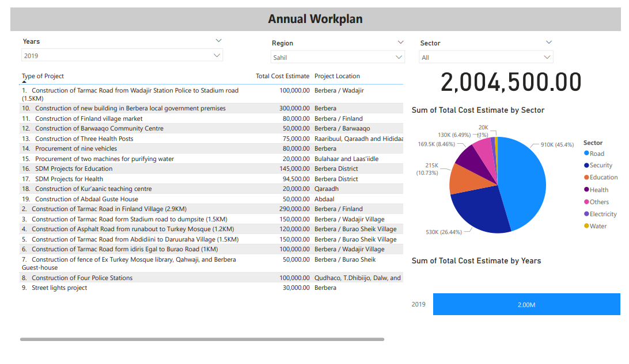

Platform Features and Functionalities
The platform boasts a diverse range of features catering to the needs of each user group:
- Web Portal: Providing secure access for all stakeholders through a user-friendly interface.
- Performance Dashboard: Visualizing key indicators, statistics, and progress graphs related to DDFs and SCAN objectives, activities, and outcomes. This data transparency empowers citizens to hold stakeholders accountable.
- Document Repository: Securely storing and organizing minutes of meetings, action plans, budgets, financial statements, audit reports, monitoring reports, evaluation reports, and other crucial documents, ensuring easy access for informed decision-making.
- Feedback Mechanism: Enabling users to submit comments, suggestions, complaints, and grievances directly to relevant stakeholders, fostering two-way communication and responsiveness.
- Notification System: Keeping users informed about new updates, events, announcements, and opportunities related to DDFs and SCAN activities, promoting active participation and engagement.
- Social Media Integration: Facilitating information and content sharing across various social media platforms (Facebook, Twitter, Instagram) to broaden outreach and citizen engagement.

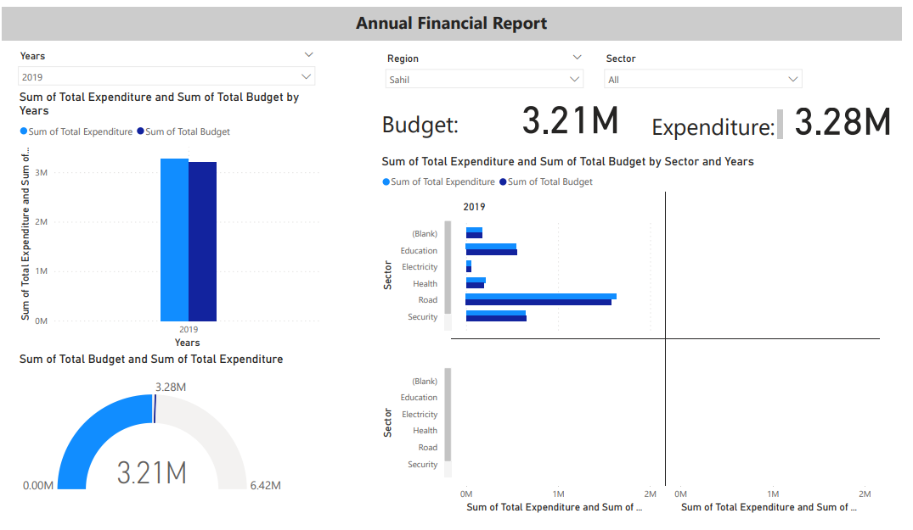

Development Process
The platform development followed a meticulous approach:
- Needs Assessment: Comprehensive consultations with DDFs, SCAN, and relevant stakeholders identified their specific needs and expectations, ensuring the platform addresses their challenges and aspirations.
- Platform Design: A user-friendly interface and intuitive structure were created, prioritizing ease of navigation and accessibility for diverse user groups with varying levels of technical proficiency.
- Content Development: Initial content, including user guides, frequently asked questions, and introductory information, was prepared to facilitate smooth platform adoption and understanding.
- Pilot Testing and Refinement: Representative users from each stakeholder group participated in usability testing, providing valuable feedback for platform improvement and ensuring optimal user experience.
- Training and Capacity Building: Comprehensive training materials and plans are being developed to equip DDFs, SCAN, and local government officials with the necessary skills and knowledge to effectively utilize the platform for communication, collaboration, and accountability purposes. (Training to be conducted prior to launch)
Upcoming Deployment and Next Steps
The platform is currently undergoing final testing and refinement, with a planned deployment in late January or early February.
The current progress of the platform can be checked at https://slmuniciplitydashboard.org/ user: talasan@talasan.onmicrosoft.com password: Somaliland1!
Following the launch, the project will focus on:
- Comprehensive training and capacity building: Equipping stakeholders with the necessary skills and knowledge to effectively utilize the platform for communication, collaboration, and accountability purposes.
- Content population and regular updates: Continuously uploading relevant local government information, DDF and SCAN documentation, and other resources to keep the platform current and informative.
- Active monitoring and evaluation: Regularly assessing the platform's effectiveness, user engagement, and impact on local governance processes to ensure its ongoing value and identify areas for improvement.
https://slmuniciplitydashboard.org/

Conclusion
The development of the digital platform marks a significant step towards empowering Somaliland CSOs as independent actors promoting transparency, accountability, and inclusivity in local governance. The upcoming deployment and subsequent training, content updates, and monitoring efforts will ensure the platform's successful implementation and maximize its positive impact on local decision-making processes in Somaliland.

Activity 1 in relation to Output 1.3
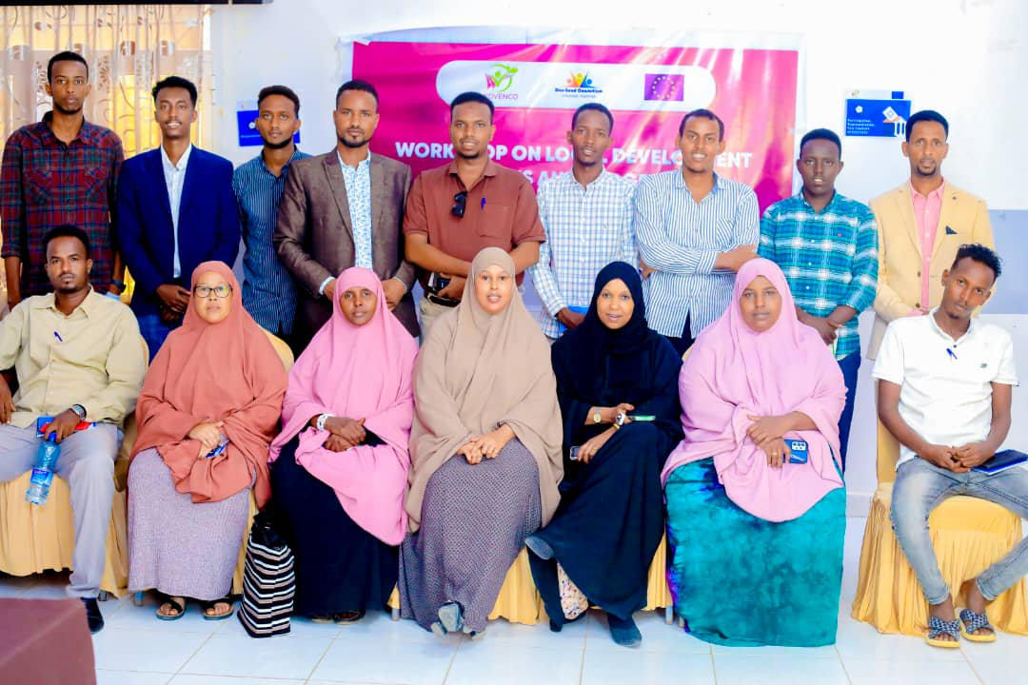
A 1.3.2 Activity Description: 4 Workshops on Local Development Plans & Budgets (YOVENCO)
Figure 10 Workshop Session in Berbera
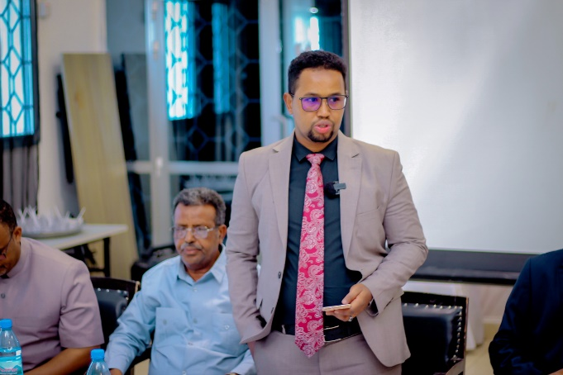
Figure 11 Deputy Mayor of Hargeisa officially opening the Hargeisa Workshop
This comprehensive report summarizes a capacity-building workshop under a project focused on enhancing local governance in Somaliland by actively involving Civil Society Organizations (CSOs) in public decision-making processes and fostering social accountability. In alignment with the project’s goal to bridge the gap on CSOs perceived lack of access to information of the government about public planning and programming as well as about external funding and projects, and potential hinderance by the non-conducive environment and by civil society's low capacity; a series of workshops were conducted, in collaboration with the Department of Planning and Budget of local governments in Hargeisa, Berbera, Buro'a, and Erigavo, aiming to build the capacities of CSOs along with local authorities in targeted needs including, the Public Expenditure Management Cycle and District Development Forums. The series of workshops were opened by the respective local government leadership in the target locations, such the mayor or its deputy. The primary focus areas were to strengthen the understanding of the local development actors on local development planning, budgeting processes, and tools for promoting accountability and transparency.
The specific objectives of the training were to enhance the understanding of CSOs and local government planning staff regarding the local development planning and budgeting processes, introduce tools and methods for their effective implementation, and identify best practices and challenges related to participatory local governance.
Methodology:
The training program was designed, with a greater focus on the Public Expenditure Management (PEM) cycle and the preparation of the District Development Framework (DDF). The content was catagorized into key components:
- Public Expenditure Management Cycle:
  - Conceptual understanding of PEM and its steps.
  - Identification of the DDF as the main output of Step 1: Planning.
  - Activities and tasks in DDF preparation, including timelines and responsibilities.
  - Principles guiding the preparation of the DDF.
- District Development Framework (DDF):
  - Reinforcement of the DDF as a pivotal output of the Planning phase.
  - Detailed overview of activities and tasks in DDF preparation.
  - Specific timelines and responsibilities associated with different stages of DDF preparation.
  - Application of principles in the practical preparation of the DDF.
Key Focus Areas:
- Conceptual Empowerment:
  - The training highlighted the significant stages of the PEM cycle, providing participants with a critical foundation.
  - This boost of understanding has improved the abilities of local development actors to confidently make well use of the process and the relevant tools.
- Strategic Focus on DDF Preparation:
  - By highlighting the DDF as a crucial tool to spearhead local development founded with the key principle of participatory process, the training empowered participants with a hands-on experience on the preparation, and establishment of DDFs.
  - The training positioned the participants to clearly explore key activities and principles of the development of DDF documents.
- Practical Application and Skill Development:
  - The trainer showcased several examples in demonstration to the participants to ensure that the objectives of the training are met through fostering discussion and hand-on experience.
  - This approach has given the participants the opportunity to engage with training content more broadly and inquire the trainer on the specifics.
- Strengthening Collaborative Governance:
  - The training has established seeds for closer collaboration between the civil society actors and the local authorities on the shared prospect of local development delivery.
  - Participants fostered understanding on important relationships between stakeholders, culminating an environment of coordinated efforts in planning and budgeting processes.
Activity Achievements & Results
Our program focused on empowering participants with a deep understanding of the Public Expenditure Management (PEM) Cycle, emphasizing its role in participatory community development planning. The training facilitated collaboration between civil society groups (CSOs) and local authorities, fostering informed stakeholders committed to transparency, accountability, and participatory practices.
A key aspect of our strategic training was the emphasis on the District Development Framework (DDF) within the PEM cycle. Participants gained practical insights, enabling them to actively contribute to local development initiatives. By emphasizing specific activities, timelines, and responsibilities associated with DDF preparation, participants acquired a clear sense of purpose and strategic perspective deemed to be effective in the full utilization of acquired skills.
Beyond individual skill enhancement, our training aimed to instill a collaborative mindset among participants. Understanding stakeholder relationships and coordinated efforts in planning and budgeting processes became integral. The impact of this collaborative governance focus extended beyond the training room, influencing day-to-day interactions and enhancing overall effectiveness in local governance initiatives.
The training signified the beginning of an era in which participants are capacitated to better contribute to the ongoing local development activities. The anticipated impact lies in the deepened understanding of the PEM cycle, heightened skills in DDF preparation, and an appreciation for collaborative governance. Participants were prepared to position themselves as catalysts for positive change, actively contributing to sustainable and participatory local development in Somaliland. This outcome reflects not just incremental improvements but a fundamental shift in the capabilities of CSOs and local government departments.
Key Takeaways:
1. Tailored Approach is Crucial:
- Lesson Learned: Recognizing and accommodating diverse participant backgrounds is essential in tailoring the training approach to address varying levels of knowledge and experience.
- Impact on Future Initiatives: Future programs should incorporate pre-assessment mechanisms to better tailor content to participants' specific needs.
2. Strategic Resource Allocation:
- Lesson Learned: Efficient allocation of limited resources is crucial for maximizing the impact of training programs.
- Impact on Future Initiatives: Future planning should involve a careful assessment of available resources to ensure a balance between depth and coverage in training content.
3. Hybrid Training Models:
- Lesson Learned: Acknowledging technological disparities, a hybrid model that combines virtual and in-person sessions may enhance accessibility and engagement.
- Impact on Future Initiatives: Future programs should consider a flexible approach, leveraging both virtual and physical platforms to accommodate varying technological capabilities.
4. Change Management Strategies:
- Lesson Learned: Implementing change management strategies is crucial to address resistance to new tools and methods.
- Impact on Future Initiatives: Future programs should incorporate change management elements, such as communication plans and stakeholder engagement strategies, to facilitate smoother transitions.
5. Post-Training Support and Reinforcement:
- Lesson Learned: Post-training support and reinforcement mechanisms are vital for sustaining the impact beyond the initial sessions.
- Impact on Future Initiatives: Future initiatives should include structured follow-up activities, mentorship programs, or periodic refreshers to ensure continued application of acquired skills.
6. Adaptive Monitoring and Evaluation:
- Lesson Learned: Adopting adaptive monitoring and evaluation strategies allows for real-time adjustments to address emerging challenges.
- Impact on Future Initiatives: Future programs should integrate ongoing evaluation mechanisms to identify challenges promptly and adapt strategies for optimal outcomes.
In conclusion, while challenges were encountered, the key takeaways provide valuable insights to inform the design and implementation of future initiatives. Adaptable and tailored approaches, strategic resource allocation, and ongoing support mechanisms are crucial elements for the success and sustainability of capacity-building efforts in local governance.
Activity 1 in relation to Output 1.4
Activity 1.4 - Support to independent research, evidence-based advocacy, and/or participatory community monitoring of public services at the local level;
The participatory community monitoring (PCM) research study was intended to largely influence Somaliland’s local governance and equip the civil society as actors and drivers of good governance and development in Somaliland. The study was undertaken in a stakeholder participatory and inclusive manner to ensure close consultation and ownership of the action and its outcomes by local communities especially the marginalized community groups, CSOs and local authorities in the Somaliland local governance process aimed at and contributing to strengthening civil society partner’s institutional and operational capacity through a comprehensive approach; enabling and ensuring their participation; and on improving the environment in which they operate.
The study was undertaken, in Berbera, Burao and Hargeisa as the selected locations to provide insight into how communities, local authorities and CSOs undertake PMC and data was collected through Focus Group Discussions (FGDs), and Key Informant Interviews (KIIs), administered to Community Committees, Civil Society Organisations (CSOs), Community-Based Organisations (CBOs), Local Authorities, Development Partners and the National Government through District Representatives. In addition, case studies were employed to complement/validate the information gathered during the FGD and KIIs. The study found that communities in in Somaliland have limited capacity and understanding of participatory community monitoring and what they undertake are just meetings which don’t provide them with the pre-requisite information needed to do this effectively. In addition, local authorities equally lack the capacity and infrastructure to collectively implement and support PCM which is compounded by the lack of technical capacity in areas of transparency and accountability which are the bedrock for PCM. In addition, CSOs which play a pivotal role in the development and stabilization of Somaliland, equally lack the capacity to lead PCM activities although they are working in collaboration with local authorities and act as a bridge between local governments and the citizens. Development partners through the UN Joint Programme on Local Governance (JPLG) seek to improve the way government is run at the city and state levels in order to boost economic development and make communities stronger in the face of conflict, climate disaster and other challenges. The JPLG aims to create a “local government ecosystem” that includes: (a) well-designed laws and systems for public procurement, budgeting, oversight, tax collection and other government functions, (b) well-trained staff with the administrative, financial and other skills needed to implement these laws and systems; and (c) an empowered citizenry that is involved in decision making through regular discussion forums and consultation meetings in both towns and villages.

The study has come up with a raft of recommendations which include these ones among others (i) Support Local Authorities in Somaliland to Participatory Community Monitoring Tools and Mechanisms; (ii) Support Local Authorities in Somaliland to develop policies and legal frameworks that back Participatory Community Monitoring; (iii) Anchor Participatory Community Monitoring into the Local Government Act in Somaliland; (iv)Capacity Building for CSOs and Local Authorities on Participatory Community Monitoring; (v) Institutionalise and Operationalise Participatory Community Monitoring; (vi) Build the capacity for Community Committees to undertake Participatory Community Monitoring; and (v) Awareness raising to members of the public on the import of Participatory Community Monitoring.

Output 2: Women, Youth, Marginalized, and Vulnerable people, PWDs, and minority clans take a leading role in the promotion and support of entrenching the engendering policy and decision-making in local governance and social accountability in Somaliland.

Activity 1 related to Output 2.1
A 2.1.2: Tailored Capacity Building Trainings for Somaliland Blind Organization (SOBO) and Xaq-U-Dood Organization (YOVENCO)

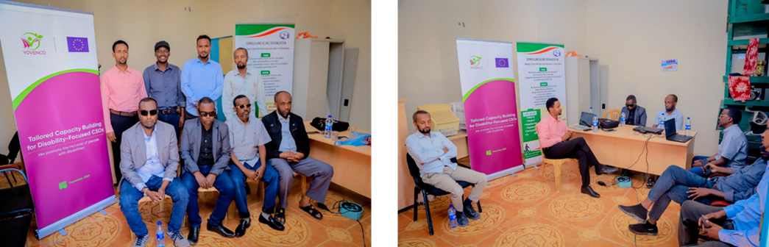
Introduction:
YOVENCO organization successfully implemented two tailored capacity-building training programs for Somaliland Blind Organization (SOBO) and Xaq-U-Dood Organization. The organizations were selected based on program, capacity-building needs using Capacity-building Assessment Toolkit developed prior to the trainings, and the recommendation of the Somaliland National Disability Forum (SNDF). These trainings, held in December 2023, aimed to equip the organizations with the skills and knowledge needed to effectively engage in governance processes and improve their leadership capacities. The report details the training design, delivery, achieved results, and recommendations for future initiatives.
Somaliland Blind Organization (SOBO)
SOBO is a voluntary, humanitarian, non-profit making and non-political organization based in Somaliland, engaged in the development of blind society in Somaliland.
Why SOBO is established:
SOBO was established 2011. The aims and objectives established for this organization is empowerment of community needs and solving problems as whole with special emphasis to visual impairment people problems and needs. Because blind community are a lot of people in our country and yet are the most vulnerable in terms to access education, Health, face violation of human rights and also the poorest of the poor.
MISSION
With its expertise SOBO investigates social problems in order to mobilize and strives to upgrade social services, human rights and livelihoods for vulnerable and disadvantaged blind people in Somaliland through advocacy, enhancing education and skills training. In order to realize this mission, SOBO focuses on 3 intervention areas through its investigation:
- Education
- Advocacy
- Sector support
VISION
SOBO's vision is to increase the number of visual impairments who are educators, employers and employees.
OBJECTIVES:
- To provide empowerment and capacity building for visual impairment people on participation in decision-making and development of the country.
- Advocacy for fundamental human rights for visual impairment people.
- Raise awareness about stigmatization and cultural barriers that restrict the ability of visual impairment person.
- To create job opportunities for blind people.

Xaq-U-Dood Organization
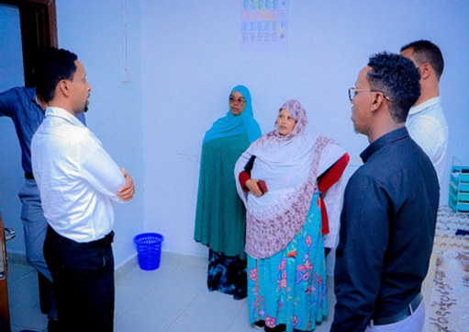
The Xaq U Dood Charity Organization is dedicated to improving the lives of individuals and communities through various initiatives.
The organization offers a wide range of services and programs, including healthcare, education, vocational training, and emergency relief. Over the years, the Xaq-U -Dood Charity Organization has made significant achievements and had a positive impaction the community. It has successfully provided support to thousands of individuals, educated underprivileged children with special needs, and empowered vulnerable communities through skill development. These efforts have improved the quality of life for many, contributing to the overall well-being of the community.
Figure 12 Tailored ongoing inside Xaq-u-dood Site
MISSION
Provide support and assistance to those in need, promoting social welfare and sustainable development.
VISION
Xaq-U-Dood Charity Organization for Mothers and Children with Special Needs is of an inclusive, equitable society where mothers and children with special needs in Somaliland are empowered, valued and given the opportunity to lead a dignified life. Envision a future where they are free from socio-economic deprivation, antagonism, and despair, and can access every opportunity for physical, intellectual, emotional and social growth.
Training Design and Delivery:
Capacity Assessment:
Prior to the trainings, YOVENCO conducted a comprehensive capacity assessment using the toolkit developed under Activity 2.1.1. This assessment identified key areas for improvement in each organization, including organizational structure, human resource management, workplan development, reporting, communication, and advocacy.
Tailored Training Modules:
Based on the needs assessment findings, YOVENCO designed two-day training programs specifically tailored to the unique needs of each organization. The modules covered essential topics such as:
- SOBO:
  - Organizational Structure and Leadership: Understanding roles and responsibilities, effective leadership practices, and building a strong organizational culture.
  - Human Resource Management: Recruitment, selection, performance management, and building a motivated team.
  - Introduction to Workplan Development and Budgeting: Setting SMART goals, developing realistic workplans, and managing budgets effectively.
  - Reporting (Narrative and Financial): Accurate and timely reporting for stakeholders, including donors and government agencies.
  - Communications and Advocacy: Effective communication strategies for raising awareness, building partnerships, and advocating for the rights of persons with disabilities.
  - Record Management: Maintaining accurate and secure records for improved organizational efficiency and accountability.

- Xaq-U-Dood:
  - Organizational Structure and Leadership: Clarifying roles and responsibilities, delegating tasks effectively, and fostering a collaborative environment.
  - Human Resource Management: Efficient recruitment, performance management, and implementing fair compensation practices.
  - Introduction to Workplan Development and Budgeting: Setting measurable goals, developing realistic workplans, and managing budgets effectively.
  - Reporting (Narrative and Financial): Transparent and accurate reporting processes for stakeholders.
  - Communications and Advocacy: Building relationships with key stakeholders, effectively communicating project outcomes, and advocating for community needs.
  - Asset Management: Developing and implementing systems for managing and maintaining assets effectively.

Training Methodology:
The trainings employed a participatory approach, incorporating interactive lectures, group discussions, case studies, role-playing exercises, and practical activities. This approach ensured active engagement from participants and facilitated the application of acquired knowledge to real-world scenarios.
Training Resources and Tools:
To support the ongoing application of the learned skills, YOVENCO provided participants with practical tools and resources, including:
- Customized workplan and budget templates
- Reporting templates (narrative and financial)
- Communications and advocacy plan template
- Asset management template
- Financial management manual
- Additional resource materials
Technical Assistance:
Following the trainings, the consultant provided five days of technical assistance to each organization. This support addressed specific questions or challenges participants faced in implementing the learned skills and utilizing the provided tools.
Achieved Results:
The trainings demonstrably achieved the intended objectives:
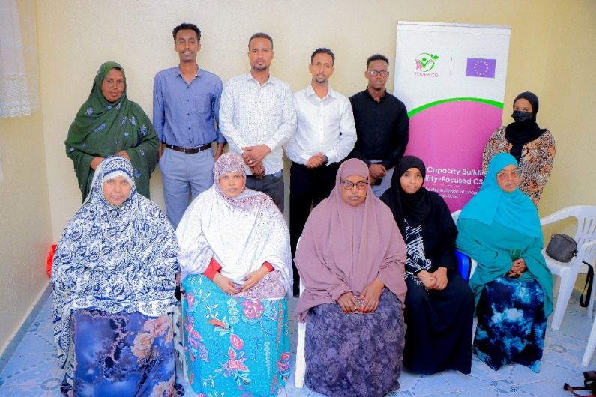
- Enhanced Skills and Knowledge: Participants showcased a significant improvement in their understanding and ability to apply the training modules, particularly in areas identified as capacity gaps. This was evident through active participation, successful completion of exercises, and positive feedback from participants.
- Increased Confidence and Competence: Participants expressed increased confidence in their ability to lead and manage their organizations effectively. This was observed through their engagement in discussions, proactive problem-solving approaches, and willingness to take on new responsibilities.
- Improved Policy and Manual Adoption: Both organizations expressed commitment to adopting and implementing the provided policies and manuals. They demonstrated this through incorporating the tools and resources into their work processes and developing action plans for implementation.

YOVENCO will continue to monitor the progress of SOBO and Xaq-U-Dood organizations through regular communication, follow-up visits, and potential surveys. This ongoing monitoring will ensure sustained impact and identify any areas requiring further support.
Recommendations:
- YOVENCO can continue to provide ongoing support and guidance to SOBO and Xaq-U-Dood organizations, tailoring interventions to their specific needs and challenges.
- The lessons learned from these trainings can be used to develop similar capacity-building initiatives for other civil society organizations in Somaliland, empowering the sector to contribute more effectively to governance processes.

Activity 2 related to output 2.1
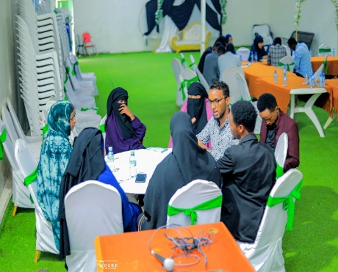
A 2.1.4 Seven Sessions of Community Conversation on Strengthening Civil Society Organizations (CSOs) for Inclusion of People with Disabilities and Other Vulnerable Groups in Burao and Erigavo (SOYDAVO)
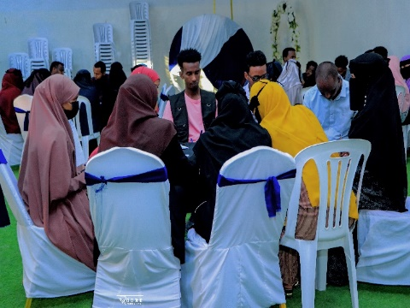
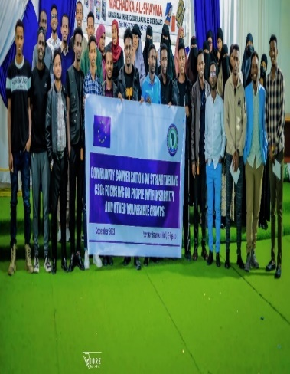

Background:
Seven Community Conversations on Strengthening Civil Society Organizations (CSOs) for Inclusion of People with Disabilities and Other Vulnerable Groups was initiated and held in Burao, to enhance the capacity of CSOs to promote inclusion and support individuals with disabilities and other vulnerable groups. This report provides a comprehensive overview of the training sessions, including their objectives, methodologies, activities achievements, expected results, and suggestions for future actions.
The training sessions also commenced with a warm welcome to all participants, emphasizing the importance of their role in promoting inclusive communities. It was stressed that the success of these initiatives depends on the active participation and commitment of all attendees. Ground rules were established to create a safe and respectful environment for learning and sharing, including principles such as active listening, respect for diverse perspectives, and maintaining confidentiality. Some of the sessions were attended by 50 participants while others attended 30 participants among CSOs, PWDs, and vulnerable and minority groups in Burao and Erigavo.
Community Conversations on Strengthening Civil Society Organizations for Inclusion" training sessions hold great promise in fostering a more inclusive society that respects and supports individuals with disabilities and other vulnerable groups. The collaborative efforts of CSOs, participants, and the local community are crucial in achieving the desired outcomes and building a more inclusive future.
The primary objectives of the training sessions were as follows:
- To enhance the understanding of disability and vulnerability through discussions on terminology, etiquette, and a rights perspective.
- To equip CSOs with inclusive strategies and action plans to promote the well-being and social inclusion of people with disabilities and vulnerable groups.
- To overcome stigma and discrimination through open conversations and community engagement.
- To strengthen CSOs' capacity to work effectively in advocating for the rights and needs of individuals with disabilities and other vulnerable groups.
Methodology:
The training methodologies have incorporated a variety of interactive and participatory techniques, including:
- Community Conversations: A series of conversations with local community members, including individuals with disabilities and their families, to gain insights into their experiences, needs, and aspirations.
- Group Discussions: Participants were divided into smaller groups to discuss key topics related to inclusion, share their thoughts, and brainstorm ideas for practical solutions.
- Presentations: A series of presentations, translated into Somali, were delivered to ensure accessibility and understanding. These presentations covered topics such as disability terminology, etiquette, the rights perspective, and inclusive strategies.
Activities Achievements:
- Understanding Disability and Vulnerability: The training sessions successfully improved participants' understanding of disability, both visible and invisible, and the impact of disability on individuals and their communities.
- Inclusion Strategies: The group discussions allowed participants to exchange ideas on developing actionable inclusion strategies that can be implemented by CSOs in their communities.
- Overcoming Stigma and Discrimination: Open and candid conversations helped address prevailing stigmas and discriminatory attitudes towards individuals with disabilities, fostering empathy and understanding.
- Community Engagement: Participants engaged in meaningful conversations with local community members, strengthening their connections and building a network of support for inclusive initiatives.
The conversations were expected to yield several positive outcomes, including:
- Enhanced Capacity: CSOs better equipped to support people with disabilities and vulnerable groups, creating a more inclusive environment.
- Increased Awareness: Participants carried their knowledge of disability terminology, etiquette, and the rights perspective into their work and communities, challenging stereotypes and promoting understanding.
- Inclusive Initiatives: CSOs identified inclusive strategies and activities, leading to a positive impact on the lives of people with disabilities and other vulnerable groups.
Learnings:
To sustain the momentum and continue working towards inclusive communities, the following suggestions are proposed:
- Regular Follow-up: Organize follow-up sessions to assess the progress of CSOs in implementing inclusive strategies and addressing challenges they encounter.
- Networking: Facilitate networking opportunities among CSOs and provide a platform for sharing best practices and experiences in inclusion.
- Community Engagement: Encourage continued engagement with the local community, involving people with disabilities and their families in decision-making processes.
- Awareness Campaigns: Develop and implement awareness campaigns to challenge societal attitudes and promote inclusion.
- Capacity Building: Offer further training and resources to enhance the skills and knowledge of CSOs in supporting individuals with disabilities and vulnerable groups.
Activity 3 related to output 2.1
2.1.4 Two community conversations on the issues faced by people with disabilities and other vulnerable groups in Somaliland (SOYDAVO)

Two Community conversation on strengthening CSOs focusing on people with disabilities and other vulnerable groups was conducted by SOYDAVO in Buro’a, inviting civil society organizations to discuss how to accelerate and mainstream their project implementation to the people with disability. 50 members among the following CSO participated in each session to discuss the current challenges people with a disability deal with at the family level, community level, and national level. Some of the CSOs are currently implementing projects regarding disabled people such as Diversity Action Network which are momentary providing equipment for people with disabilities.
People with disability are left behind by discrimination against them and their health complications both physical and mental.
Disabilities are now challenging.
People with disabilities in Somaliland face numerous challenges, including discrimination, lack of access to essential services, and exploitation. These challenges are often amplified for women and girls with disabilities. CSOs and humanitarian actors are not always adequately including people with disabilities in their programming. There is a lack of awareness of the rights of people with disabilities at the national level.
In order to address these challenges, two community conversations were held on the issues faced by people with disabilities and other vulnerable groups in Somaliland. The conversations were organized by SOYDAVO.
The conversations were attended by representatives from CSOs, government agencies, and the media. The participants discussed the challenges faced by people with disabilities, as well as the ways in which these challenges can be addressed.
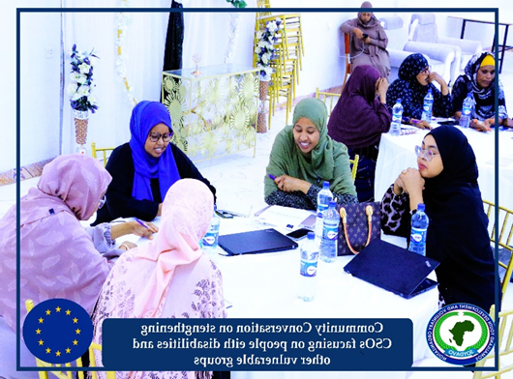
People with disabilities in Somaliland as in many other countries, face numerous challenges that result in their exclusion from the mainstream of society, making it difficult for them to access their fundamental social political and economic rights. Many make their way through life impoverished. Abandoned uneducated, malnourished, discriminated against, neglected, and vulnerable for them, life is a daily struggle to survive. Whether they live in urban centers or in rural areas, they share those common problems. They are largely excluded from essential services and lack protection of the family and community and are often at risk of exploitation and abuse. Factors contributing to this pathetic situation are many and varied but include poverty, unemployment social isolation, and environmental institutional attitudinal, and economic barriers.
Figure 13 Photo of the participants in a community conversation in Bur'oa
During the meeting CSOs representative highlighted people with disability specialty women and girls are at high risk in IDPs, often living with no permanent shelter; they face rape, sexual harassment, and domestic violence. When crises hit, they are the most vulnerable to Gender-Based Violence (GBV) and early and forced marriage. Perpetrators often exploit their vulnerabilities, targeting them when they leave camps to perform domestic chores or fetch water from distant boreholes.
Higher levels of unemployment, discrimination, and lack of access to quality education make it harder for people with disabilities to find decent work.
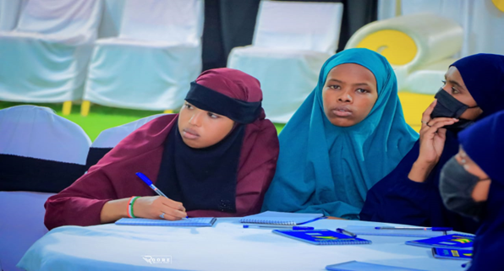
Meeting outcomes
Figure 14 Photo of the participants in a community conversation in Bur'oa
- Discrimination and barriers to access to services often amplify the challenges and risks internally displaced people (IDPs) with disabilities face. They also hinder their ability to achieve durable solutions to their displacement.
- Normally CSOs and humanitarian actors’ current projects mostly are not directly involved people with disability
- People with disability laws and policies are not on the table at the national level and even some of the current Somaliland constitution articles are against the people of disability for example the political candidate requirement
Recommendations & the way out of the existing challenges

- There should be growing recognition at the policy level of the need to protect the rights of persons with disabilities affected by conflict, violence, and disasters, and include them in humanitarian action and sustainable development.
- Governments and humanitarian and development organizations should overlook their rights and role as agents of change, and the media and academia pay them more attention.
- To drive change, it is essential to guarantee the meaningful participation of persons with disabilities in all decisions that concern them, remove barriers, and recognize and strengthen their capacity to lead activities to address and take part in community development programs.

Activity 4 related to output 2.1
A 2.1.4 Community Conversation on promoting the rights of people living with disability at the community level (SOYDAVO)

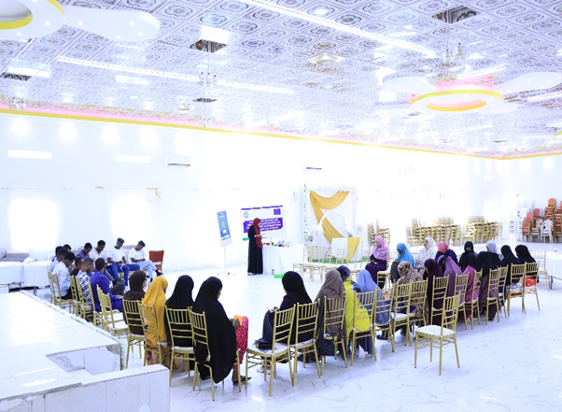
People with disabilities are often viewed as warm and kind, but not necessarily competent. However, people with disabilities can be exceptionally talented. They can contribute to their communities in many ways, but they often face barriers that prevent them from doing so.
One way to address these barriers is through community conversations. Community conversations are an asset-based approach to solving community-based problems. They bring together an interdisciplinary group of individuals who typically may not have a chance to interact and provide them an opportunity to identify innovative solutions to pervasive problems within their community.
In quarter two of 2023, a community conversation was conducted to discuss the rights of people with disabilities. The conversation was attended by 50 participants from different institutions, including university students, civil society members, and government officials.
The conversation highlighted the importance of equitable access to supports and services for people with disabilities. Participants agreed that the public needs to be better educated about the capabilities of people with disabilities. They also agreed that the government needs to take action to ensure that people with disabilities have equal access to all community services.
The community conversation was a valuable opportunity to discuss the challenges and opportunities facing people with disabilities. The findings of the conversation will be used to inform the development of policies and programs that will help to create a more inclusive society for all.
Findings
- The public largely views people with disabilities as warm and kind, but not necessarily competent.
- People with disabilities can be exceptionally talented.
- There is a need for equitable access to supports and services for people with disabilities.
- Community conversations are an effective way to bring multiple stakeholders together to identify innovative solutions to pervasive problems.
Lessons
- It is important to create a safe and inclusive space for people with disabilities to share their ideas.
- It is important to listen to the voices of people with disabilities and to take their perspectives into account when developing solutions.
- Community conversations can be a powerful tool for promoting the rights of people with disabilities. It provides the platform to dig deeper understanding of their priorities on the public service providers.
Specific Recommendations
- The government should develop a comprehensive plan to ensure that people with disabilities have equal access to all community services. YOVENCO leadership started to engage mayors of the target districts to persuade disability inclusiveness of their institutional implementations.
- The government should provide funding for specific programs dedicated to the people with disabilities that provide supports and services. Local government budgets require attention on its inclusiveness.
- The government should work with the media to promote positive images of people with disabilities.

Activity 1 related to output 2.2
A 2.2.1.1 Public Campaigns on Gender Tranformative Action in Local Governance (Hargeisa & Borama) (YOVENCO)
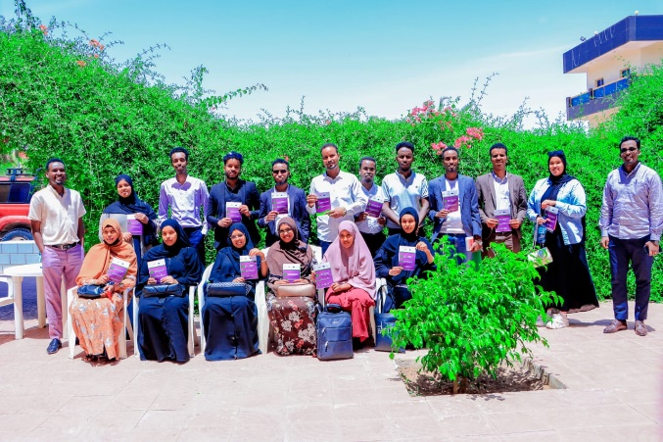
YOVENCO Organization has also organized two public campaigns on Gender Transformative Action in local governance in Borama and Hargeisa on the 19th of June and the 5th of July, respectively. The public campaigns held in these cities aimed to roll out and spread campaign messages on gender-transformative action in local governance; raise awareness of the community, political leaders, and other key community members on underlying gender norms that hinder women’s inclusion in local governance affairs; and host an interactive session with social media activists in order to bring about an increased understanding of culturally rigid gender norms for greater advocacy.
Figure 15 Social media Activists holding campaign messages flyers
The public campaigns attracted active social media influencers who have been instrumental in spreading the campaign messages to masses of local communities in Borama and Hargeisa, respectively.
Public Campaign Methodology:

1. The right influencers were chosen: The influencers chosen had a large following
of people and were interested in the issues of gender transformation. They were
credible and trustworthy with a transformation-minded following.
2. Compelling campaign messages were created: The messages of the campaign which are clear, concise, and easy to understand were created. The messages were relevant to the target audience and persuasive enough to change their minds about gender norms.
3. An eye-catching art installation was designed: The art installation posters were visually
appealing and thought-provoking. They were also relevant to the message of the
campaign and easy to understand.
4. Hosted an event: The host event was organized to bring people together and raise
awareness of the campaign. The event featured the art installation, speeches from
influencers, and opportunities for people to learn more about gender norms. Campaign working groups were created as a result of the event.
5. Used social media: social media is a powerful tool that can be used to reach a large
audience. Share photos and videos of the art installation, as well as messages from the
influencers were shared on social media.
Campaign Messages Rolled Out:

- English: “It is the time for our local leaders and service deliverers to be chosen on merit, regardless of their sex.”
Somali: “ Waxa la gaadhay xilligii addeegayaasheenna iyo hogaamiyeyaasheenna bulsho aynnu ku xullan lahayn xirfad-yaqaannimo iyo aqoon, inagoon u eegayn lab iyo dhedig.”

This message emphasized the importance of focusing on merit, rather than gender, when choosing leaders and social service deliverers. When we focus on merit, we are more likely to choose qualified people capable of doing the job. We are also more likely to choose people committed to serving the community, regardless of gender.

- English: “ Women are both leaders at home and in our community; hence, let us all be courageous with our support for them.”
Somali: “Haweenkeennu waa hogaanka qoysaskeenna, iyo hogaanka bulshadeennaba ee ku dhiirro taageeradooda.”

This message highlighted the importance of supporting women in their leadership roles. Women are often underrepresented in leadership positions in local government and even in community committees, but they play a vital role in the success of their families, and communities and are the most active members of community committees. By supporting women in their leadership roles, we can help to create a much better communities.

3. English: "When tasks are divided along gender lines, it limits the potential of the community as a whole.”
Somali: “Labbeynta iyo dheddigeynta shaqooyinku waxa ay bulshadeenna ka curyaamin karaan iskaashiga iyo wadashaqeynta bulshada.”

This message emphasized the importance of unity in communities. When tasks are divided along gender lines, it can create divisions and tensions within the community. By working together, communities can build stronger bonds and achieve more.

4. English: “ "When women's voices are heard, the whole community is heard."
Somali: “Haweenka oo la tixgeliyo arragtiyahooda lana dhegaystaa waa bulshada inteedii badnayd oo la dhegaystay.”

This message emphasized the importance of listening to women's voices and the power that women have to inform better decisions at the local level. The fact that women can articulate the needs of all community members necessitates that when women are heard, the whole community is heard.

5. English: “Women as natural caregivers are simply better informed of everyone’s needs. Let us hear them.”
Somali: “Haweenku waa hooyo, hooyaduna iyadaa ugu xog-ogaalsan baahida cid walba ee ha lala tashado.”

This message simply meant that mothers are naturally attuned to the needs of others, especially their children. They are often able to anticipate needs before they are even expressed. On a deeper level, the quote stands as a metaphor for the role of women in society. Women are often seen as the caregivers and nurturers of society, and they are often called upon to meet the needs of others.
Key Campaign Achievements:
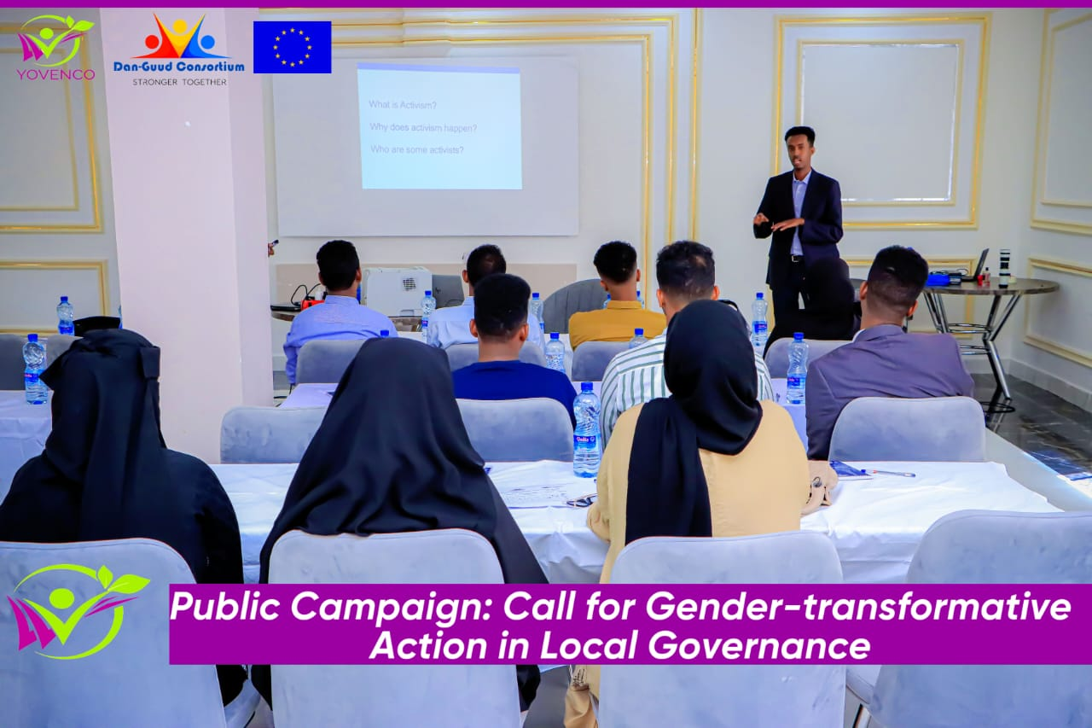
- Increased awareness of gender inequality and gender stereotypes: The campaign raised awareness of the ways in which gender inequality manifests itself in society, such as through the unequal distribution of power, resources, and opportunities between men and women. The campaign also challenged gender stereotypes, such as the idea that men are only good at certain things and women are only good at other things through distributing messages clearly aimed at pointing the torch on such issues. The campaign has reached 40 social media activists directly and around 10 thousand people on social media indirectly.
Figure 16 Public Campaign Host Event in Borama
- Started discourse on attitudes and beliefs about gender roles: The campaign helped to change attitudes and beliefs about gender roles, such as the idea that women are not as capable as men of holding leadership positions or contributing to public policy, through discussions with social activists. The campaign also challenged the idea that men are the only ones who could be contributive, assertive, and successful in community work through sound campaign messages sent to the masses.
- Founded a dedicated team of social media activists for the campaigns: The campaign has set up teams of social media activists in Borama and Hargeisa to participate in amplifying our social media campaigns, both as users and as creators of content. This would help to amplify the voices of all gender groups and particularly that of women, to challenge the dominant narratives about gender.

Activity 2 related to output 2.2
A 2.2.1.2 Activity report Two Public Campaigns for Involving Women’s Organizations, Youth Organizations, and Media in the Transformative Process of Engendering Social Change, in particular by challenging stereotypes in Burao & Erigavo. (SOYDAVO)

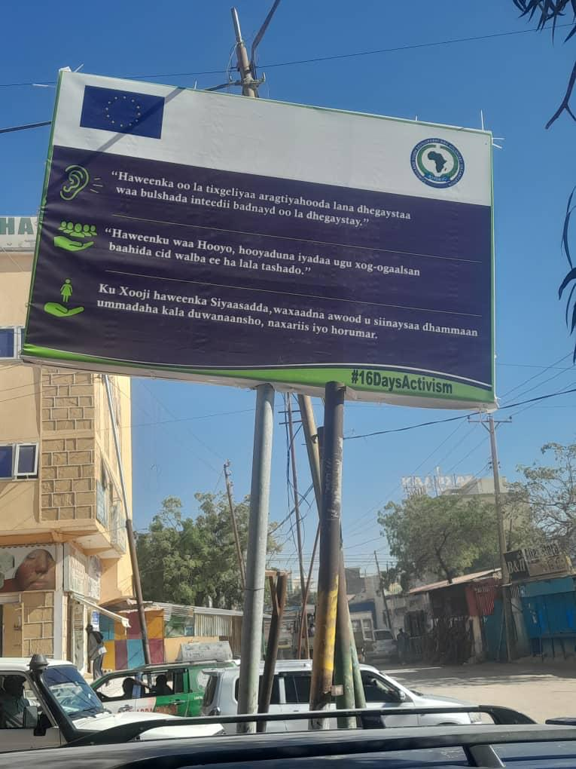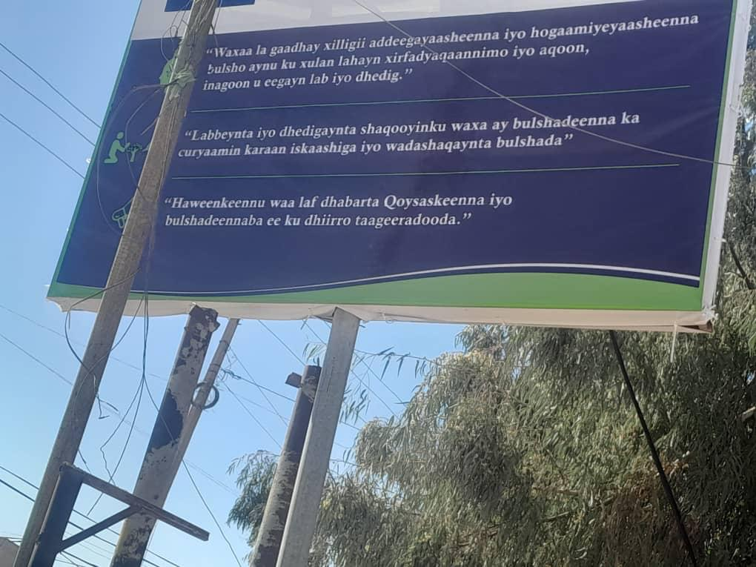
Background:
The commencement of the 16 Days of Activism Against Gender-Based Violence served as a pivotal juncture to amplify the impact of a collaborative public campaigns were initiated in Erigavo and Burao on August 31st and November 09, 2023, respectively. These concerted efforts brought together women's and youth organizations, media entities, and local stakeholders, with a mission to champion gender equality, challenge deeply rooted stereotypes, and fortify women's involvement in the political sphere. The public campaigns in Erigavo and Buro’a were a collective endeavor involving the active participation of women's and youth organizations, media outlets, and local stakeholders. At its core, the campaign aimed to not only challenge prevailing gender stereotypes but also to actively promote inclusivity in key societal domains such as education, employment, and leadership roles. An array of strategic tools, including social media engagement, billboards, banners, and collaboration with local media outlets, was employed to effectively disseminate messages addressing gender equality.
The primary aim was to disrupt entrenched gender stereotypes and transform societal attitudes. The campaign sought to foster inclusivity, ensuring equal participation across genders in education, employment, and leadership. Additionally, it aspired to inspire a surge in women's political involvement. Engaging stakeholders, including local leaders, influencers, educational institutions, and civil society organizations, was instrumental in amplifying the campaign's impact.
Methodology:
Strategically placed billboards along Erigavo and Burao's highways and stand banners in the campaign office featured quotes challenging stereotypes and promoting gender parity. The campaign harnessed the reach of social media platforms, billboards, and local media outlets to amplify its messages.
Activity Results & Achievements:
The campaign achieved a significant milestone by reshaping societal attitudes, evident in social media feedback indicating a decline in acceptance of traditional gender stereotypes. Women's heightened engagement in political activities, reflected in increased participation in running for office and assuming leadership roles, marked a positive outcome. The campaigns’ success laid in its adept creation and dissemination of diverse media content, including videos, posters, and social media campaigns, fostering meaningful conversations on gender roles and identities.
Anticipated outcomes included positive shifts in societal attitudes, increased female participation in political activities, and successful media content creation and dissemination.
Learnings:
Building on the campaigns’ success, ongoing engagement with local media outlets is recommended for sustained momentum. Collaboration with local schools to integrate gender equality education into curricula can perpetuate long-term change. Follow-up surveys and studies can assess the campaign's lasting impact while organizing workshops and seminars that further empower women in leadership and decision-making roles. This approach ensures the 16 Days of Activism catalyze enduring societal transformation.

Output 3: The Somaliland Media and Population take an active role in participation and decision-making in the governance of local authorities

Activity 1 related to output 3.1
A 3.1.1.2 Talk Show on peace-building & community resilience (SOYDAVO)

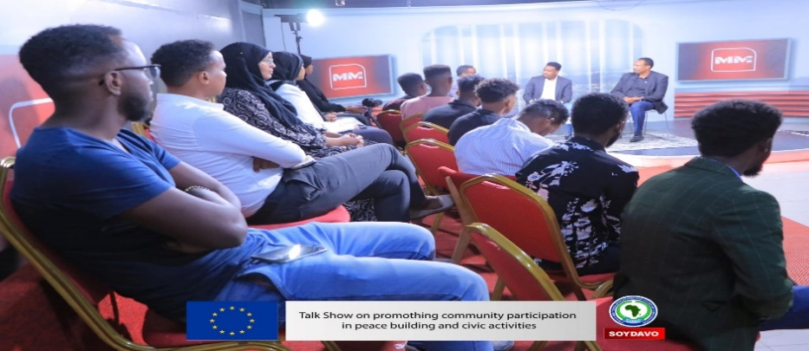
The talk show was organized to raise awareness on the importance of peacebuilding and stability. The government officials in presence discussed the different dimensions of peacebuilding, including conflict resolution, reconciliation, and the promotion of human rights. They also highlighted the challenges of peacebuilding, such as the lack of resources and the presence of spoilers.
The audience engaged in a lively discussion with the speakers, asking questions about the role of individuals, communities, and governments in peacebuilding. The talk show concluded with a call to action for everyone to work together to create a more peaceful world.
Key Takeaways:
- Peacebuilding is a complex and long-term process that requires the involvement of all sectors of society.
- There are many different approaches to peacebuilding, but all of them share the common goal of creating a more just and equitable world.
- The challenges of peacebuilding are significant, but the rewards are also great. A peaceful world is a world where everyone can live in safety and security.
Recommendations:
- The organizers of the talk show should consider inviting speakers from a wider range of backgrounds, including those from conflict-affected countries.
- The talk show should be made available to a wider audience, such as through live streaming or podcasting.
- The organizers of the talk show should develop a follow-up plan to engage the audience in further discussions and actions on peacebuilding.
Overall, the talk show was a success in raising awareness on the importance of peacebuilding and stability. The speakers provided valuable insights into the challenges and rewards of peacebuilding, and the audience engaged in a lively discussion. The organizers of the talk show should consider making the talk show available to a wider audience and developing a follow-up plan to engage the audience in further discussions and actions on peacebuilding.
Activity 2 related to output 3.1
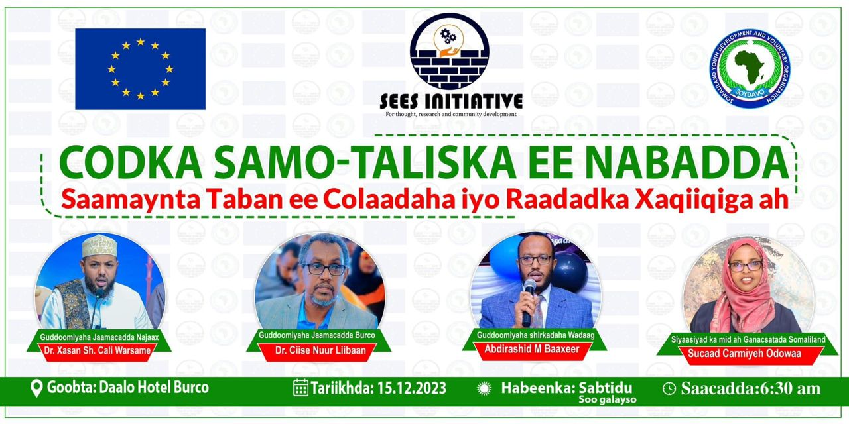
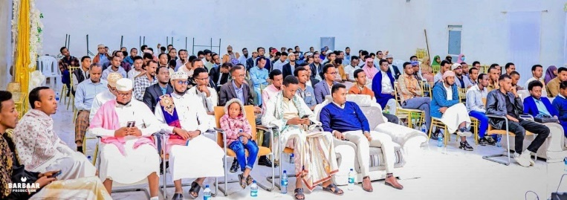
A 3.1.1.2 Hold Talk Shows on Civic Education, Advocacy, and Awareness-Raising Activities at the Grassroots Level in Burao (SOYDAVO)
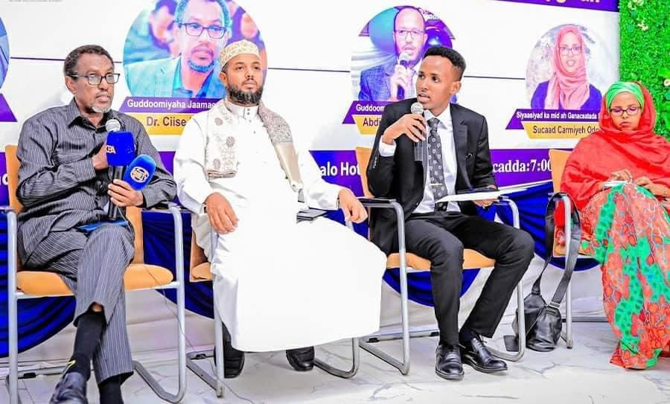

Background:
On December 17, 2023, SOYDAVO organized "The Intellectual Voice of Peace," a program aimed at fostering substantive discussions about peace within the community. Distinguished speakers from diverse fields engaged in conversations addressing the significance of peace, the challenges posed by conflicts, and the shared responsibility of society in championing peace and unity.
"The Intellectual Voice of Peace" aimed to catalyze positive societal change by inspiring unity, compassion, and shared prosperity. It sought to educate citizens on the human, economic, and social costs of conflicts, fostering a deep understanding of their broader impact. Actively encouraging civic engagement, the program empowered individuals to shape their communities and cultivate a culture marked by peace, understanding, and collective well-being.
Methodology:
The program included talk shows designed for active engagement, featuring open discussions, Q&A sessions, and remote participation via Zoom to enhance inclusivity. Saab TV recorded debates, amplifying the impact by sharing insights with a wider audience. The carefully curated format epitomized "The Intellectual Voice of Peace," fostering dialogue, inclusivity, and technological reach beyond the immediate audience.
Session Achievements & Results:
The talk shows achieved significant milestones by fostering constructive dialogue on peace, providing a platform for diverse perspectives. Beyond mere discourse, the program instigated a palpable sense of responsibility among participants, encouraging active involvement in ongoing peace-building efforts. This newfound commitment marked a tangible step towards collective engagement in fostering a culture of harmony and understanding within the community.
Anticipated outcomes included heightened awareness, increased civic participation, and the establishment of a foundational framework for sustained peace-building activities. The initiative aimed to elevate consciousness regarding the importance of peace, encouraging individuals to actively engage in civic affairs. Moreover, it sought to lay the groundwork for enduring peace by fostering a sense of collective responsibility and commitment among community members.
Learnings:
Valuable suggestions emerged, emphasizing the necessity for sustained educational initiatives and collaborative efforts between academia and businesses. There was a strong emphasis on the active involvement of political figures, signaling the need for leadership to champion and advance initiatives contributing to building a lasting and harmonious society.
Conclusion:
"The Intellectual Voice of Peace" successfully created a platform for substantial discussions, laying the groundwork for increased civic awareness and participation. It went beyond discourse to instigate a palpable sense of responsibility, encouraging active involvement in peace-building efforts. Anticipated outcomes include heightened awareness, increased civic participation, and the establishment of a foundational framework for sustained peace-building activities. Valuable suggestions emphasize the necessity for sustained educational initiatives, collaboration between academia and businesses, and the active involvement of political figures. Overall, the program contributes to a culture marked by peace, understanding, and collective well-being within the community.
Activity 3 related to output 3.1
A 3.1.1.3 Activity Report of Two Community Conversations on Civic education, advocacy and awareness-raising activities at the grassroots level to increase citizen participation in civic activities in Burao (SOYDAVO)

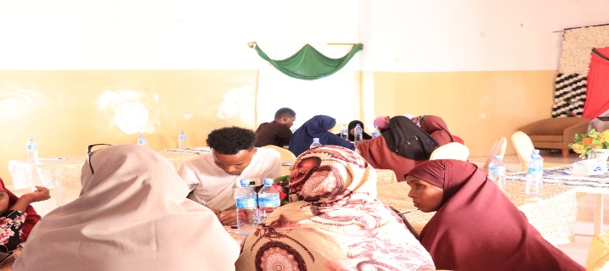
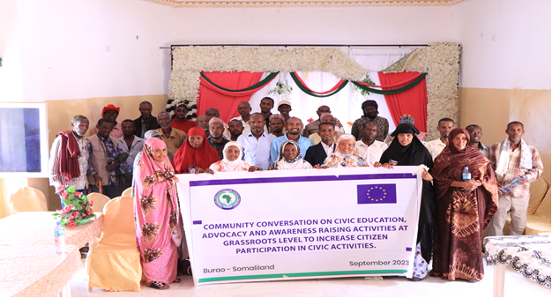
Background:
A highly engaging Civic Education and Advocacy Initiatives for Youth Empowerment in Peacebuilding was set to unfold on September 28, 2023, and again on, December 25, 2023, recognizing the indispensable role of youth in shaping community peace and stability. The initiative aims to instill a sense of responsibility and ownership among the younger generation, acknowledging their pivotal position as torchbearers of change.
The primary objectives were multifaceted, focusing on empowering youth with knowledge and skills for civic engagement, fostering advocacy skills, and raising awareness about the role of youth in peacebuilding. Also, the initiatives aimed to promote a deeper understanding of civic education, stimulate discussions on the pivotal role of volunteerism in civic initiatives, pinpoint effective strategies to bolster civic participation, and cultivate collaborative partnerships within the local community.
The initiative aspired to lay the groundwork for a more peaceful and stable community by emphasizing the indispensable role of informed and engaged youth.
Methodology:
The initiative employed a comprehensive methodology, including workshops, seminars, and discussions led by experts in civic education, peacebuilding, and advocacy. Practical exercises and case studies allow participants to apply theoretical knowledge to real-world scenarios. The initiative achieves significant milestones in fostering youth empowerment and engagement through these interactive educational programs.
Activity Achievements & Results:
The initiative achieved significant milestones in fostering youth empowerment and engagement. Participants gain a comprehensive understanding of civic responsibilities, democratic values, and conflict resolution mechanisms. The advocacy component successfully equips youth with effective communication skills, fostering a sense of ownership and responsibility. The youth demonstrate increased empowerment and commitment to actively contribute to community well-being, reflecting practical application of acquired knowledge and skills.
Upon the conclusion of the initiatives, it is anticipated that participating youth exhibit increased awareness of civic responsibilities, enhanced advocacy skills, and a heightened sense of empowerment. The initiative aims to stimulate a tangible increase in youth participation in community-based civic activities, contributing to the overall peace and stability of the community. The anticipated results include a more informed and engaged youth population actively contributing to democratic processes and social development within their localities.
Learnings:
Building on the success of the initiative, future programs should prioritize the empowerment of youth in civic engagement. Establishing sustained platforms for ongoing dialogue and collaboration is recommended to maintain momentum. Efforts should be made to expand program's reach to involve a broader spectrum of youth. Continuous evaluation and adaptation of content and methodologies based on participant feedback will enhance the effectiveness of future initiatives. Collaborations with local community leaders, schools, and youth organizations can further amplify the impact, fostering a culture of active citizenship and sustained peacebuilding efforts.
Conclusion:
The Civic Education and Advocacy Initiative for Youth Empowerment in Peacebuilding demonstrated considerable success in achieving its objectives. By providing a robust educational foundation, fostering advocacy skills, and instilling a sense of responsibility, the initiative contributed to the creation of a more empowered and engaged youth population, laying the groundwork for a more peaceful and stable community.
Activity 4 related to output 3.1
A 3.1.1.3.1 Activity Report of Community Conversations on Civic education, advocacy and awareness-raising activities at the grassroots level to increase citizen participation in civic activities in Burao (SOYDAVO)
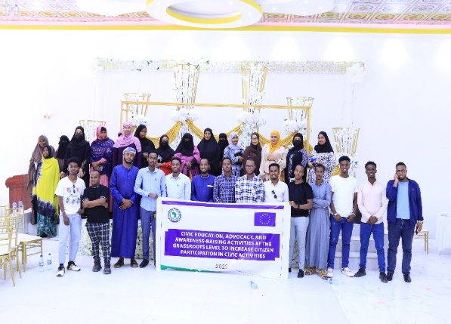
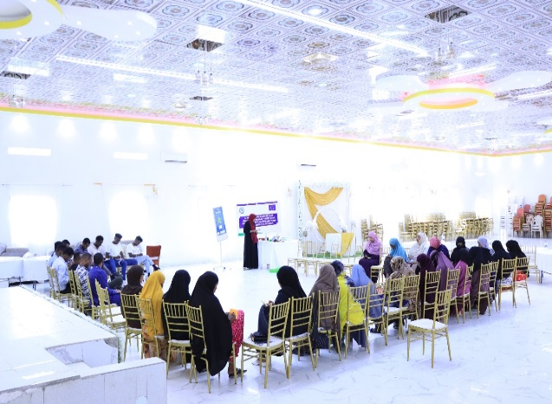

During quarter one community conversation conducted and invited fifty participants from different institution including university students, civil society members, government officials
Community conversation improves the participants to share their ideas and local solutions to promote the rights of people living with disability and how they can get access to all community services equally. During the session, participants agreed that the public largely views people with disabilities as warm and kind, but not necessarily competent. However, people with disabilities can be exceptionally talented. After all, this activity aims to increase a future in which all people, including those living with developmental and other disabilities, are fully included, participating members of their communities. We see equitable access to supports and services that reflect the preferences and values of diverse communities and that lead to self-determination, independence, productivity, and a healthy and satisfying quality of life. This community conversation is one strategy to bring multiple stakeholders to the table is community conversations, an asset-based approach to solving community-based problems and the purpose of community conversations is to bring together an interdisciplinary group of individuals who typically may not have a chance to interact and provide them an opportunity to identify innovative solutions to pervasive problems within their community (identified four core principles of community conversations. There have been several occasions in which community conversations have been used to identify barriers and formulate solutions that individuals with disabilities face regarding employment and the Successful implementation of a community conversations event necessitates the commitment of a group of community stakeholders with a mission to identify solutions to a pervasive issue in their community.
During the community conversation participants highlighted the importance and opportunity to discuss and find solutions to their social current issues including an increasing number of IDP camps, gender-based violence, and exclusion of people leaving with disabilities, However, institutions responsible for representing citizens and holding government accountable, such as parliaments, councils, assemblies, are often part of the system or upward accountable instead of downward towards their constituencies. Community conversation helps participants ask themselves about public resources management and “ask the right questions, to the right people, at the right moment.
Activity 5 related to output 3.1
A 3.1.1.3.2 Activity Report of Community Conversations on Civic education, advocacy and awareness-raising activities at the grassroots level to increase citizen participation in civic activities in Burao (SOYDAVO)
Community Conversation on civil education for advocating awareness-raising activity at the grassroots level to increase citizen participation in civic activities 50 community members including youth leaders, women groups, University students, and CSOs representatives speed up the massage and increase community engagement and role of civil society public support.
This primer focuses this conversation was to be exploring and demonstrating how to build, execute, and advocate civic education and motivate both youth and adult students that have meaningful effects on a variety of important democratic orientations, including political knowledge, skills, and competencies; support for democratic norms and values; and participation in voting and other forms of political behavior.
Fundings during the community conversations
During the session, participants defined the meaning of civic education as it related to voter education citizenship, democratic processes, and media ecosystem literacy and mention the active role that youth leaders, civil society organizations, and women groups can play to accumulate the ability to reach better and community wellbeing. And one of the major challenges they mention was that the community is less aware of the true meaning of their role because of the scarcity of public information and lack of civic education in the public schools and inter Somaliland education system.

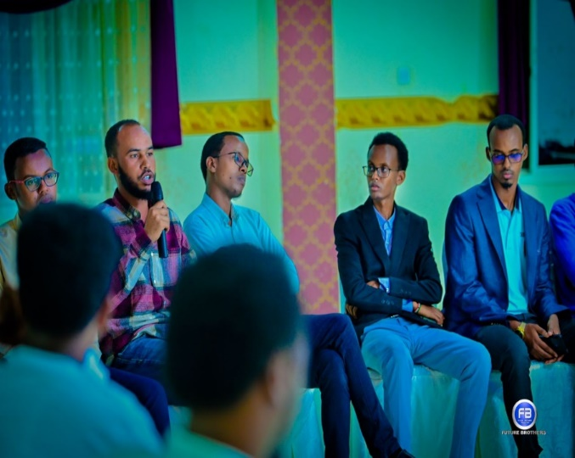
The overarching goal of the activity is to give the community the space and opportunity to discuss their basic undertaking of civic engagement and increase civic participation in the legislative process of the Somaliland government and socio-political institutions. Civic engagement activities address both the structural and attitudinal barriers to full civic/electoral participation, activities that are vital to the social, economic, and political welfare of the nation. This workshop focused on a segment of the population crucial to the future of our democracy, yet generally excluded.
Session Methodology
All presentations and speakers were carefully selected to address a specific topic related to civic education and engagement. The topics presented included “Rights, laws, and the legislative process,” and “Defining Civic Education.

Activity 1 related to output 3.2
A 3.2.1 Community consultations on increasing community participation in local government planning processes (SOYDAVO)

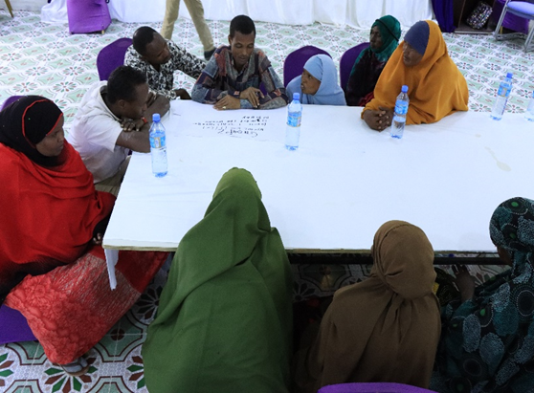
Community consultations were conducted for the local community authorities and civil society actors to increase community participation and take part in local government planning processes. The Participatory Planning for Social Inclusion methodology aims to improve social services aimed at poverty reduction and social inclusion through a participatory process that brings all relevant local stakeholders together, including social service users, CSOs, local authorities, government agencies, social service providers, and the public citizens. The results of the process are 1) a locally initiated and approved strategy and an action plan for the provision of social service and social inclusion 2) mutual trust is built among all relevant stakeholders, which is equally important as the strategy and plan itself.
Figure 17 Photo of Consultation participants in Buro'a
The consultations focused on increasing community participation in local government planning processes for the provision of social services. The goal of the consultations was to improve the quality of life of vulnerable groups by ensuring that their needs are reflected in local government planning.
The consultations revealed that there are a number of barriers to community participation in local government planning processes, including lack of information, lack of trust, and lack of resources. However, there is also a clear desire among participants to increase community participation.
Findings and lessons
- The consultations were well-attended by a diverse group of stakeholders, including local community authorities, civil society actors, social service users, and government agencies.
- There was a clear desire among participants to increase community participation in local government planning processes.
- Participants identified a number of barriers to community participation, including lack of information, lack of trust, and lack of resources.
- Participants also identified a number of potential benefits of increased community participation, including improved decision-making, improved service delivery, and increased social cohesion.
Recommendations
- The local government should take steps to address the barriers to community participation identified by participants.
- The local government should develop a strategy for increasing community participation in local government planning processes.
- The local government should provide training and resources to support community participation.
- The local government should work with civil society actors to promote community participation.
- Developing a strategy for increasing community participation in local government planning processes.
- Providing training and resources to support community participation.
- Working with civil society actors to promote community participation.
Activity 2 related to output 3.2
A 3.2.1 Organizing Four community consultations, developing and implementing participatory planning processes between the local population, the authorities and civil society actors in Burao and Erigavo (SOYDAVO)
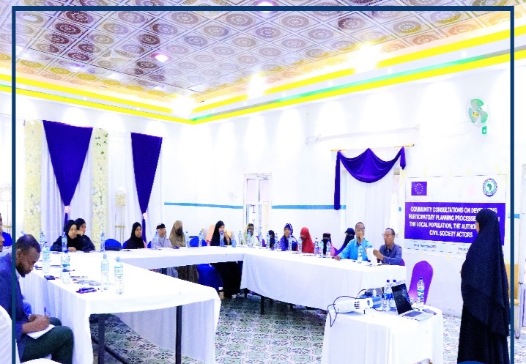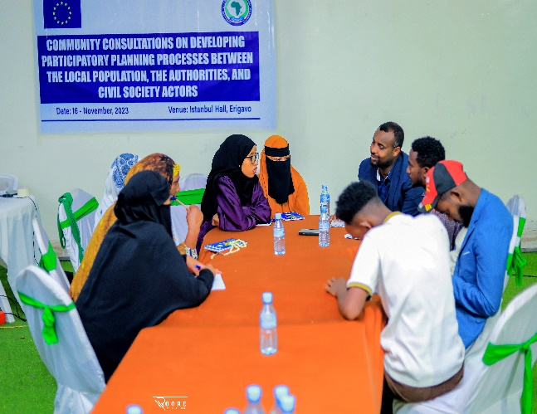
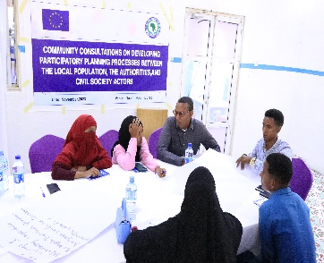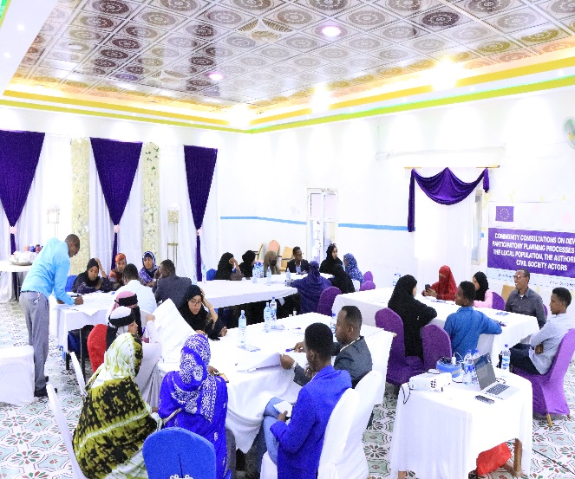
Introduction:
Recognizing the urgent need for improved socio-economic development in Somaliland, SOYDAVO is spearheading an initiative to empower communities through participatory planning. This collaborative effort with local authorities and civil society organizations aims to address specific challenges by engaging in comprehensive community consultations and developing a participatory planning tool, organized in Buro’a and Erigavo.
The primary objectives include facilitating community consultations in Burao and Erigavo, engaging diverse stakeholders such as government officials, local authorities, and civil society organizations. These sessions fostered collaboration, aiming to create an inclusive framework for open communication. A key outcome is the development of a comprehensive community planning tool, complemented by capacity-building efforts for effective utilization.
Methodology:
Employing a participatory approach, the initiative facilitated community consultations, emphasizing stakeholder engagement, needs assessments, and collaborative tool development. Continuous learning and feedback mechanisms are embedded in each phase. Moreover, the community consultation utilized a participatory approach, including group discussions and brainstorming sessions. Participants were divided into smaller groups to discuss key topics related to civic education, advocacy, media engagement, and inclusivity. Facilitators guided the discussions and encouraged the sharing of ideas and experiences.
Achievements:
The initiatives strive for driving impacts on community development, emphasizing community empowerment and participation in decision-making processes. Culturally sensitive participatory planning tools were developed to align community priorities with government policies, fostering inclusive development plans. Capacity-building focuses on enhancing local authorities' capabilities, contributing to improved governance and responsiveness. Collaborative partnerships are established to create ongoing dialogue and coordination among stakeholders. The participatory planning initiative was designed to create momentum toward sustaine impact by fostering community development. Empowered communities are expected to lead in addressing socio-economic challenges through locally driven solutions. The alignment of community priorities with government policies is anticipated to enhance the effectiveness and sustainability of development plans. Strengthened collaboration among civil society organizations, local authorities, and government agencies promotes a multi-stakeholder approach for holistic community development.
Learnings:
To ensure success, community sensitization efforts should be prioritized thorough awareness campaigns. Inclusive data collection methods, including surveys and participatory mapping, aim to capture diverse perspectives. Continuous feedback loops are established to maintain open communication, ensuring regular assessment and adaptation of participatory planning tools. Long-term planning integrates training into local government institutions and educational programs. A robust monitoring and evaluation framework is recommended for evidence-based adjustments. Documenting the entire process ensures shared learning through knowledge-sharing sessions and workshops.
To build upon the success of the community consultation, it is also recommended to:
- Organize follow-up workshops and training sessions to implement the identified strategies and further enhance civic education and awareness.
- Establish a civic education program in local schools and community centres to ensure ongoing learning and engagement.
- Continue collaboration between local media outlets and civic organizations to ensure effective coverage of governance-related topics.
- Create specific initiatives to address the needs and concerns of marginalized groups, ensuring their continued participation in local governance.
- Monitor and evaluate the progress of civic initiatives regularly to measure their impact on local governance and citizen participation.
Conclusion:
SOYDAVO's initiative stands as an intervention toward bringing about strengthened governance in Somaliland, emphasizing community engagement, inclusivity, and sustainable practices. The comprehensive participatory planning approach not only addresses immediate challenges but also sets the stage for long-term socio-economic development. The collaborative model, with its emphasis on community empowerment, stakeholder engagement, and continuous learning, serves as a blueprint for future initiatives, fostering a culture of shared knowledge and improvement in the humanitarian development landscape.
Activity 1 related to output 3.4
A 3.4.1.1 Cultural Events (bi-annual) (SOYDAVO)
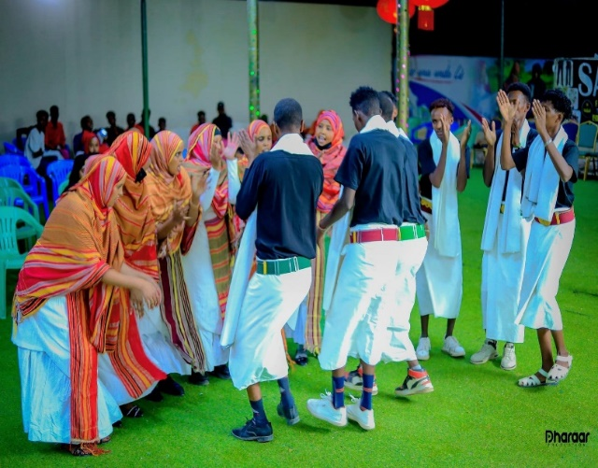
A competition was held for some of the youth groups who play traditional Somali dances, and three structured groups were selected and nominated to take part in the competitive competition in addition to external charges those who have deep knowledge and experience regarding traditional songs and dance. The event was conducted in the Isha Burao Hotel and invited different people from different backgrounds including government officials, university students, the host community, and youth leaders.
This event increased the Positive interactions with peers to build self-confidence. The program also provided youth with civic engagement opportunities, including peer-to-peer dialogue allowing youth to engage in support especially their own culture, and interaction within communities through dancing. After all the groups presented their performance, the charges selected one group as the winner and their gift was submitted by the SOYDAVO administration team with charges.

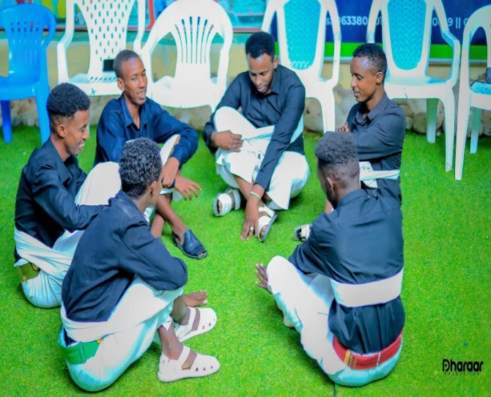
Structured cultural groups are less motivated by the government and even the NGOs after they have received this opportunity for them to perform their talent, they were excited and happy to participate as well as got hope for their skills to be promoted and also to show other youth how Somali cultural dancing is rich and beautiful. Additionally, the candidates were informed by the Somali cultural clothing and carried cultural accessories as well.

Activity 2 related to output 3.4
A 3.4.1.2 Cultural Event (bi-annual) on Lobbying, advocacy and awareness campaigns, including the use of media on transparency, accountability, gender equality and environmental stability in Burao (SOYDAVO)
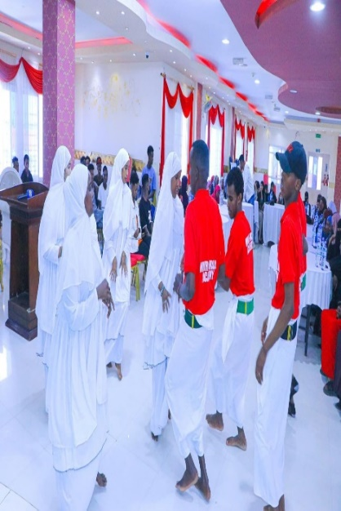
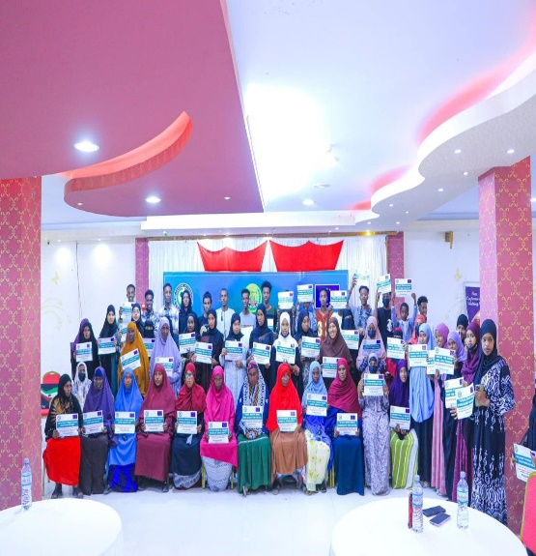
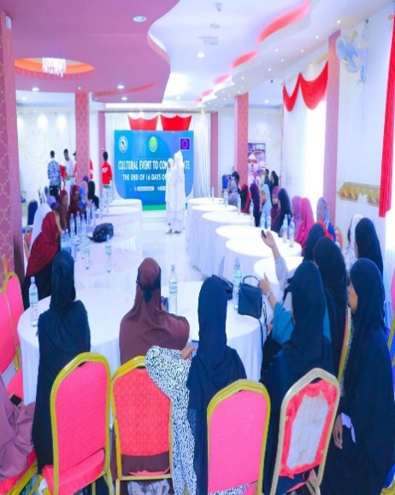

Background:
Our cultural event, inspired by the global initiative "16 Days of Activism Against Gender-Based Violence," served as a culmination of dedicated lobbying, advocacy, and awareness campaigns. Aligned with the dual objectives of raising awareness and eradicating violence against women globally, the event emphasized the interconnected roles of transparency, accountability, gender equality, and environmental stability in fostering a socially just and sustainable society. With 50 participants, including civil society organizations, NGOs, youth leaders, government officials, and communities, the event leveraged the momentum generated during the 16 Days of Activism.
The primary objective was to illuminate the significance of transparency, accountability, gender equality, and environmental stability through cultural expressions, mobilizing support for policy changes and social initiatives. Additionally, the event aimed to motivate individuals and communities to actively engage in fostering a culture aligned with these values. Celebrating the accomplishments of the 16 Days of Activism and emphasizing the positive impact of collective efforts stand as key objectives.
Methodology:
Inspired by the collaborative spirit of the 16 Days of Activism, the methodology employs cultural expressions and artistic presentations to highlight the importance of transparency, accountability, gender equality, and environmental stability. Interactive discussions with community leaders and participatory activities with youth amplify impact. Media professionals play a crucial role in disseminating the message, and collaboration with civil society organizations and government representatives ensures a comprehensive and inclusive approach.
Achievements & Results:
The envisioned achievements extend beyond immediate impact, contributing to lasting societal change. Through cultural expressions, the event anticipates heightened awareness about transparency, accountability, gender equality, and environmental stability. Tangible outcomes include increased support for policy changes and social initiatives aligned with campaign goals. Motivating individuals to become active agents of change and fostering community engagement are central to the event's objectives. Celebrating the accomplishments of the 16 Days of Activism reinforces the positive impact of collective efforts.
The event aimed to generate heightened awareness about the interconnectedness of transparency, accountability, gender equality, and environmental stability. Advocating for and potentially influencing policy changes toward a more equitable and sustainable society is a key outcome. Fostering community engagement to encourage individuals to actively participate in initiatives supporting the campaign's objectives is crucial. Media support amplifies the message, encouraging widespread public discourse. Cultural expressions presented aim to leave a lasting impression, inspiring positive cultural shifts.
Learnings:
Building on the success of the 16 Days of Activism, sustained commitment to ongoing advocacy efforts is suggested. Strengthening collaborations with community leaders, youth, media professionals, civil society organizations, and government representatives should be prioritized for continued impact. Exploring innovative ways to leverage media influence and disseminate messages effectively is recommended. Ongoing engagement with policymakers is crucial for influencing and implementing policy changes. Suggestions also include exploring opportunities for continued community involvement beyond the event, fostering a sense of shared responsibility in championing transparency, accountability, gender equality, and environmental sustainability.
Conclusion:
All activities were conducted successfully, achieving their objectives and paving the way for continued progress in promoting inclusivity, gender equality, lobbying, advocacy, and awareness campaigns, emphasizing transparency, accountability, civic engagement, and media participation in Erigavo and Burao. These events exemplify how informed dialogue, community involvement, and collaboration can drive positive change, creating more inclusive and equitable societies. Sustaining momentum through follow-up initiatives, ongoing collaboration, and regular assessments is essential for the long-term impact of these efforts.

2.3 Logframe Matrix Updated
The Logical framework (logframe) matrix should be used as a reporting tool of the expected results (impact, outcomes, outputs) during implementation. Values on indicators aimed at measuring the results will be regularly updated in the column foreseen for monitoring and reporting purposes (see “Current value”). Columns for intermediary targets could be added, if needed.

Results chain | Indicator | Baseline  (value & reference year) | Target  (value & reference year) | Current value*  (reference year)  (* to be included in interim and final reports) | Sources of data | Assumptions
To strengthen Somaliland CSOs to be independent actors in the promotion of transparent, accountable and inclusive local governance in their own right. | 1: The number of Somaliland CSOs that promoting transparent, accountable and inclusive local governance disaggregated by vulnerability category and location | Baseline for impact indicator 1 | 1. 30 CSOs | TBD | 1. Project Reports  2. Attendance Records  3. FGDs, Interviews  4. GPRS Images and videos  5. Pre and Post Training Surveys  6. Training Materials | 1. The newly elected local authorities require capacity-building support and training to enable them to deliver people-centred services and that there are CSOs targeting women, youth and the marginalised who are advocating for their inclusion in planning, budgeting and decision making.  2. Somaliland CSOs have been actively involved in various segments of Somaliland’s development in peace building, political participation, governance, democracy, human rights and security.  3. Somaliland enjoys relative peace and stability
 | 2: The number of local authorities that Somaliland CSOs are supporting to entrench transparent, accountable and inclusive local governance disaggregated by vulnerability category and location | Baseline for impact indicator 2 | 6 Local Authorities | TBD | 1. Project Reports  2. Interviews  3. FGD  4. GPRS Images and videos
 | 3: The number of frameworks and mechanisms implemented to promote inclusivity, transparency, and accountability in local governance in local authorities in Somaliland | Baseline for impact indicator # | 1. 6 Development Forums  2. 1 Policy Frameworks | TBD | 1. Project Reports  2. Local Government Reports  3. Transparency Index reports  4. GPRS Images and videos
Outcome 1: To enhance local governance through the participation of CSOs in public decision-making processes and social accountability | 1.1 Number of CSOs engaged in the enhancement of local governance through increased public participation | 1.1 | 1.1 30 CSOs | 28 | 1. Social Media Pages  2. Pubic Engagement Action Reports  3. Project/ Activity Reports  4. GPRS Images and videos
 | 1.2 Number of local authorities using participatory planning tool | 1.2 | 1.2 6 Local Authorities | 0 | 1. Local Government Action plans  2. Local Government Assessment Reports  3. FGDs  4. GPRS Images and videos
 | 1.3 Number of women, youth, internally displaced persons (IDPs), minority clan groups and persons with disabilities (PwDs) CSOs participating in the planning and decision making in local authorities | 1.3 | 1.3 20 CSOs | 10 | 1. CSO activity reports  2. Project reports  3. FGDs, Interviews  4. GPRS Images and videos
Outcome 2: To increase local CSO capacities to engage in gender equality | 2.1 Number of CSO whose capacity has been enhanced to engage in gender equality | 2.1 | 2.1 12 CSOs | 10 | 1. Project Reports  2. CSO activity Reports  3. Public Engagement Reports and Action Points  4. GPRS Images and videos
 | 2.2 Number of CSO engaged in sustained advocacy on gender equality and environmental stability | 2.2 | 2.2 20 CSOs | 6 CSOs | 1. Project/ Activity Reports  2. FGDs, Interviews  3. GPRS Images
Output 1: Somaliland CSOs Empowered to promote and support transparency, accountability and policy-making in the local government | 1.1 Number of CSOs empowered to promote and support transparency, accountability and policy-making in the local government | 1.1 | 1.1 30 CSOs, with 10@region | 28 | 1. CSO activity reports  2. Project reports  3. FGDs, Interviews  4. GPRS Images and videos
 | 1.2 Number of CSO and Local Government Development Forums established | 1.2 | 1.2. 6 Development Forums | 0 | 1. CSO activity reports  2. Project reports  3. FGDs, Interviews  4. Local Government Reports
 | 1.3 Frameworks developed to support policy development | 1.3 | 1.3 1 framework | 1 Framework | 1. Local Government Reports and Plans  2. Project Reports  3. GPRS Images and videos
 | 1.4 Study findings and recommendations on evidence-based advocacy and participatory community monitoring of public services at local level | 1.4 | 1.4 1 CSO Study findings and recommendations | 1 study | 1. CSO Study Report
Output 2: Women, Youth, Marginalised, and Vulnerable people, PWDs and minority clans take a leading role in the promotion and support of entrenching the engendering policy and decision making in local governance and social accountability in Somaliland. | 2.1 Number of CSO strengthened to focus on people with disability, and other vulnerable groups | 2.1 | 2.1 12 CSOs | 2.1 10 CSOs | 1. CSO Activity Reports  2. FGDs, Interviews  3. GPRS Images and videos
 | 2.2 Number of Women, Youth, Marginalised, and Vulnerable people, PWDs and minority CSOs involved in the process of engendering social change, in particular by challenging stereotypes; | 2.2 | 2.2 30 CSOs | 10 CSOs | 1. CSO Activity Reports  2. FGDs, Interviews  3. GPRS Images and videos
 | (…) | (…) | (…) | (…) | (…)
Output 3: The Somaliland Media and Population take an active role in participation, and decision-making in the governance of local | 3.1 Number of citizens taking an active role in participation, and decision-making in the governance of local authorities | 3.1 | 3.1 1,500 citizens | 350 citizens | 1. Public Engagement Reports and Action Points  2. Project Reports  3. FGDs, Interviews  4. GPRS Images and videos
 | 3.2 Number of community-led initiatives at neighbourhood level | 3.2 | 3.2 20 community-led initiatives, with 5 @ region | 0 | 1. Community Activity Reports  2. Project Reports  3. FGDs, Interviews  4. GPRS Images and videos
 | 3.3 Number of women, youth and vulnerable groups led CSOs engaged in sustained advocacy on gender equality and environmental stability | 3.3 | 3.3 20 CSOs | 6 CSOs | 1. CSO Activity Reports  2. FGDs, Interviews  3. GPRS Images and videos

2.4 Activity Matrix

What are the key activities to be carried out to produce the intended outputs?  (*activities should be linked to corresponding output(s) through clear numbering) | Means  What are the political, technical, financial, human, and material resources required to implement these activities, e.g. staff, equipment, supplies, operational facilities, etc.  Costs  What are the action costs? How are they classified? (Breakdown in the Budget for the Action) | Assumptions  External, necessary, and positive conditions for implementing the intervention that are outside of its management's control.
A 1.2.1  1 Townhall  Meeting | Means:  - Facilitator  - visibility materials  - Stationery  - Venue  The Cost of the one activity is 2980 Euro | - Stakeholder Commitment  The political climate
A 2.1.2 3 Tailored Capacity Building | Means:  - Training Facilitator  - visibility materials  - Stationery  - Venue  - Lunch  - Refreshment  - Perdeim  The total cost for one training is 1680 Euro and 3 trainings = 3 trainings* 1680 Euro= 5,040 Euro | - Availability of Expertise  - The political climate
A 1.1.1 3 Capacity-building Trainings | Means:  - Consultant  - visibility materials  - Stationery  - Venue  - Lunch  - Refreshment  - Perdeim  The total cost for one training is 2,180 Euro and 3 trainings = 3 trainings* 2,180 Euro= 6,540 Euro | - Availability of Expertise  - CSOs commitment  - The political climate
A 1.2.2 2 Consultations | Means:  - Stationery  - Venue  - Lunch  - Refreshment  - Perdeim  The total for one community conversation is 1480Euro and 3 consultations = 3 consultations* 1480Euro = 4,440 | The political climate
A 1.2.3 Facilitation of 4 interactive meetings | Means:  - Facilitator  - visibility materials  - Stationery  - Venue  - Lunch  - Refreshment  - Perdeim  The total cost for one training is 1528 Euro and 4 meetings = 4 meetings* 1528 Euro= 6,112 Euro | - Stakeholder Commitment  - The political climate
A 1.3.1 6  Consultation Forums | Means:  - Facilitator  - visibility materials  - Stationery  - Venue  - Lunch  - Refreshment  - Perdeim  The total cost for one training is 1,168 Euro and 3 trainings = 3 trainings* 1,168 Euro= 3,504 Euro | - Stakeholder Commitment  - The political climate
A1.3.2 4 Workshops @region | Means:  - Training Facilitator  - visibility materials  - Stationery  - Venue  - Lunch  - Refreshment  - Perdeim  The total cost for one training is 2248 Euro and 4 trainings = 4 trainings* 2248 Euro= 5040 Euro | - Availability of Expertise  - CSOs commitment  - The political climate
A 2.1.3 4 Public Campaigns | Means:  - Printing of 4 Billboards  - Printing and designing of banners  - Social Media Influencers  The total cost for one Public Campaign is 1500 Euros and 4 Public Campaigns= 4 campaigns * 1500 Euros= 6000 Euros | - The political climate
A 2.2.1 3 Public  Campaigns | Means:  - Printing of 4 Billboards  - Printing and designing of banners  - Social Media Influencers  The total cost for one Public Campaign is 1500 Euros and 4 Public Campaigns= 3 campaigns * 1500 Euros= 4500 Euros | - The political climate
A 2.2.2  2 Community Conversations | Means:  - Facilitator  - Stationery  - Venue  - Lunch  - Refreshment  - Perdeim  The total for one community conversation is 1980Euro and 2 community conversations = 2 conversations* 1980Euro = 3,960 | - The political climate
A 3.1.1 5 Training  of Trainers | Means:  - Consultant  - Stationery  - Venue  - Lunch  - Refreshment  - Perdeim  The cost of one TOT is 1200= 2 talk shows *1200= 6,000 Euro | - The political climate
A 3.1.2 2 Talk  Shows | Means:  - Facilitator  - visibility materials  - Venue  The cost of one talk show is 2000= 2 talk shows *2000= 4,000 Euro | - The political climate
A 3.1.3  1 Community Conversation | Means:  - Facilitator  - Stationery  - Venue  - Lunch  - Refreshment  - Perdeim  The total for one community conversation is 1980 Euro | - Stakeholder Commitment  - The political climate
A 3.2.2 2 Workshops | Means:  - Training Facilitator  - visibility materials  - Stationery  - Venue  - Lunch  - Refreshment  - Perdeim  The total cost for one training is 2248 Euro and 2 trainings = 2 trainings* 2248 Euro= 4496 Euro | - Availability of Expertise  - CSOs commitment  - The political climate
A 3.3 Establishment of 10 community-led initiatives | Means:  - Selection Committee  - Advertisement  The cost of each initiative is 1000= 10 community initiatives *1000= 10,000 Euro | - The political climate
A3.4.1 2 Cultural Events (bi-annual) | Means:  - Event Presenters  - visibility  - Venue  - Lunch  - Refreshment  The total for one cultural event is 3000 Euro and 2 cultural events = 2 events* 3000Euro = 6000 Euro | - The political climate  - The social and cultural context
A 3.4.2  2Workshops | Means:  - Training Facilitator  - visibility materials  - Stationery  - Venue  - Lunch  - Refreshment  - Perdeim  The total cost for one training is 2280 Euro and 2 trainings = 2 trainings* 2280 Euro= 4560 Euro | - Availability of Expertise  - CSOs commitment  - The political climate

Updated Action Plan

Year 2
 | Half-year 1 |  |  |  |  |  | Half-year 2
Activity | Month 1 | 2 | 3 | 4 | 5 | 6 | 7 | 8 | 9 | 10 | 11 | 12 | Implementing body
Project Review Meeting |  |  |  |  |  |  |  |  |  |  |  |  | YOVENCO/SOYDAVO
Preparation Activity 1: Capacity building of civil society organisations for participation in local governance and in accountability processes, including in planning and decision-making of local authorities |  |  |  |  |  |  |  |  |  |  |  |  | YOVENCO
Execution Activity 1.1 3 CSO Capacity Building Trainings
Preparation Activity 1.2: Training of civil society organisations and other relevant stakeholders on promotion of transparency and accountability mechanisms; |  |  |  |  |  |  |  |  |  |  |  |  | YOVENCO
Execution Activity 1.2.1 1 Townhall Meeting |  |  |  |  |  |  |  |  |  |  |  |  | YOVENCO
Execution Activity 1.2.2 2 Consultations |  |  |  |  |  |  |  |  |  |  |  |  | YOVENCO
Execution Activity 1.2.3 Facilitation of 4 interactive meetings |  |  |  |  |  |  |  |  |  |  |  |  | YOVENCO
Preparation Activity 1.3 Capacity building of civil society organisations to support local authorities in policy development/reforms, local development plans and budgets using participatory approaches; support to the establishment of frameworks to enhance a more permanent collaboration between CSOs and local authorities in the implementation of development project Consultations |  |  |  |  |  |  |  |  |  |  |  |  | YOVENCO
Execution Activity 1.2.1 6 Consultation Forums
Execution Activity 1.3.2 4 Workshops
Preparation Activity 2.1 Strengthening CSOs focusing on people with disability, and other vulnerable groups |  |  |  |  |  |  |  |  |  |  |  |  | YOVENCO
Execution Activity 2.1.2  3 Tailored Capacity Building |  |  |  |  |  |  |  |  |  |  |  |  | YOVENCO
Execution Activity 2.1.3 4 Public Campaigns |  |  |  |  |  |  |  |  |  |  |  |  | YOVENCO
Preparation Activity 2.2 Involving women’s organisations, youth organisations, and media in the transformative process of engendering social change, in particular by challenging stereotypes |  |  |  |  |  |  |  |  |  |  |  |  | SOYDAVO
Execution Activity 2.2.1 3 Public Campaigns |  |  |  |  |  |  |  |  |  |  |  |  | SOYDAVO
Execution Activity 2.2.2 2 Community Conversations
Preparation Activity 3.1 Civic education, advocacy and awareness raising activities at grassroots level to increase citizen participation in civic activities |  |  |  |  |  |  |  |  |  |  |  |  | SOYDAVO
Execution Activity 3.1.1 5 Training of Trainers
Execution Activity 3.1.2 2 Talk Shows |  |  |  |  |  |  |  |  |  |  |  |  | SOYDAVO
Execution Activity 3.1.3  1 Community Conversation |  |  |  |  |  |  |  |  |  |  |  |  | SOYDAVO
Preparation Activity 3.2 Organising community consultations, developing and implementing participatory planning processes between the local population, the authorities and civil society actors; |  |  |  |  |  |  |  |  |  |  |  |  | SOYDAVO
Execution Activity 3.2.2  2 Workshops |  |  |  |  |  |  |  |  |  |  |  |  | SOYDAVO
Preparation Activity 3.3 Establishment of community-led initiatives at neighbourhood level |  |  |  |  |  |  |  |  |  |  |  |  | SOYDAVO
Execution Activity 3.3 Establishment of 10 community-led initiatives |  |  |  |  |  |  |  |  |  |  |  |  | SOYDAVO
Preparation Activity 3.4 Lobbying, advocacy and awareness campaigns, including use of media on transparency, accountably, gender equality and environmental stability. |  |  |  |  |  |  |  |  |  |  |  |  | SOYDAVO
Execution Activity 3.4.1 2 Bi-annual Cultural Events |  |  |  |  |  |  |  |  |  |  |  |  | SOYDAVO
Execution Activity 3.4.2 2 Workshops |  |  |  |  |  |  |  |  |  |  |  |  | SOYDAVO

3. Beneficiaries/affiliated entities, trainees and other cooperation

YOVENCO, as the lead organization, met with key project stakeholders, including the officials of the Local Government Institute, so that solid collaboration and partnership are established with relevant stakeholders.
Also, the Executive Director of YOVENCO had meetings with the mayors of Hargeisa and Berbera, and SOYDAVO had met with Burco local council officials to communicate the project’s objectives, methodology, value-addition and coordination for collaboration on strengthening the work of local governments through effective community engagement, transparent and accountable service delivery.
YOVENCO established engagement with the Association of Local Government Authorities of Somaliland and discussed collaborating with the project target milestones and inject anticipated changes of the local government plans and program through their association. The aim is to unite partnerships for common interests.
Similarly, working relationships were established with the other local governments, namely; Borama, and Erigavo.
Additionally, the project established the Somaliland CSOs Accountability Network with 18 member organizations from all six regions in Somaliland.

Visibility

YOVENCO and SOYDAVO had a planning meeting on the EU project communication and visibility to ensure visibility of the project at the inception stage of the project. Throughout the reporting period, the visibility of the EU contribution to this action was ensured in a number of ways including the following:
- Including the donor's name and logo on all materials related to the action, such as signage, brochures, campaign posts, banners, and project factsheet.
- Acknowledged the donor's contribution about the action in project-related meetings, consultations, conversations, and all other activities. This has helped to raise awareness of the donor's support to the action.
- Published regular updates on the progress of the action and highlighting the role of the donor in YOVENCO’s semi-annual newsletter.
- The implemented project activities was shared on YOVENCO and SOYDAVO’s social media channels acknowledging the EU as the donor of this project as well as including the EU’s logo in the shared pictures and videos.

Conclusion

In sum, the project activities planned for the reporting period were all completed without a considerable challenge that hindered the project progress towards achieving the outcome indicators.

